Configuring ROS 2 Environment

1. Source the Setup Files
To access ROS 2 commands in a new shell, run:
source /opt/ros/humble/setup.bash
Replace .bash with .sh or .zsh if needed. Ensure the file path is correct based on your installation.

2. Add Sourcing to Shell Startup Script
To avoid manually sourcing every time, add the command to your shell startup script:
echo "source /opt/ros/humble/setup.bash" >> ~/.bashrc
To undo, remove the appended line from your startup script.

3. Check Environment Variables
Ensure ROS 2 is set up correctly by checking environment variables:
printenv | grep -i ROS
Expected output includes:
ROS_VERSION=2
ROS_PYTHON_VERSION=3
ROS_DISTRO=humble
If variables are missing, revisit the installation guide.

3.1 Set ROS_DOMAIN_ID
To assign a unique domain ID to ROS 2 nodes:
export ROS_DOMAIN_ID=<your_domain_id>
Persist this setting across sessions:
echo "export ROS_DOMAIN_ID=<your_domain_id>" >> ~/.bashrc

3.2 Set ROS_LOCALHOST_ONLY
To limit ROS 2 communication to localhost:
export ROS_LOCALHOST_ONLY=1
Persist this setting:
echo "export ROS_LOCALHOST_ONLY=1" >> ~/.bashrc

Using Turtlesim, ROS 2, and RQT

1. Install Turtlesim
First, source your setup files in a new terminal. Then, install turtlesim:
sudo apt update
sudo apt install ros-humble-turtlesim
Verify installation:
ros2 pkg executables turtlesim
This should list available executables.

2. Start Turtlesim
Run the turtlesim simulator:
ros2 run turtlesim turtlesim_node
A window with a turtle should appear.

3. Use Turtlesim
Open a new terminal, source ROS 2, and run:
ros2 run turtlesim turtle_teleop_key
Use arrow keys to move the turtle. You can list ROS nodes, topics, services, and actions:
ros2 node list
ros2 topic list
ros2 service list
ros2 action list

4. Install RQT
Install rqt and its plugins:
sudo apt update
sudo apt install '~nros-humble-rqt*'
Run rqt:
rqt

5. Use RQT
If the window is blank, select Plugins > Services > Service Caller. If options are missing, run:
rqt --force-discover

5.1 Try the Spawn Service
Use rqt to call /spawn and create a new turtle:
- Set name to turtle2
- Set x = 1.0, y = 1.0
- Click Call

5.2 Try the Set_Pen Service
Modify turtle1's pen using /set_pen:
- Set r = 255, width = 5
- Click Call Move turtle1 to see the new pen color.

6. Remapping
To control turtle2, remap the cmd_vel topic:
ros2 run turtlesim turtle_teleop_key --ros-args --remap turtle1/cmd_vel:=turtle2/cmd_vel
Now, each terminal controls a different turtle.

7. Close Turtlesim
Stop the simulation:
- Press Ctrl + C in the turtlesim_node terminal
- Press q in turtle_teleop_key terminals

Understanding Nodes

1. ROS 2 Graph
The ROS 2 graph consists of nodes that communicate via topics, services, actions, and parameters.

2. Running Nodes
Launch a node:
ros2 run <package_name> <executable_name>
Example:
ros2 run turtlesim turtlesim_node

3. List Active Nodes
ros2 node list
Example output:
/turtlesim
/teleop_turtle

4. Remapping Node Names
Run a node with a custom name:
ros2 run turtlesim turtlesim_node --ros-args --remap __node:=my_turtle
Check nodes again:
ros2 node list
Expected output:
/my_turtle
/turtlesim
/teleop_turtle

5. Get Node Info
ros2 node info <node_name>
Example:
ros2 node info /my_turtle
This shows the node’s publishers, subscribers, services, and actions.

Understanding Topics

1. ROS 2 Topics Overview
Topics are the primary means of communication between nodes in ROS 2. Nodes can publish messages to topics and subscribe to topics to receive messages.

2. Visualizing Topics with rqt_graph
To visualize topic connections, run:
rqt_graph
This displays nodes and the topics they communicate over.

3. Listing Active Topics
ros2 topic list
To see topics with their message types:
ros2 topic list -t

4. Inspecting Topic Data
Use ros2 topic echo to see real-time messages:
ros2 topic echo /turtle1/cmd_vel

5. Getting Topic Info
ros2 topic info /turtle1/cmd_vel
This returns the topic type, publisher count, and subscription count.

6. Checking Message Structure
ros2 interface show geometry_msgs/msg/Twist
This shows the fields and structure of the message type used in the topic.

7. Publishing Messages to a Topic
Manually send a command to move the turtle:
ros2 topic pub /turtle1/cmd_vel geometry_msgs/msg/Twist "{linear: {x: 2.0, y: 0.0, z: 0.0}, angular: {x: 0.0, y: 0.0, z: 1.8}}"
To publish once instead of continuously:
ros2 topic pub --once /turtle1/cmd_vel geometry_msgs/msg/Twist "{linear: {x: 2.0, y: 0.0, z: 0.0}, angular: {x: 0.0, y: 0.0, z: 1.8}}"

8. Monitoring Topic Rates
Check how frequently a topic is publishing:
ros2 topic hz /turtle1/pose

9. Measuring Topic Bandwidth
Check data usage of a topic:
ros2 topic bw /turtle1/pose

10. Finding Topics by Type
List topics using a specific message type:
ros2 topic find geometry_msgs/msg/Twist

Summary
- Topics allow nodes to exchange data asynchronously.
- Use ros2 topic list to find active topics.
- ros2 topic echo shows real-time topic data.
- ros2 topic pub allows sending messages to topics.
- ros2 topic hz and ros2 topic bw help monitor performance.
These tools help in debugging and understanding ROS 2 communication.

Understanding Services

1. List Available Services
ros2 service list
Displays all active services in the system.

2. Check Service Type
ros2 service type <service_name>
Example:
ros2 service type /clear
Output:
std_srvs/srv/Empty

3. List Services with Types
ros2 service list -t
Displays services with their corresponding types.

4. Find Services by Type
ros2 service find <type_name>
Example:
ros2 service find std_srvs/srv/Empty
Output:
/clear
/reset

5. Show Service Interface
ros2 interface show <type_name>
Example:
ros2 interface show turtlesim/srv/Spawn
Displays request and response structure.

6. Call a Service
ros2 service call <service_name> <service_type> <arguments>
Example:
ros2 service call /clear std_srvs/srv/Empty
Clears the turtlesim window.
Spawn a new turtle:
ros2 service call /spawn turtlesim/srv/Spawn "{x: 2, y: 2, theta: 0.2, name: ''}"
Creates a new turtle at (2,2) with a heading of 0.2 radians.

Summary
- Nodes communicate via services using request/response patterns.
- Use ros2 service list to find active services.
- ros2 service type shows a service’s type.
- ros2 service call invokes a service.
- Services are ideal for discrete actions, not continuous communication.

Understanding ROS2 Parameters
This document provides an overview of how to manage parameters in ROS2, particularly for nodes like /turtlesim and /teleop_turtle. Parameters control the behavior and configuration of nodes and can be manipulated at runtime.

1. Setup
To start the turtlesim nodes:
- Open a terminal and run:
ros2 run turtlesim turtlesim_node
- In another terminal, run:
ros2 run turtlesim turtle_teleop_key

2. Listing Parameters: ros2 param list
To see the parameters for a node, use:
ros2 param list
This will show the parameters for /teleop_turtle and /turtlesim nodes, including values for background color and QoS settings.

3. Getting Parameter Values: ros2 param get
To get the value of a specific parameter, use:
ros2 param get <node_name> <parameter_name>
For example:
ros2 param get /turtlesim background_g
This will return the value of background_g, such as 86.

4. Setting Parameters: ros2 param set
To change a parameter's value at runtime, use:
ros2 param set <node_name> <parameter_name> <value>
For example, to change the background color:
ros2 param set /turtlesim background_r 150
This will update the background color in the turtlesim window.

5. Dumping Parameters: ros2 param dump
To save the current parameters of a node to a file:
ros2 param dump <node_name> > <file_name>.yaml
For example:
ros2 param dump /turtlesim > turtlesim.yaml
This creates a YAML file with the node’s parameter values.

6. Loading Parameters: ros2 param load
To load parameters from a file into a running node:
ros2 param load <node_name> <parameter_file>
For example:
ros2 param load /turtlesim turtlesim.yaml
Note: Read-only parameters (e.g., QoS settings) cannot be modified during runtime.

7. Loading Parameters on Node Startup
To load parameters when starting a node:
ros2 run <package_name> <executable_name> --ros-args --params-file <file_name>
For example:
ros2 run turtlesim turtlesim_node --ros-args --params-file turtlesim.yaml
This starts the node with the saved parameters, including read-only ones.

Summary
- Parameters define node configurations.
- Use ros2 param list, get, set, dump, and load to manage parameters.
- Parameters can be saved and reloaded, ensuring consistent configurations across sessions.

Understanding ROS2 Actions
This document explains how to work with actions in ROS2, which allow long-running tasks, provide feedback, and can be canceled. The example used here involves controlling the turtle's rotation in the turtlesim simulation.

1. Setup
To start the turtlesim nodes:
- Open a terminal and run:
ros2 run turtlesim turtlesim_node
- In another terminal, run:
ros2 run turtlesim turtle_teleop_key

2. Using Actions
In the /teleop_turtle terminal, pressing specific keys sends action goals to the /turtlesim node to rotate the turtle. For example:
- Pressing the G, B, V, etc., rotates the turtle to different orientations.
- Pressing the F key cancels the rotation goal.
If you press a new key before a previous goal completes, the server may choose to abort the previous goal and execute the new one.

3. Viewing Action Information: ros2 node info
To see the actions a node provides, use:
ros2 node info /turtlesim
This will list the action servers, including /turtle1/rotate_absolute, which is an action server provided by the /turtlesim node.
To see the action clients:
ros2 node info /teleop_turtle
This shows /teleop_turtle as an action client for /turtle1/rotate_absolute.

4. Listing Actions: ros2 action list
To list all available actions in the ROS graph, use:
ros2 action list
This will show /turtle1/rotate_absolute, which controls the turtle's rotation.
To list actions with types, use:
ros2 action list -t
This will show the action type for each action, such as turtlesim/action/RotateAbsolute.

5. Viewing Action Details: ros2 action info
To get more information about an action, such as its clients and servers:
ros2 action info /turtle1/rotate_absolute
This will show that /teleop_turtle is the action client and /turtlesim is the action server.

6. Viewing Action Type Structure: ros2 interface show
To see the structure of an action, use:
ros2 interface show turtlesim/action/RotateAbsolute
This shows the goal request, result, and feedback structure, including fields like theta, delta, and remaining.

7. Sending Action Goals: ros2 action send_goal
To send an action goal, use:
ros2 action send_goal <action_name> <action_type> <values>
For example, to rotate the turtle by 1.57 radians:
ros2 action send_goal /turtle1/rotate_absolute turtlesim/action/RotateAbsolute "{theta: 1.57}"
This sends the goal to rotate the turtle, and you'll see feedback and results in the terminal.
To receive feedback during execution, use the --feedback flag:
ros2 action send_goal /turtle1/rotate_absolute turtlesim/action/RotateAbsolute "{theta: -1.57}" --feedback
This will display feedback on the remaining rotation as the turtle moves.

Using rqt_console to view logs
rqt_console is a GUI tool used to introspect log messages in ROS 2. Typically, log messages show up in your terminal. With rqt_console, you can collect those messages over time, view them closely and in a more organized manner, filter them, save them and even reload the saved files to introspect at a different time.
Start rqt_console in a new terminal with the following command:
ros2 run rqt_console rqt_console
The rqt_console window will open:
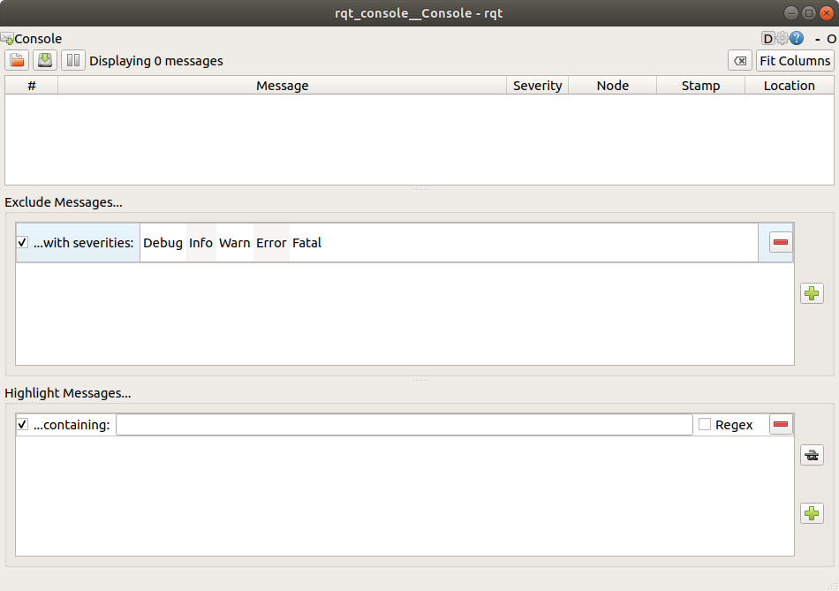
The first section of the console is where log messages from your system will display.
In the middle you have the option to filter messages by excluding severity levels. You can also add more exclusion filters using the plus-sign button to the right.
The bottom section is for highlighting messages that include a string you input. You can add more filters to this section as well.
Now start turtlesim in a new terminal with the following command:
ros2 run turtlesim turtlesim_node

2 Messages on rqt_console
To produce log messages for rqt_console to display, let’s have the turtle run into the wall. In a new terminal, enter the ros2 topic pub command (discussed in detail in the topics tutorial) below:
ros2 topic pub -r 1 /turtle1/cmd_vel geometry_msgs/msg/Twist "{linear: {x: 2.0, y: 0.0, z: 0.0}, angular: {x: 0.0,y: 0.0,z: 0.0}}"
Since the above command is publishing the topic at a steady rate, the turtle is continuously running into the wall. In rqt_console you will see the same message with the Warn severity level displayed over and over, like so:
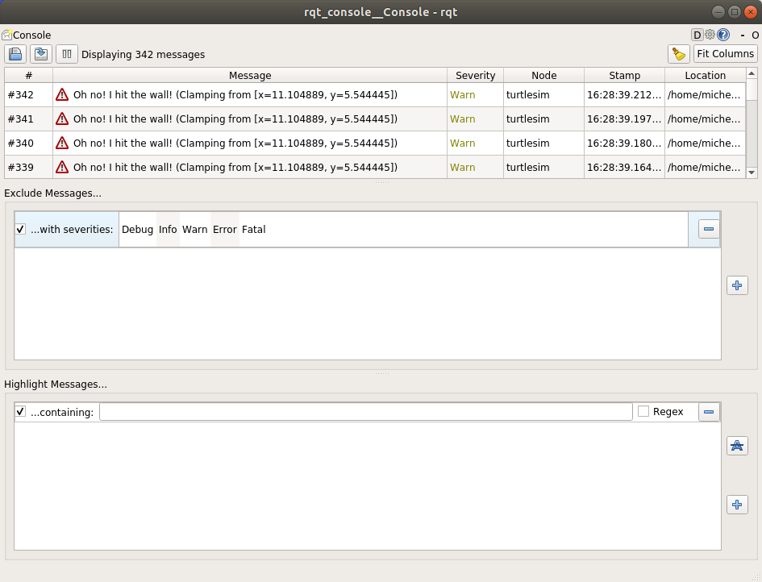

Launching Nodes in ROS2

1. Run a Launch File
To start the launch file, run this command:
ros2 launch turtlesim multisim.launch.py

2. Launch File Content
The multisim.launch.py file starts two turtlesim nodes:
from launch import LaunchDescription
import launch_ros.actions

def generate_launch_description():
return LaunchDescription([
launch_ros.actions.Node(
namespace="turtlesim1", package='turtlesim', executable='turtlesim_node', output='screen'),
launch_ros.actions.Node(
namespace="turtlesim2", package='turtlesim', executable='turtlesim_node', output='screen'),
])

3. Control the Turtles (Optional)
To move the turtles, run these commands in separate terminals:
In the second terminal:
ros2 topic pub /turtlesim1/turtle1/cmd_vel geometry_msgs/msg/Twist "{linear: {x: 2.0}, angular: {z: 1.8}}"
In the third terminal:
ros2 topic pub /turtlesim2/turtle1/cmd_vel geometry_msgs/msg/Twist "{linear: {x: 2.0}, angular: {z: -1.8}}"

4. Summary
You launched two turtlesim nodes with one command. You can control them using the ros2 topic pub command. This shows how to start and configure multiple nodes with a launch file.

Recording and Playing Back Data in ROS2

1. Setup
Start the turtlesim and teleop nodes:
ros2 run turtlesim turtlesim_node
ros2 run turtlesim turtle_teleop_key
Create a directory to store recordings:
mkdir bag_files
cd bag_files

2. Choose a Topic
To see available topics, run:
ros2 topic list
To check data on a topic, run:
ros2 topic echo /turtle1/cmd_vel
Move the turtle using the arrow keys to see data.

3. ros2 bag record

3.1 Record a Single Topic
Record data from a topic:
ros2 bag record /turtle1/cmd_vel
Stop recording with Ctrl+C. The data is saved in a new folder.

3.2 Record Multiple Topics
To record multiple topics:
ros2 bag record -o subset /turtle1/cmd_vel /turtle1/pose
The -o option names the bag file.

4. ros2 bag info
Get info about the recorded bag file:
ros2 bag info subset

5. ros2 bag play
Replay the recorded data:
ros2 bag play subset
Your turtle will follow the recorded path.

Summary
You can record and replay data using ros2 bag. This tool is helpful for sharing data or analyzing your experiments.

Using Colcon build
- Installing the colcon command:
sudo apt install python3-colcon-common-extensions
- Create a workspace and navigate to src directory:
mkdir -p ~/ros2_ws/src
cd ~/ros2_ws
- Make files to the src folder for execution or source it from git:
└── src
└── examples
├── CONTRIBUTING.md
├── LICENSE
├── rclcpp
├── rclpy
└── README.md

4 directories, 3 files
- Build the workspace:
colcon build –symlink-install
- After building we can see some log, build and install files
├── build
├── install
├── log
└── src

4 directories, 0 files
- Run test: We just build
colcon test
- Source the environment:
source install/setup.bash
- Setup colcon_cd
The command colcon_cd allows you to quickly change the current working directory of your shell to the directory of a package. As an example colcon_cd some_ros_package would quickly bring you to the directory ~/ros2_ws/src/some_ros_package.
echo "source /usr/share/colcon_cd/function/colcon_cd.sh" >> ~/.bashrc
echo "export _colcon_cd_root=/opt/ros/humble/" >> ~/.bashrc
- Setup colcon tab completion:
The colcon command supports command completion for bash and bash-like shells. The colcon-argcomplete package must be installed, and some setup may be required to make it work.
colcon test --packages-select YOUR_PKG_NAME --ctest-args -R YOUR_TEST_IN_PKG
- Setup colcon mixins
Various command line options are tedious to write and/or difficult to remember.
For example, to change the CMake build type to debug, you normally use:
colcon build --cmake-args -DCMAKE_BUILD_TYPE=Debug
To make common command line options easier to invoke this repository makes these “shortcuts” available.
To install the default colcon mixins, run the following:
colcon mixin add default https://raw.githubusercontent.com/colcon/colcon-mixin-repository/master/index.yaml
colcon mixin update default
- Then, try out using the debug mixin:
colcon build --mixin debug
Creating a workspace:

1. Source the ROS 2 Environment
Source your main ROS 2 installation in a x64 Native Tools Command Prompt:
call C:\dev\ros2\local_setup.bat
2. Create a New Directory
Create and navigate to a workspace directory:
md \ros2_ws\src
cd \ros2_ws\src
3. Clone a Sample Repository
Clone the `ros_tutorials` repository in the `src` directory:
git clone https://github.com/ros/ros_tutorials.git -b humble
4. Resolve Dependencies
From the workspace root, resolve dependencies:
rosdep install --from-paths src --ignore-src -r -y
5. Build the Workspace with Colcon
Build the workspace:
colcon build --merge-install
After building, you will see:
build
install
log
src
6. Source the Overlay
Open a new terminal, source the underlay, and then the overlay:
call C:\dev\ros2\local_setup.bat
cd \ros2_ws
call install\setup.bash
Run the `turtlesim` package:
ros2 run turtlesim turtlesim_node
7. Modify the Overlay
Edit `turtle_frame.cpp` in `\ros2_ws\src\ros_tutorials\turtlesim\src`:
cpp
setWindowTitle("TurtleSim");
to:
cpp
setWindowTitle("MyTurtleSim");
Rebuild the workspace:
colcon build --merge-install
Run `turtlesim` again in the sourced overlay terminal:
ros2 run turtlesim turtlesim_node
To confirm the underlay is unaffected, source only the underlay in a new terminal and run `turtlesim`:
ros2 run turtlesim turtlesim_node

Creating and Using a ROS 2 Package

1. Create a Package
Source your ROS 2 installation:
call C:\dev\ros2\local_setup.bat
Navigate to the src folder of your workspace:
cd \ros2_ws\src
Create a new package:
ros2 pkg create --build-type ament_cmake --license Apache-2.0 --node-name my_node my_package
This creates a folder my_package in the src directory with the following structure:
my_package
├── CMakeLists.txt
├── include
├── package.xml
└── src
└── my_node.cpp

2. Build the Package
Navigate to the workspace root:
cd \ros2_ws
Build the workspace:
colcon build --merge-install
To build only the my_package package:
colcon build --packages-select my_package

3. Source the Setup File
Open a new terminal, source the ROS 2 installation, and then source your workspace:
call C:\dev\ros2\local_setup.bat
cd \ros2_ws
call install\local_setup.bat

4. Use the Package
Run the executable created during package setup:
ros2 run my_package my_node
Expected output:
hello world my_package package

5. Examine Package Contents
The my_package directory contains the following:
CMakeLists.txt include package.xml src
The src folder contains my_node.cpp, where custom C++ nodes will be added.

6. Customize package.xml
Open package.xml in a text editor and update the following fields:
<description>Beginner client libraries tutorials practice package</description>
<maintainer email="your_email@example.com">Your Name</maintainer>
<license>Apache License 2.0</license>
Save the file after making the changes.

Writing a Simple Publisher and Subscriber (C++)

1. Create a Package
- Source ROS 2:
call C:\dev\ros2\local_setup.bat
- Navigate to Workspace:
cd \ros2_ws\src
- Create Package:
ros2 pkg create --build-type ament_cmake --license Apache-2.0 cpp_pubsub

2. Write the Publisher Node
- Download Publisher Code:
curl -sk https://raw.githubusercontent.com/ros2/examples/humble/rclcpp/topics/minimal_publisher/member_function.cpp -o publisher_member_function.cpp
- Key Features:
  - Publishes "Hello, world!" messages to the topic topic every 0.5 seconds.
  - rclcpp::Node subclass, MinimalPublisher, manages publishing.

The code :
publisher_member_function.cpp.

#include <chrono>
#include <functional>
#include <memory>
#include <string>

#include "rclcpp/rclcpp.hpp"
#include "std_msgs/msg/string.hpp"

using namespace std::chrono_literals;

/* This example creates a subclass of Node and uses std::bind() to register a
* member function as a callback from the timer. */

class MinimalPublisher : public rclcpp::Node
{
public:
MinimalPublisher()
: Node("minimal_publisher"), count_(0)
{
publisher_ = this->create_publisher<std_msgs::msg::String>("topic", 10);
timer_ = this->create_wall_timer(
500ms, std::bind(&MinimalPublisher::timer_callback, this));
}

private:
void timer_callback()
{
auto message = std_msgs::msg::String();
message.data = "Hello, world! " + std::to_string(count_++);
RCLCPP_INFO(this->get_logger(), "Publishing: '%s'", message.data.c_str());
publisher_->publish(message);
}
rclcpp::TimerBase::SharedPtr timer_;
rclcpp::Publisher<std_msgs::msg::String>::SharedPtr publisher_;
size_t count_;
};

int main(int argc, char * argv[])
{
rclcpp::init(argc, argv);
rclcpp::spin(std::make_shared<MinimalPublisher>());
rclcpp::shutdown();
return 0;
}

2.1 Examine the code:
The top of the code includes the standard C++ headers you will be using. After the standard C++ headers is the rclcpp/rclcpp.hpp include which allows you to use the most common pieces of the ROS 2 system. Last is std_msgs/msg/string.hpp, which includes the built-in message type you will use to publish data.
#include <chrono>
#include <functional>
#include <memory>
#include <string>

#include "rclcpp/rclcpp.hpp"
#include "std_msgs/msg/string.hpp"

using namespace std::chrono_literals;
These lines represent the node’s dependencies. Recall that dependencies have to be added to package.xml and CMakeLists.txt, which you’ll do in the next section.
The next line creates the node class MinimalPublisher by inheriting from rclcpp::Node. Every this in the code is referring to the node.
class MinimalPublisher : public rclcpp::Node
The public constructor names the node minimal_publisher and initializes count_ to 0. Inside the constructor, the publisher is initialized with the String message type, the topic name topic, and the required queue size to limit messages in the event of a backup. Next, timer_ is initialized, which causes the timer_callback function to be executed twice a second.
public:
MinimalPublisher()
: Node("minimal_publisher"), count_(0)
{
publisher_ = this->create_publisher<std_msgs::msg::String>("topic", 10);
timer_ = this->create_wall_timer(
500ms, std::bind(&MinimalPublisher::timer_callback, this));
}
The timer_callback function is where the message data is set and the messages are actually published. The RCLCPP_INFO macro ensures every published message is printed to the console.
private:
void timer_callback()
{
auto message = std_msgs::msg::String();
message.data = "Hello, world! " + std::to_string(count_++);
RCLCPP_INFO(this->get_logger(), "Publishing: '%s'", message.data.c_str());
publisher_->publish(message);
}
Last is the declaration of the timer, publisher, and counter fields.
rclcpp::TimerBase::SharedPtr timer_;
rclcpp::Publisher<std_msgs::msg::String>::SharedPtr publisher_;
size_t count_;
Following the MinimalPublisher class is main, where the node actually executes. rclcpp::init initializes ROS 2, and rclcpp::spin starts processing data from the node, including callbacks from the timer.
int main(int argc, char * argv[])
{
rclcpp::init(argc, argv);
rclcpp::spin(std::make_shared<MinimalPublisher>());
rclcpp::shutdown();
return0;
}

- Dependencies: Add to package.xml:
<depend>rclcpp</depend>
<depend>std_msgs</depend>
Update CMakeLists.txt:
find_package(rclcpp REQUIRED)
find_package(std_msgs REQUIRED)

add_executable(talker src/publisher_member_function.cpp)
ament_target_dependencies(talker rclcpp std_msgs)

install(TARGETS talker DESTINATION lib/${PROJECT_NAME})
Code for CmakeList.txt:
cmake_minimum_required(VERSION 3.5)
project(cpp_pubsub)

# Default to C++14
if(NOT CMAKE_CXX_STANDARD)
set(CMAKE_CXX_STANDARD 14)
endif()

if(CMAKE_COMPILER_IS_GNUCXX OR CMAKE_CXX_COMPILER_ID MATCHES "Clang")
add_compile_options(-Wall -Wextra -Wpedantic)
endif()

find_package(ament_cmake REQUIRED)
find_package(rclcpp REQUIRED)
find_package(std_msgs REQUIRED)

add_executable(talker src/publisher_member_function.cpp)
ament_target_dependencies(talker rclcpp std_msgs)

install(TARGETS
talker
DESTINATION lib/${PROJECT_NAME})

ament_package()

3. Write the Subscriber Node
- Download Subscriber Code:
curl -sk https://raw.githubusercontent.com/ros2/examples/humble/rclcpp/topics/minimal_subscriber/member_function.cpp -o subscriber_member_function.cpp
- Key Features:
  - Subscribes to topic and logs received messages.
  - rclcpp::Node subclass, MinimalSubscriber, manages subscriptions.
- Update CMakeLists.txt:
add_executable(listener src/subscriber_member_function.cpp)
ament_target_dependencies(listener rclcpp std_msgs)

install(TARGETS talker listener DESTINATION lib/${PROJECT_NAME})

4. Build and Run
- Build Package:
colcon build --merge-install --packages-select cpp_pubsub
- Source Workspace:
call install\local_setup.bat
- Run Publisher:
ros2 run cpp_pubsub talker
- Run Subscriber:
ros2 run cpp_pubsub listener
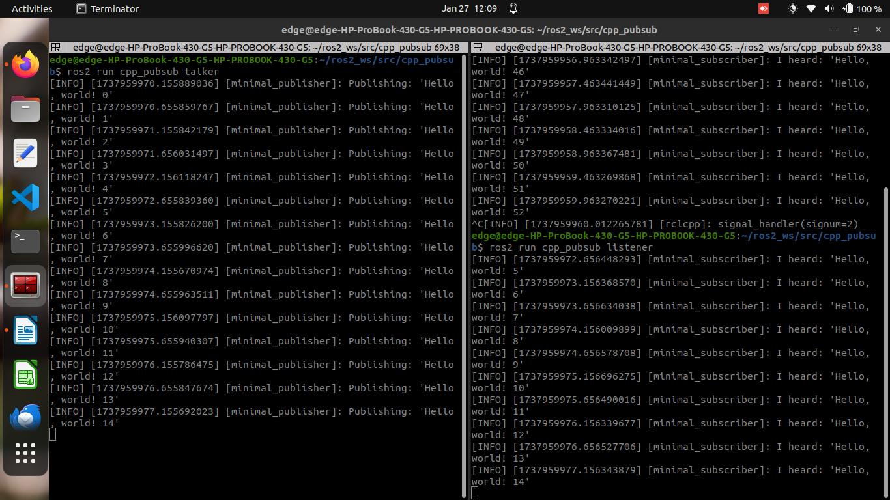
Expected Output:
- Publisher: Logs "Publishing: Hello, world! <count>".
- Subscriber: Logs "I heard: Hello, world! <count>".

Writing a Simple Service and Client in C++

1. Create a Package
Create a new package with dependencies:
ros2 pkg create --build-type ament_cmake --license Apache-2.0 cpp_srvcli --dependencies rclcpp example_interfaces
Edit package.xml with description and maintainer info.

2. Write the Service Node
Create a service node file add_two_ints_server.cpp:
#include "rclcpp/rclcpp.hpp"
#include "example_interfaces/srv/add_two_ints.hpp"

void add(const std::shared_ptr<example_interfaces::srv::AddTwoInts::Request> request,
std::shared_ptr<example_interfaces::srv::AddTwoInts::Response> response)
{
response->sum = request->a + request->b;
RCLCPP_INFO(rclcpp::get_logger("rclcpp"), "Incoming request\na: %ld b: %ld", request->a, request->b);
RCLCPP_INFO(rclcpp::get_logger("rclcpp"), "sending back response: [%ld]", (long int)response->sum);
}

int main(int argc, char **argv)
{
rclcpp::init(argc, argv);
auto node = rclcpp::Node::make_shared("add_two_ints_server");
rclcpp::Service<example_interfaces::srv::AddTwoInts>::SharedPtr service =
node->create_service<example_interfaces::srv::AddTwoInts>("add_two_ints", &add);
RCLCPP_INFO(rclcpp::get_logger("rclcpp"), "Ready to add two ints.");
rclcpp::spin(node);
rclcpp::shutdown();
}

2.1 Examine the Code
- The add function computes the sum and logs the request and response.
- The main function initializes ROS, creates a node, and spins the service.

2.2 Add Executable
In CMakeLists.txt, add:
add_executable(server src/add_two_ints_server.cpp)
ament_target_dependencies(server rclcpp example_interfaces)
install(TARGETS server DESTINATION lib/${PROJECT_NAME})

3. Write the Client Node
Create a client node file add_two_ints_client.cpp:
#include "rclcpp/rclcpp.hpp"
#include "example_interfaces/srv/add_two_ints.hpp"

int main(int argc, char **argv)
{
rclcpp::init(argc, argv);
if (argc != 3) {
RCLCPP_INFO(rclcpp::get_logger("rclcpp"), "usage: add_two_ints_client X Y");
return 1;
}
auto node = rclcpp::Node::make_shared("add_two_ints_client");
rclcpp::Client<example_interfaces::srv::AddTwoInts>::SharedPtr client =
node->create_client<example_interfaces::srv::AddTwoInts>("add_two_ints");

auto request = std::make_shared<example_interfaces::srv::AddTwoInts::Request>();
request->a = atoll(argv[1]);
request->b = atoll(argv[2]);

while (!client->wait_for_service(1s)) {
if (!rclcpp::ok()) {
RCLCPP_ERROR(rclcpp::get_logger("rclcpp"), "Interrupted while waiting for the service. Exiting.");
return 0;
}
RCLCPP_INFO(rclcpp::get_logger("rclcpp"), "service not available, waiting again...");
}

auto result = client->async_send_request(request);
if (rclcpp::spin_until_future_complete(node, result) == rclcpp::FutureReturnCode::SUCCESS) {
RCLCPP_INFO(rclcpp::get_logger("rclcpp"), "Sum: %ld", result.get()->sum);
} else {
RCLCPP_ERROR(rclcpp::get_logger("rclcpp"), "Failed to call service add_two_ints");
}

rclcpp::shutdown();
return 0;
}

3.1 Examine the Code
- The client sends a request with two integers and waits for the response.
- The client logs the result or error message.

3.2 Add Executable
In CMakeLists.txt, add:
add_executable(client src/add_two_ints_client.cpp)
ament_target_dependencies(client rclcpp example_interfaces)
install(TARGETS client DESTINATION lib/${PROJECT_NAME})

4. Build and Run
Install dependencies and build the package:
rosdep install -i --from-path src --rosdistro humble -y
colcon build --packages-select cpp_srvcli
Source the setup files:
source install/setup.bash
Run the service node:
ros2 run cpp_srvcli server
In another terminal, run the client node with arguments:
ros2 run cpp_srvcli client 2 3
The client should output:
[INFO] [rclcpp]: Sum: 5

Summary
You created a service and client in ROS 2 using C++. The service computes the sum of two integers, and the client sends a request and displays the result.
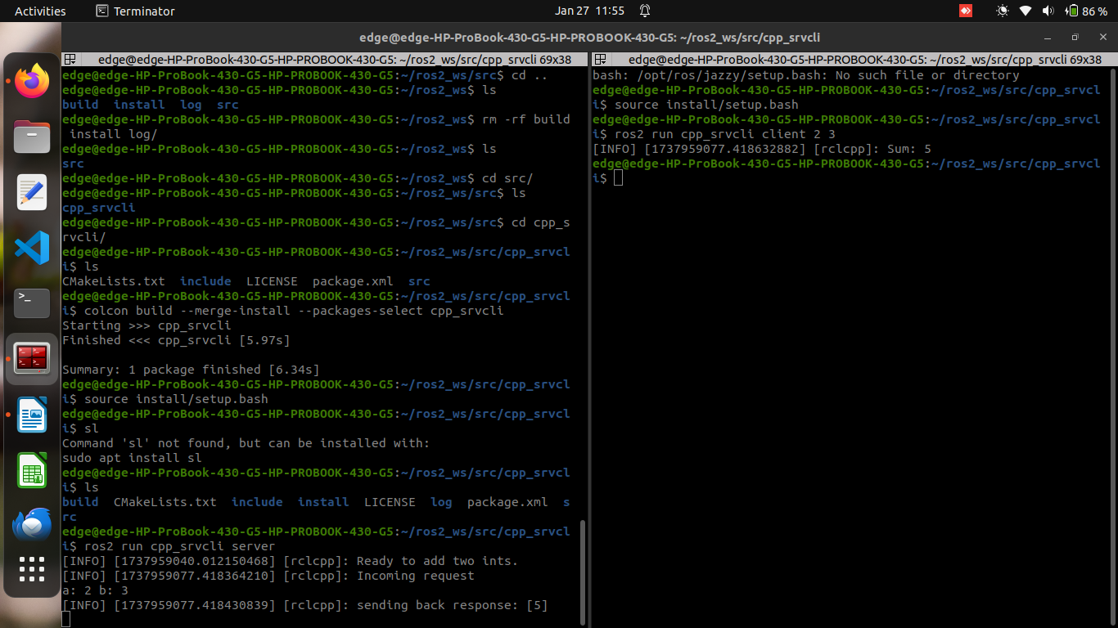

Creating custom msg and srv file

1. Create a New Package
To start, create a new package for the custom interfaces. In your workspace, run:
ros2 pkg create --build-type ament_cmake --license Apache-2.0 tutorial_interfaces
This will create a package named tutorial_interfaces.

2. Create Custom Definitions

2.1 msg Definition
In the tutorial_interfaces/msg directory, create two message files:
- Num.msg
int64 num
- Sphere.msg
geometry_msgs/Point center
float64 radius

2.2 srv Definition
In the tutorial_interfaces/srv directory, create the service file:
- AddThreeInts.srv
int64 a
int64 b
int64 c
---
int64 sum

3. Modify CMakeLists.txt
In CMakeLists.txt, add the following to enable the generation of language-specific code for your custom messages and services:
find_package(geometry_msgs REQUIRED)
find_package(rosidl_default_generators REQUIRED)

rosidl_generate_interfaces(${PROJECT_NAME}
"msg/Num.msg"
"msg/Sphere.msg"
"srv/AddThreeInts.srv"
DEPENDENCIES geometry_msgs
)

4. Modify package.xml
In package.xml, declare dependencies and build tools:
<depend>geometry_msgs</depend>
<buildtool_depend>rosidl_default_generators</buildtool_depend>
<exec_depend>rosidl_default_runtime</exec_depend>
<member_of_group>rosidl_interface_packages</member_of_group>

5. Build the tutorial_interfaces Package
Now that the interfaces are defined, build the package:
colcon build --packages-select tutorial_interfaces

6. Confirm msg and srv Creation
Source the workspace and confirm the creation of the interfaces:
source install/setup.bash
ros2 interface show tutorial_interfaces/msg/Num
ros2 interface show tutorial_interfaces/msg/Sphere
ros2 interface show tutorial_interfaces/srv/AddThreeInts

7. Test the New Interfaces

7.1 Testing Num.msg with Pub/Sub
Modify the publisher and subscriber nodes to use Num.msg.
Publisher (C++)
#include "rclcpp/rclcpp.hpp"
#include "tutorial_interfaces/msg/num.hpp"

using namespace std::chrono_literals;

class MinimalPublisher : public rclcpp::Node
{
public:
MinimalPublisher()
: Node("minimal_publisher"), count_(0)
{
publisher_ = this->create_publisher<tutorial_interfaces::msg::Num>("topic", 10);
timer_ = this->create_wall_timer(
500ms, std::bind(&MinimalPublisher::timer_callback, this));
}

private:
void timer_callback()
{
auto message = tutorial_interfaces::msg::Num();
message.num = this->count_++;
RCLCPP_INFO_STREAM(this->get_logger(), "Publishing: '" << message.num << "'");
publisher_->publish(message);
}
rclcpp::TimerBase::SharedPtr timer_;
rclcpp::Publisher<tutorial_interfaces::msg::Num>::SharedPtr publisher_;
size_t count_;
};

int main(int argc, char * argv[])
{
rclcpp::init(argc, argv);
rclcpp::spin(std::make_shared<MinimalPublisher>());
rclcpp::shutdown();
return 0;
}
Subscriber (C++)
#include "rclcpp/rclcpp.hpp"
#include "tutorial_interfaces/msg/num.hpp"

using std::placeholders::_1;

class MinimalSubscriber : public rclcpp::Node
{
public:
MinimalSubscriber()
: Node("minimal_subscriber")
{
subscription_ = this->create_subscription<tutorial_interfaces::msg::Num>(
"topic", 10, std::bind(&MinimalSubscriber::topic_callback, this, _1));
}

private:
void topic_callback(const tutorial_interfaces::msg::Num & msg) const
{
RCLCPP_INFO_STREAM(this->get_logger(), "I heard: '" << msg.num << "'");
}
rclcpp::Subscription<tutorial_interfaces::msg::Num>::SharedPtr subscription_;
};

int main(int argc, char * argv[])
{
rclcpp::init(argc, argv);
rclcpp::spin(std::make_shared<MinimalSubscriber>());
rclcpp::shutdown();
return 0;
}

7.2 Testing AddThreeInts.srv with Service/Client
Modify the service and client nodes to use AddThreeInts.srv.
Service (C++)
#include "rclcpp/rclcpp.hpp"
#include "tutorial_interfaces/srv/add_three_ints.hpp"

void add(const std::shared_ptr<tutorial_interfaces::srv::AddThreeInts::Request> request,
std::shared_ptr<tutorial_interfaces::srv::AddThreeInts::Response> response)
{
response->sum = request->a + request->b + request->c;
RCLCPP_INFO(rclcpp::get_logger("rclcpp"), "Incoming request: a: %ld, b: %ld, c: %ld", request->a, request->b, request->c);
RCLCPP_INFO(rclcpp::get_logger("rclcpp"), "Sending back response: [%ld]", (long int)response->sum);
}

int main(int argc, char **argv)
{
rclcpp::init(argc, argv);
auto node = rclcpp::Node::make_shared("add_three_ints_server");

rclcpp::Service<tutorial_interfaces::srv::AddThreeInts>::SharedPtr service =
node->create_service<tutorial_interfaces::srv::AddThreeInts>("add_three_ints", &add);

RCLCPP_INFO(rclcpp::get_logger("rclcpp"), "Ready to add three ints.");
rclcpp::spin(node);
rclcpp::shutdown();
}
Client (C++)
#include "rclcpp/rclcpp.hpp"
#include "tutorial_interfaces/srv/add_three_ints.hpp"
#include <chrono>
#include <cstdlib>
#include <memory>

using namespace std::chrono_literals;

int main(int argc, char **argv)
{
rclcpp::init(argc, argv);
if (argc != 4) {
RCLCPP_INFO(rclcpp::get_logger("rclcpp"), "Usage: add_three_ints_client X Y Z");
return 1;
}

auto node = rclcpp::Node::make_shared("add_three_ints_client");
rclcpp::Client<tutorial_interfaces::srv::AddThreeInts>::SharedPtr client =
node->create_client<tutorial_interfaces::srv::AddThreeInts>("add_three_ints");

auto request = std::make_shared<tutorial_interfaces::srv::AddThreeInts::Request>();
request->a = atoll(argv[1]);
request->b = atoll(argv[2]);
request->c = atoll(argv[3]);

while (!client->wait_for_service(1s)) {
if (!rclcpp::ok()) {
RCLCPP_ERROR(rclcpp::get_logger("rclcpp"), "Interrupted while waiting for the service. Exiting.");
return 0;
}
RCLCPP_INFO(rclcpp::get_logger("rclcpp"), "Service not available, waiting again...");
}

auto result = client->async_send_request(request);
if (rclcpp::spin_until_future_complete(node, result) == rclcpp::FutureReturnCode::SUCCESS) {
RCLCPP_INFO(rclcpp::get_logger("rclcpp"), "Sum: %ld", result.get()->sum);
} else {
RCLCPP_ERROR(rclcpp::get_logger("rclcpp"), "Failed to call service add_three_ints");
}

rclcpp::shutdown();
return 0;
}

8. Build the Package
After modifying the nodes, CMakeLists.txt, and package.xml, build the package:
colcon build --packages-select cpp_pubsub
colcon build --packages-select cpp_srvcli

9. Run the Nodes
In two separate terminals, source the workspace and run the publisher and subscriber:
ros2 run cpp_pubsub talker
ros2 run cpp_pubsub listener
For the service and client:
ros2 run cpp_srvcli server
ros2 run cpp_srvcli client 2 3 1

Summary
This tutorial covered how to:
- Create custom .msg and .srv files.
- Modify CMakeLists.txt and package.xml for building and runtime dependencies.
- Build and test the custom interfaces with publisher/subscriber and service/client examples.
Let me know if you need further clarification!

Implementing custom interfaces

1. Create a Package
- In your workspace's src directory, create a package for custom interfaces:
ros2 pkg create --build-type ament_cmake --license Apache-2.0 more_interfaces
mkdir more_interfaces/msg

2. Create a Message File
- Inside more_interfaces/msg, create a file AddressBook.msg with the following structure:
uint8 PHONE_TYPE_HOME=0
uint8 PHONE_TYPE_WORK=1
uint8 PHONE_TYPE_MOBILE=2

string first_name
string last_name
string phone_number
uint8 phone_type
- This message contains fields for storing a person's name, phone number, and type of phone.

3. Modify package.xml
- Add the following dependencies and group to package.xml:
<buildtool_depend>rosidl_default_generators</buildtool_depend>
<exec_depend>rosidl_default_runtime</exec_depend>
<member_of_group>rosidl_interface_packages</member_of_group>

4. Modify CMakeLists.txt
- Find and include necessary packages for message generation:
find_package(rosidl_default_generators REQUIRED)

set(msg_files "msg/AddressBook.msg")

rosidl_generate_interfaces(${PROJECT_NAME} ${msg_files})
ament_export_dependencies(rosidl_default_runtime)
- This configures the build process to generate C++ and Python code from your message file.

5. Write Publisher Code
- In more_interfaces/src, create publish_address_book.cpp to publish the AddressBook message:
#include <chrono>
#include "rclcpp/rclcpp.hpp"
#include "more_interfaces/msg/address_book.hpp"

class AddressBookPublisher : public rclcpp::Node
{
public:
AddressBookPublisher() : Node("address_book_publisher")
{
address_book_publisher_ = this->create_publisher<more_interfaces::msg::AddressBook>("address_book", 10);
auto publish_msg = [this]() -> void {
auto message = more_interfaces::msg::AddressBook();
message.first_name = "John";
message.last_name = "Doe";
message.phone_number = "1234567890";
message.phone_type = message.PHONE_TYPE_MOBILE;
this->address_book_publisher_->publish(message);
};
timer_ = this->create_wall_timer(1s, publish_msg);
}

private:
rclcpp::Publisher<more_interfaces::msg::AddressBook>::SharedPtr address_book_publisher_;
rclcpp::TimerBase::SharedPtr timer_;
};

int main(int argc, char * argv[])
{
rclcpp::init(argc, argv);
rclcpp::spin(std::make_shared<AddressBookPublisher>());
rclcpp::shutdown();
return 0;
}

6. Modify CMakeLists.txt for the Publisher
- Add the following to link against the ROS 2 libraries and include message generation:
find_package(rclcpp REQUIRED)
add_executable(publish_address_book src/publish_address_book.cpp)
ament_target_dependencies(publish_address_book rclcpp)
install(TARGETS publish_address_book DESTINATION lib/${PROJECT_NAME})
rosidl_get_typesupport_target(cpp_typesupport_target ${PROJECT_NAME} rosidl_typesupport_cpp)
target_link_libraries(publish_address_book "${cpp_typesupport_target}")

7. Build and Run the Package
- Build the package:
cd ~/ros2_ws
colcon build --packages-up-to more_interfaces
- Source the workspace and run the publisher:
source install/local_setup.bash
ros2 run more_interfaces publish_address_book
- To verify the message is being published, use another terminal to echo the topic:
source install/setup.bash
ros2 topic echo /address_book
This process outlines how to create a custom message interface, write a publisher node, and run it in ROS 2.

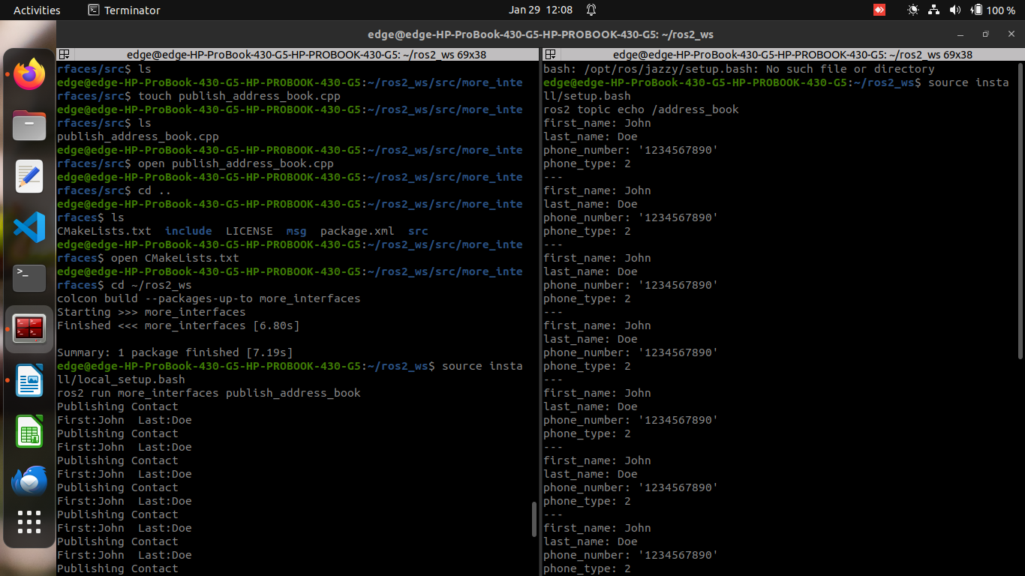

Using parameters in a class (C++)
Here’s a summarized version of the process for using parameters in a C++ ROS 2 node:

1. Create a Package
- Create a new package named cpp_parameters in the src directory of your workspace:
ros2 pkg create --build-type ament_cmake --license Apache-2.0 cpp_parameters --dependencies rclcpp
- This automatically adds necessary dependencies to package.xml and CMakeLists.txt.

2. Update package.xml
- Ensure the following details are included in package.xml:
<description>C++ parameter tutorial</description>
<maintainer email="you@email.com">Your Name</maintainer>
<license>Apache License 2.0</license>

3. Write the C++ Node
- In cpp_parameters/src, create a file cpp_parameters_node.cpp with the following code:
#include <chrono>
#include <functional>
#include <string>
#include <rclcpp/rclcpp.hpp>

using namespace std::chrono_literals;

class MinimalParam : public rclcpp::Node
{
public:
MinimalParam()
: Node("minimal_param_node")
{
this->declare_parameter("my_parameter", "world");
timer_ = this->create_wall_timer(1000ms, std::bind(&MinimalParam::timer_callback, this));
}

void timer_callback()
{
std::string my_param = this->get_parameter("my_parameter").as_string();
RCLCPP_INFO(this->get_logger(), "Hello %s!", my_param.c_str());
std::vector<rclcpp::Parameter> all_new_parameters{rclcpp::Parameter("my_parameter", "world")};
this->set_parameters(all_new_parameters);
}

private:
rclcpp::TimerBase::SharedPtr timer_;
};

int main(int argc, char ** argv)
{
rclcpp::init(argc, argv);
rclcpp::spin(std::make_shared<MinimalParam>());
rclcpp::shutdown();
return 0;
}

4. Examine the Code
- The constructor declares a parameter my_parameter with a default value "world". A timer is set to call the timer_callback function every second.
- The timer_callback function retrieves the parameter value, logs it, and resets the parameter to its default value.

5. Optional: Add Parameter Descriptor
- You can add a description for the parameter:
auto param_desc = rcl_interfaces::msg::ParameterDescriptor{};
param_desc.description = "This parameter is mine!";
this->declare_parameter("my_parameter", "world", param_desc);

6. Add Executable to CMakeLists.txt
- In CMakeLists.txt, add:
add_executable(minimal_param_node src/cpp_parameters_node.cpp)
ament_target_dependencies(minimal_param_node rclcpp)

install(TARGETS minimal_param_node DESTINATION lib/${PROJECT_NAME})

7. Build and Run
- Run rosdep to check for missing dependencies:
rosdep install -i --from-path src --rosdistro humble -y
- Build the package:
colcon build --packages-select cpp_parameters
- Source the setup files and run the node:
source install/setup.bash
ros2 run cpp_parameters minimal_param_node

8. Change Parameters via Console
- To view and modify the parameter, use:
ros2 param list
ros2 param set /minimal_param_node my_parameter earth
- The output will change to:
[INFO] [minimal_param_node]: Hello earth!
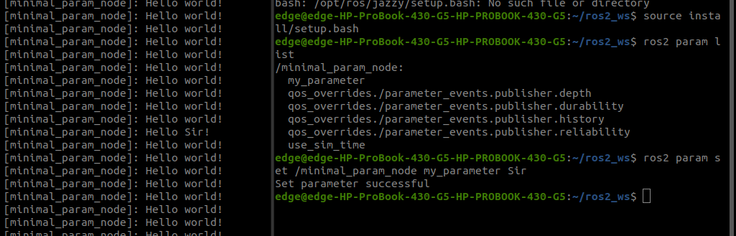

9. Change Parameters via Launch File
- Create a launch directory and a file cpp_parameters_launch.py:
from launch import LaunchDescription
from launch_ros.actions import Node

def generate_launch_description():
return LaunchDescription([
Node(
package="cpp_parameters",
executable="minimal_param_node",
name="custom_minimal_param_node",
output="screen",
emulate_tty=True,
parameters=[{"my_parameter": "earth"}]
)
])
- In CMakeLists.txt, add:
install(DIRECTORY launch DESTINATION share/${PROJECT_NAME})
- Build and run the launch file:
colcon build --packages-select cpp_parameters
source install/setup.bash
ros2 launch cpp_parameters cpp_parameters_launch.py
- The terminal will output:
[INFO] [custom_minimal_param_node]: Hello earth!
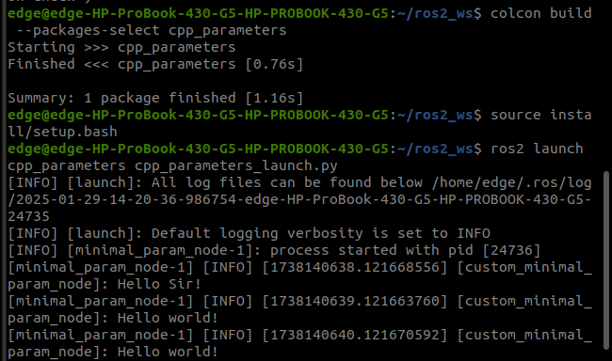

ROS2 Doctor
- Check Your Setup
  - Use ros2 doctor to check your overall ROS 2 setup by running:
ros2 doctor
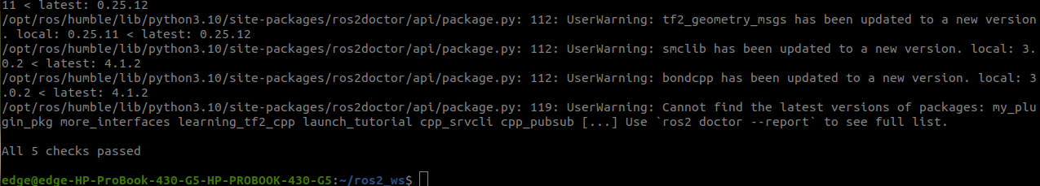
  - If your setup is fine, you’ll see a message like "All checks passed." Warnings are common and indicate non-ideal configurations, but they don't necessarily mean your setup is broken.
  - Errors (e.g., UserWarning: ERROR:) indicate critical issues that need fixing, such as missing settings crucial to ROS 2.
- Check a Running System
  - To diagnose issues in a running system, launch a ROS 2 node like turtlesim:
ros2 run turtlesim turtlesim_node
Then, run the teleop controls:
ros2 run turtlesim turtle_teleop_key
  - Running ros2 doctor while the system is running will show new warnings like "Publisher without subscriber detected" if certain topics aren't being subscribed to. These can be fixed by echoing the topics:
ros2 topic echo /turtle1/color_sensor
ros2 topic echo /turtle1/pose
- Get a Full Report
  - To get a more detailed analysis of your system, use the --report argument:
ros2 doctor --report
  - This provides a detailed report in five categories: Network Configuration, Platform Information, RMW Middleware, ROS 2 Information, and Topic List. This is useful for diagnosing issues, understanding your setup, and providing detailed information when seeking help.
By using ros2 doctor, you can identify configuration issues, diagnose communication problems, and generate detailed reports to assist with troubleshooting.
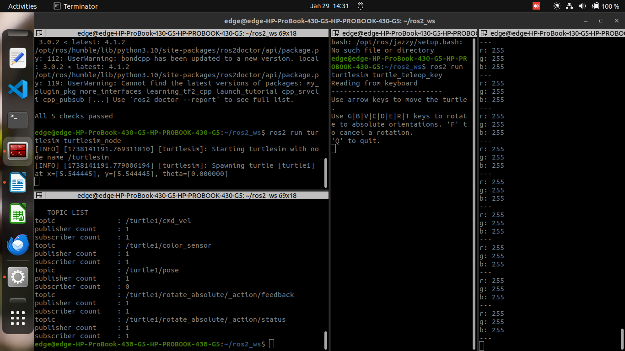

Creating and using plugins (C++)

Summary of Creating Plugins in ROS 2 Using pluginlib
This tutorial walks through the process of creating and using plugins in ROS 2. The approach involves defining a base class, implementing plugins, and dynamically loading them using pluginlib.

1. Create the Base Class Package
- Create a package polygon_base:
ros2 pkg create --build-type ament_cmake --license Apache-2.0 --dependencies pluginlib --node-name area_node polygon_base
- Define an abstract class RegularPolygon in regular_polygon.hpp with:
  - A pure virtual initialize(double side_length) method.
  - A pure virtual area() method.
- Modify CMakeLists.txt to export the header files:
install(DIRECTORY include/ DESTINATION include)
ament_export_include_directories(include)

2. Create the Plugin Package
- Create a package polygon_plugins:
ros2 pkg create --build-type ament_cmake --license Apache-2.0 --dependencies polygon_base pluginlib --library-name polygon_plugins polygon_plugins
- Implement two concrete classes (Square and Triangle) in polygon_plugins.cpp:
  - Both inherit from polygon_base::RegularPolygon and implement initialize() and area().
- Register the plugins using:
PLUGINLIB_EXPORT_CLASS(polygon_plugins::Square, polygon_base::RegularPolygon)
PLUGINLIB_EXPORT_CLASS(polygon_plugins::Triangle, polygon_base::RegularPolygon)

3. Plugin Declaration
- Create an XML file plugins.xml to declare plugins:
<library path="polygon_plugins">
<class type="polygon_plugins::Square" base_class_type="polygon_base::RegularPolygon">
<description>This is a square plugin.</description>
</class>
<class type="polygon_plugins::Triangle" base_class_type="polygon_base::RegularPolygon">
<description>This is a triangle plugin.</description>
</class>
</library>
- Modify CMakeLists.txt to export the plugin description:
pluginlib_export_plugin_description_file(polygon_base plugins.xml)

4. Use the Plugins
- In polygon_base, create a node area_node.cpp to load plugins dynamically:
pluginlib::ClassLoader<polygon_base::RegularPolygon> poly_loader("polygon_base", "polygon_base::RegularPolygon");

std::shared_ptr<polygon_base::RegularPolygon> triangle = poly_loader.createSharedInstance("polygon_plugins::Triangle");
triangle->initialize(10.0);

std::shared_ptr<polygon_base::RegularPolygon> square = poly_loader.createSharedInstance("polygon_plugins::Square");
square->initialize(10.0);

printf("Triangle area: %.2f\n", triangle->area());
printf("Square area: %.2f\n", square->area());
- The base package does not depend on the plugin package; plugins are loaded dynamically.

5. Build and Run
- Build both packages:
colcon build --packages-select polygon_base polygon_plugins
- Source the setup files:
source install/setup.bash
- Run the node:
ros2 run polygon_base area_node
- Expected output:
Triangle area: 43.30
Square area: 100.00

Key Takeaways
- Base class: Defines the interface for plugins.
- Plugin package: Implements and registers plugins.
- XML declaration: Helps ROS 2 find and load plugins.
- Dynamic loading: Plugins are instantiated at runtime without direct dependencies.
This method enables modular and extensible ROS 2 systems using pluginlib.

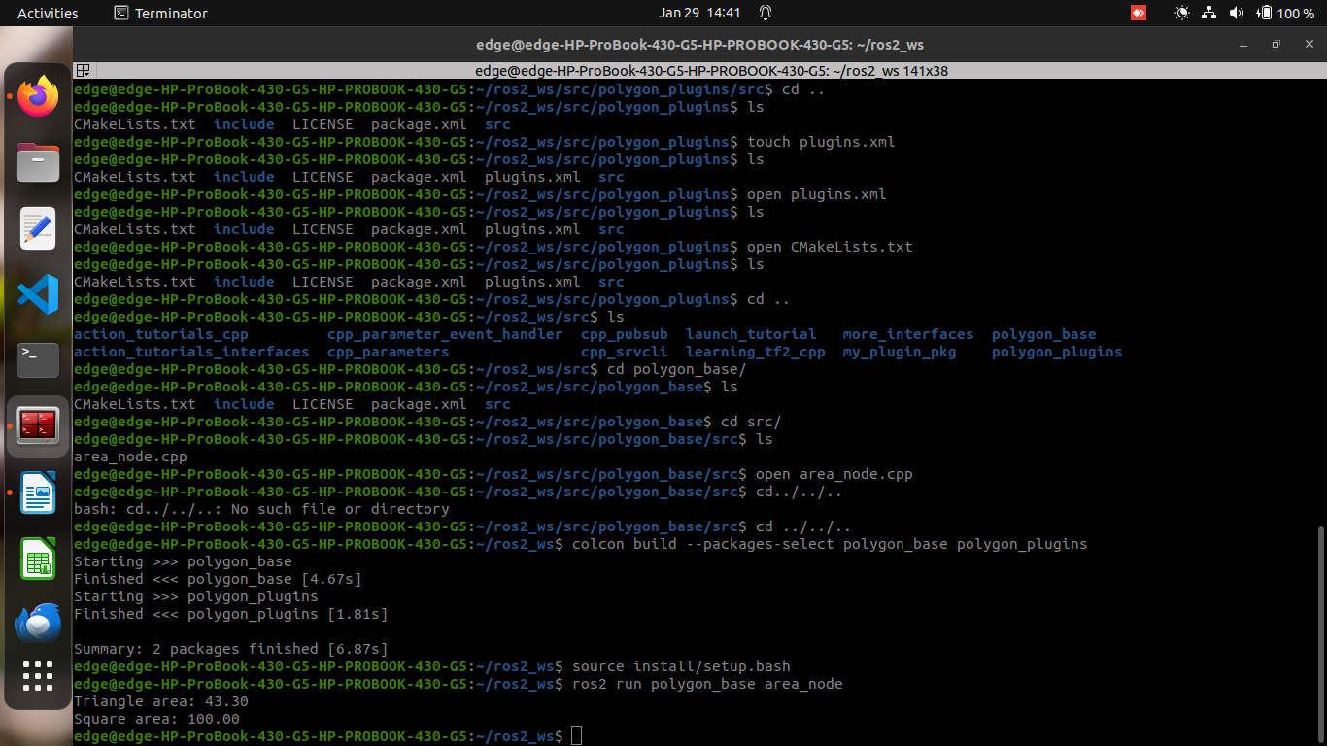

Managing Dependencies with rosdep

What is rosdep?
- rosdep is a command-line dependency management tool for ROS and non-ROS projects.
- It identifies and installs dependencies using system package managers (apt, dnf, etc.).
- Primarily used before building a workspace to ensure all dependencies are installed.
- Not a package manager itself but a meta-package manager.

package.xml and rosdep Keys
- package.xml defines dependencies, ensuring correct build and execution order.
- Dependency tags:
  - <depend>: Required at both build and run time.
  - <build_depend>: Needed only for building.
  - <build_export_depend>: Needed if exporting headers or CMake files.
  - <exec_depend>: Required only at runtime.
  - <test_depend>: Required only for tests.
- Dependencies are referred to as rosdep keys, which must be manually added.

How rosdep Works
- Scans package.xml files to find rosdep keys.
- Matches keys to known system dependencies from rosdistro.
- Uses a locally cached index to install the correct packages.

Finding the Right rosdep Keys
- ROS package dependencies: Use the package name if it exists in the ROS ecosystem.
- Non-ROS dependencies: Find the correct key in rosdep/base.yaml (for system libraries) or rosdep/python.yaml (for Python dependencies).
- Example: doxygen is mapped to system package names across different OS distributions.

Handling Missing Dependencies
- If a library is not in rosdistro, you can submit a pull request to add it.
- Alternatively, maintain a custom fork of rosdistro.

Using rosdep
- Installation:
  - For ROS: apt-get install python3-rosdep
  - For non-ROS: pip install rosdep
- Initialization (first-time use):
sudo rosdep init
rosdep update
- Installing Dependencies:
rosdep install --from-paths src -y --ignore-src
  - --from-paths src: Scans src/ for dependencies.
  - -y: Automatically confirms installations.
  - --ignore-src: Skips dependencies already present in the workspace.

Creating an Action in ROS 2

1. Defining an Action
- Actions are defined in .action files with three sections:
  - Request: Sent from client to server to start a goal.
  - Result: Sent from server to client when the goal is completed.
  - Feedback: Periodic updates from server to client.
Example: Fibonacci Action
cd action_tutorials_interfaces
mkdir action
Create Fibonacci.action:
int32 order
---
int32[] sequence
---
int32[] partial_sequence
- Request: order (sequence length).
- Result: sequence (final Fibonacci numbers).
- Feedback: partial_sequence (progress updates).

2. Building the Action
- Add to CMakeLists.txt before ament_package():
find_package(rosidl_default_generators REQUIRED)

rosidl_generate_interfaces(${PROJECT_NAME}
"action/Fibonacci.action")
- Add dependencies to package.xml:
<buildtool_depend>rosidl_default_generators</buildtool_depend>
<depend>action_msgs</depend>
<member_of_group>rosidl_interface_packages</member_of_group>

3. Compiling and Verifying
- Build the package:
cd ~/ros2_ws
colcon build
- Source the workspace: Source install/setup.bash
- Verify the action definition:
ros2 interface show action_tutorials_interfaces/action/Fibonacci
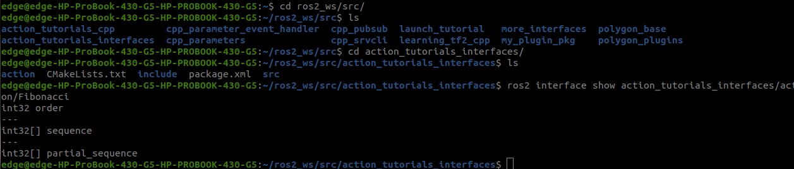

Summary of the ROS2 Action Tutorial

1. Creating the action_tutorials_cpp Package
- Create a new ROS2 package named action_tutorials_cpp with dependencies:
cd ~/ros2_ws/src
ros2 pkg create --dependencies action_tutorials_interfaces rclcpp rclcpp_action rclcpp_components -- action_tutorials_cpp
- Add visibility control for Windows compatibility by defining macros in visibility_control.h.

2. Writing an Action Server
- Implement a Fibonacci sequence action server in fibonacci_action_server.cpp.
- Define a class FibonacciActionServer that:
  - Registers an action server for the "fibonacci" action.
  - Handles goal requests, cancellations, and execution.
  - Executes the Fibonacci sequence in a separate thread while publishing feedback.
- Modify CMakeLists.txt to compile the server and register it as a component.
- Build the package:
colcon build
- Run the action server:
ros2 run action_tutorials_cpp fibonacci_action_server

3. Writing an Action Client
- Implement a Fibonacci action client in fibonacci_action_client.cpp.
- Define a class FibonacciActionClient that:
  - Creates an action client for the "fibonacci" action.
  - Sends a goal request to compute the Fibonacci sequence.
  - Handles goal responses, feedback, and result processing.
- Register the client node as a component.
- Build and run the client:
ros2 run action_tutorials_cpp fibonacci_action_client
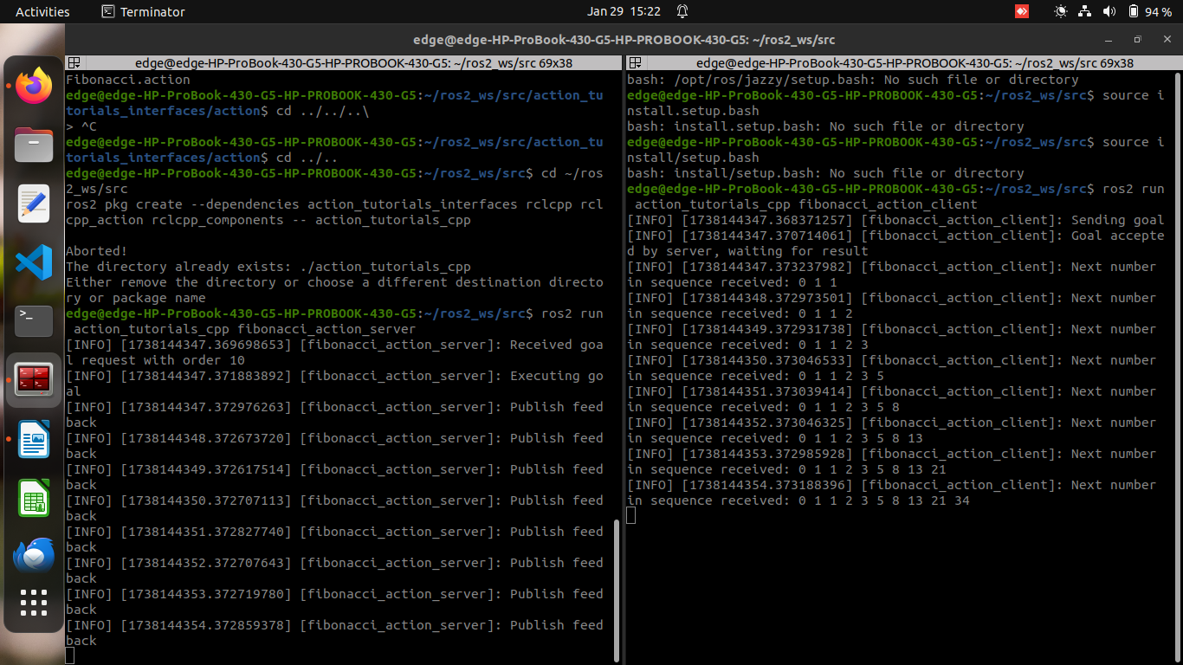
This tutorial provides a complete example of setting up a ROS2 action server and client to compute the Fibonacci sequence, demonstrating goal handling, feedback, and result processing.

Composing multiple nodes in a single process

Run the demos

Discover available components
To see what components are registered and available in the workspace, execute the following in a shell:
ros2 component types
The terminal will return the list of all available components:
(... components of other packages here)
composition
composition::Talker
composition::Listener
composition::NodeLikeListener
composition::Server
composition::Client
(... components of other packages here)

Run-time composition using ROS services with a publisher and subscriber
In the first shell, start the component container:
ros2 run rclcpp_components component_container
Open the second shell and verify that the container is running via ros2 command line tools:
ros2 component list
You should see a name of the component:
/ComponentManager
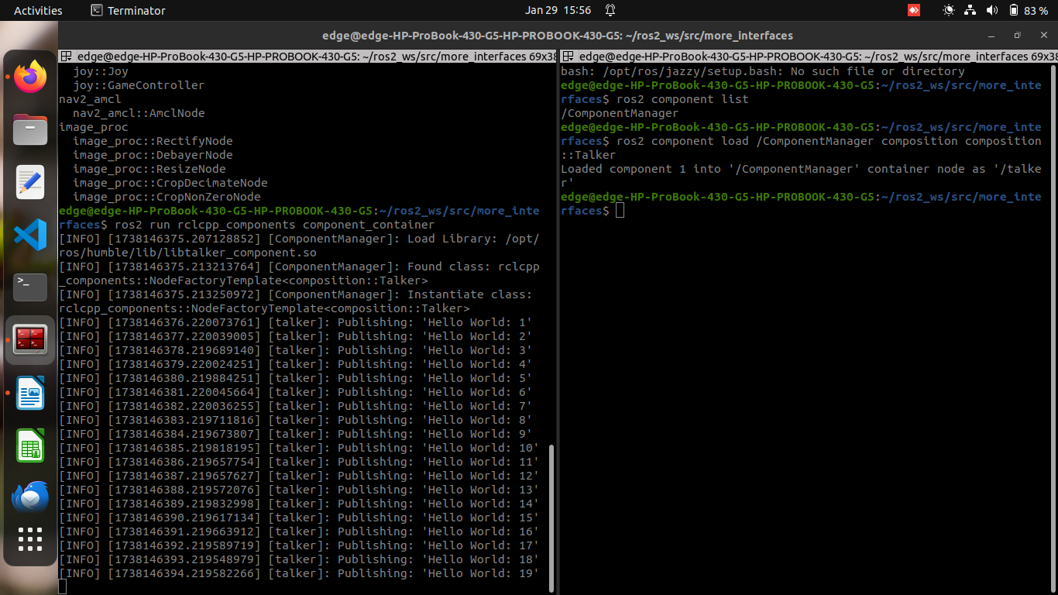
In the second shell load the talker component (see talker source code):
ros2 component load /ComponentManager composition composition::Talker
The command will return the unique ID of the loaded component as well as the node name:
Loaded component 1 into '/ComponentManager' container node as '/talker'
Now the first shell should show a message that the component was loaded as well as repeated message for publishing a message.
Run another command in the second shell to load the listener component (see listener source code):
ros2 component load /ComponentManager composition composition::Listener
Terminal will return:Loaded component 2 into '/ComponentManager' container node as '/listener'
The ros2 command line utility can now be used to inspect the state of the container:
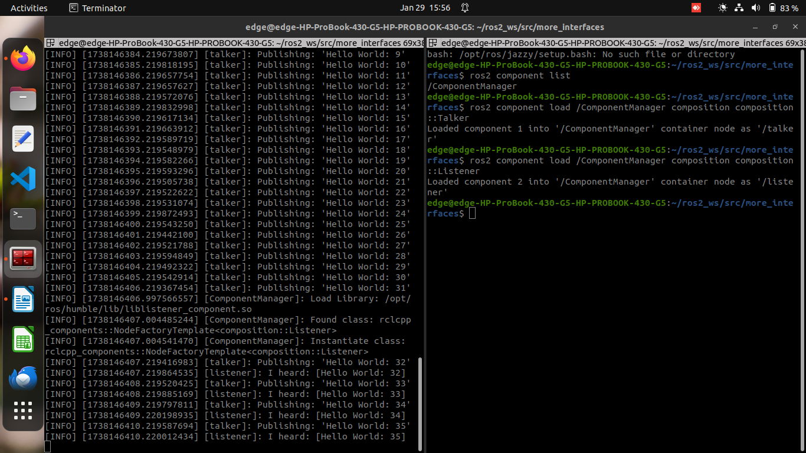
ros2 component list
You will see the following result:
/ComponentManager
1 /talker
2 /listener
Now the first shell should show repeated output for each received message.
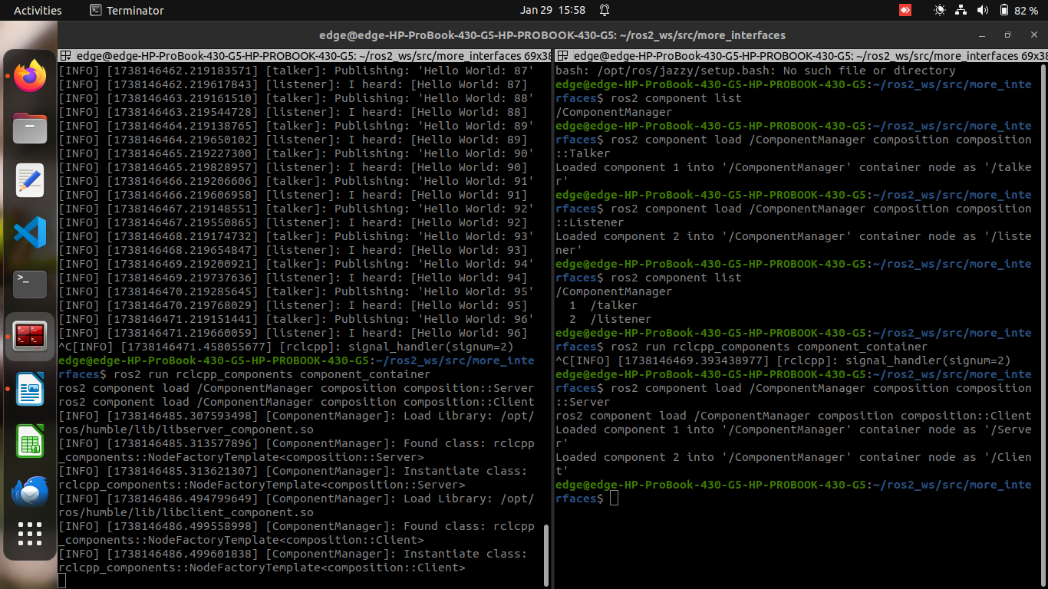

Compile-time composition with hardcoded nodes
ros2 run composition manual_composition

Run-time composition using dlopen
This demo presents an alternative to run-time composition by creating a generic container process and explicitly passing the libraries to load without using ROS interfaces. The process will open each library and create one instance of each “rclcpp::Node” class in the library (source code).
ros2 run composition dlopen_composition `ros2 pkg prefix composition`/lib/libtalker_component.so `ros2 pkg prefix composition`/lib/liblistener_component.so
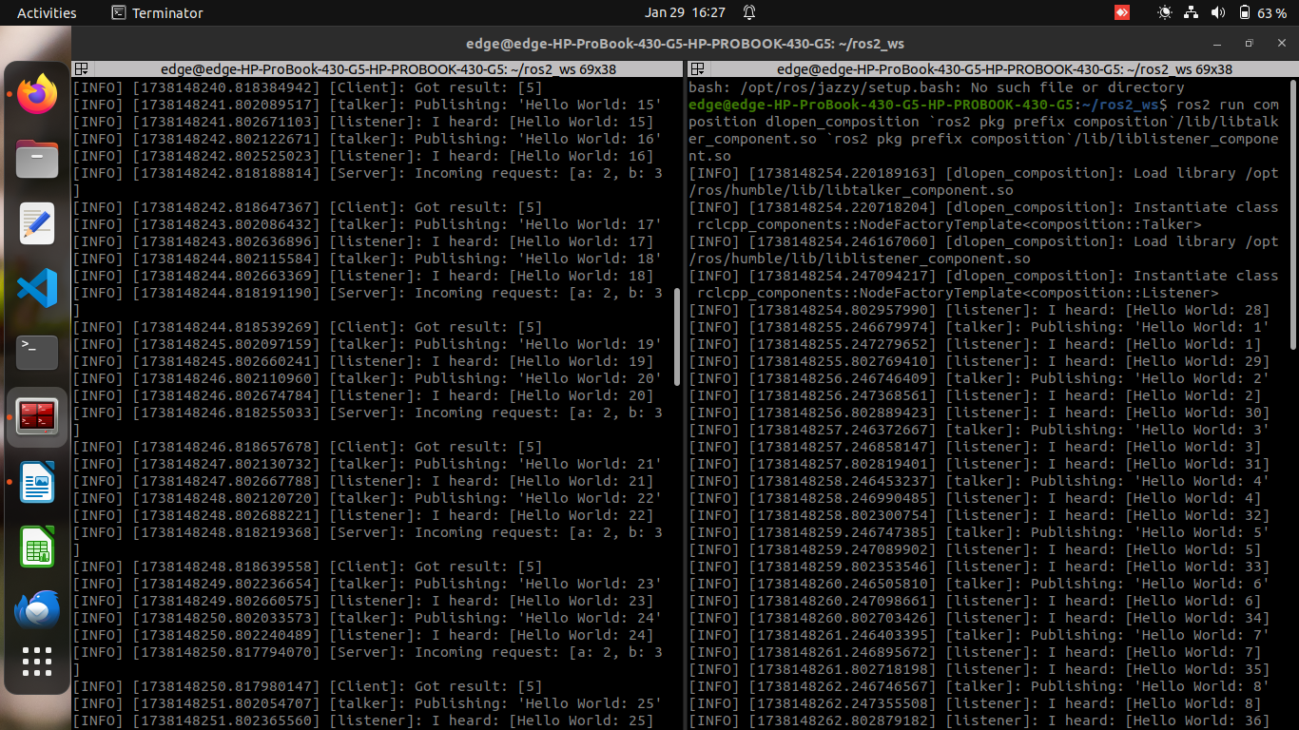
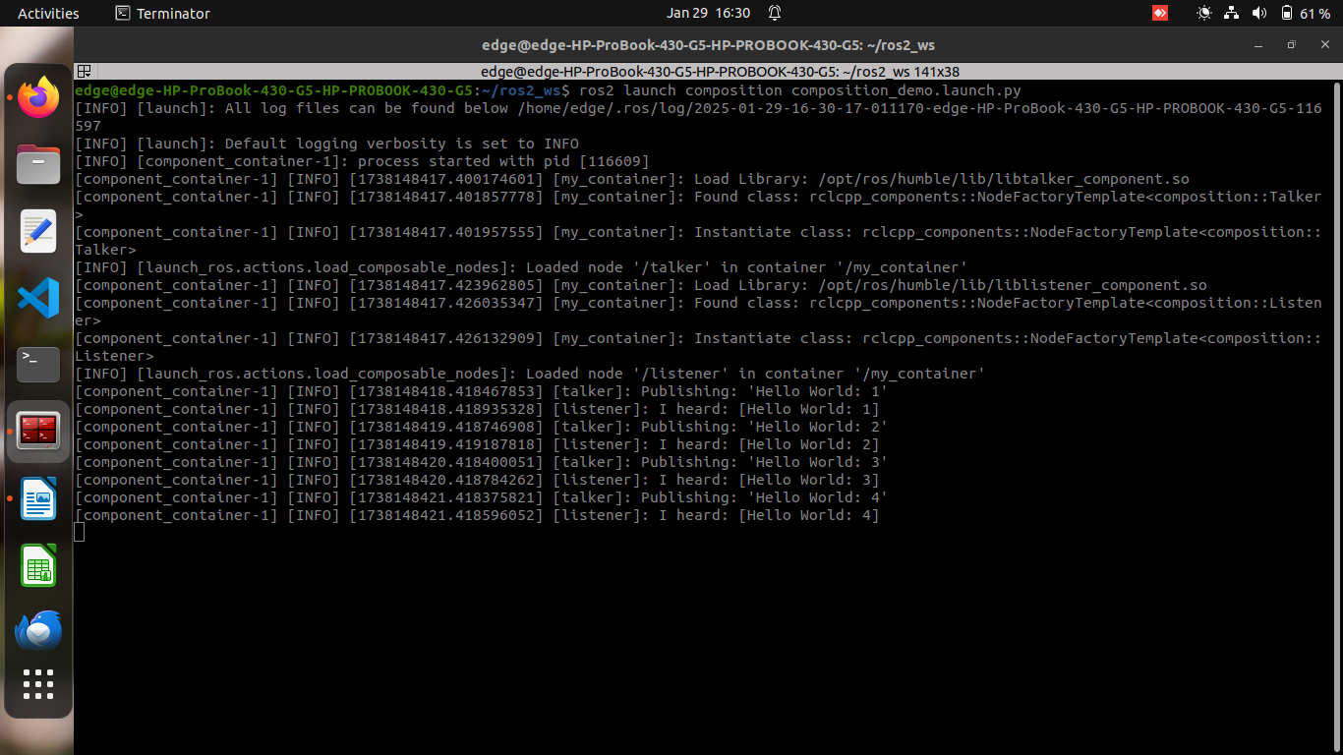
Launch file of demo node:

Monitoring for parameter changes (C++)
Often a node needs to respond to changes to its own parameters or another node’s parameters. The ParameterEventHandler class makes it easy to listen for parameter changes so that your code can respond to them. This tutorial will show you how to use the C++ version of the ParameterEventHandler class to monitor for changes to a node’s own parameters as well as changes to another node’s parameters.
Task is to create a new package to contain some sample code, write some C++ code to use the ParameterEventHandler class, and test the resulting code.

Create a package
ros2 pkg create --build-type ament_cmake --license Apache-2.0 cpp_parameter_event_handler --dependencies rclcpp

Update package.xml
<description>C++ parameter events client tutorial</description>
<maintainer email="you@email.com">Your Name</maintainer>
<license>Apache License 2.0</license>

C++ Node (parameter_event_handler.cpp)
#include <memory>
#include "rclcpp/rclcpp.hpp"

class SampleNodeWithParameters : public rclcpp::Node
{
public:
SampleNodeWithParameters()
: Node("node_with_parameters")
{
this->declare_parameter("an_int_param", 0);
param_subscriber_ = std::make_shared<rclcpp::ParameterEventHandler>(this);

auto cb = [this](const rclcpp::Parameter & p) {
RCLCPP_INFO(
this->get_logger(), "cb: Received an update to parameter \"%s\" of type %s: \"%ld\"",
p.get_name().c_str(),
p.get_type_name().c_str(),
p.as_int());
};
cb_handle_ = param_subscriber_->add_parameter_callback("an_int_param", cb);
}

private:
std::shared_ptr<rclcpp::ParameterEventHandler> param_subscriber_;
std::shared_ptr<rclcpp::ParameterCallbackHandle> cb_handle_;
};

int main(int argc, char ** argv)
{
rclcpp::init(argc, argv);
rclcpp::spin(std::make_shared<SampleNodeWithParameters>());
rclcpp::shutdown();
return 0;
}

Add executable (CMakeLists.txt)
add_executable(parameter_event_handler src/parameter_event_handler.cpp)
ament_target_dependencies(parameter_event_handler rclcpp)

install(TARGETS
parameter_event_handler
DESTINATION lib/${PROJECT_NAME}
)

Build and Run
rosdep install -i --from-path src --rosdistro $ROS_DISTRO -y
colcon build --packages-select cpp_parameter_event_handler
. install/setup.bash
ros2 run cpp_parameter_event_handler parameter_event_handler

Test Parameter Updates
ros2 param set node_with_parameters an_int_param 43
Expected Output:
[INFO] [node_with_parameters]: cb: Received an update to parameter "an_int_param" of type integer: "43"

Monitor Another Node's Parameters (Updated Code)

Updated Constructor:
auto cb2 = [this](const rclcpp::Parameter & p) {
RCLCPP_INFO(
this->get_logger(), "cb2: Received an update to parameter \"%s\" of type: %s: \"%.02lf\"",
p.get_name().c_str(),
p.get_type_name().c_str(),
p.as_double());
};

auto remote_node_name = std::string("parameter_blackboard");
auto remote_param_name = std::string("a_double_param");
cb_handle2_ = param_subscriber_->add_parameter_callback(remote_param_name, cb2, remote_node_name);

Add Additional Member Variable:
private:
std::shared_ptr<rclcpp::ParameterEventHandler> param_subscriber_;
std::shared_ptr<rclcpp::ParameterCallbackHandle> cb_handle_;
std::shared_ptr<rclcpp::ParameterCallbackHandle> cb_handle2_; // Add this
};

Build and Run Again
colcon build --packages-select cpp_parameter_event_handler
. install/setup.bash
ros2 run cpp_parameter_event_handler parameter_event_handler

Start Remote Node
ros2 run demo_nodes_cpp parameter_blackboard

Test Remote Parameter Updates
ros2 param set parameter_blackboard a_double_param 3.45
Expected Output:
[INFO] [node_with_parameters]: cb2: Received an update to parameter "a_double_param" of type: double: "3.45"

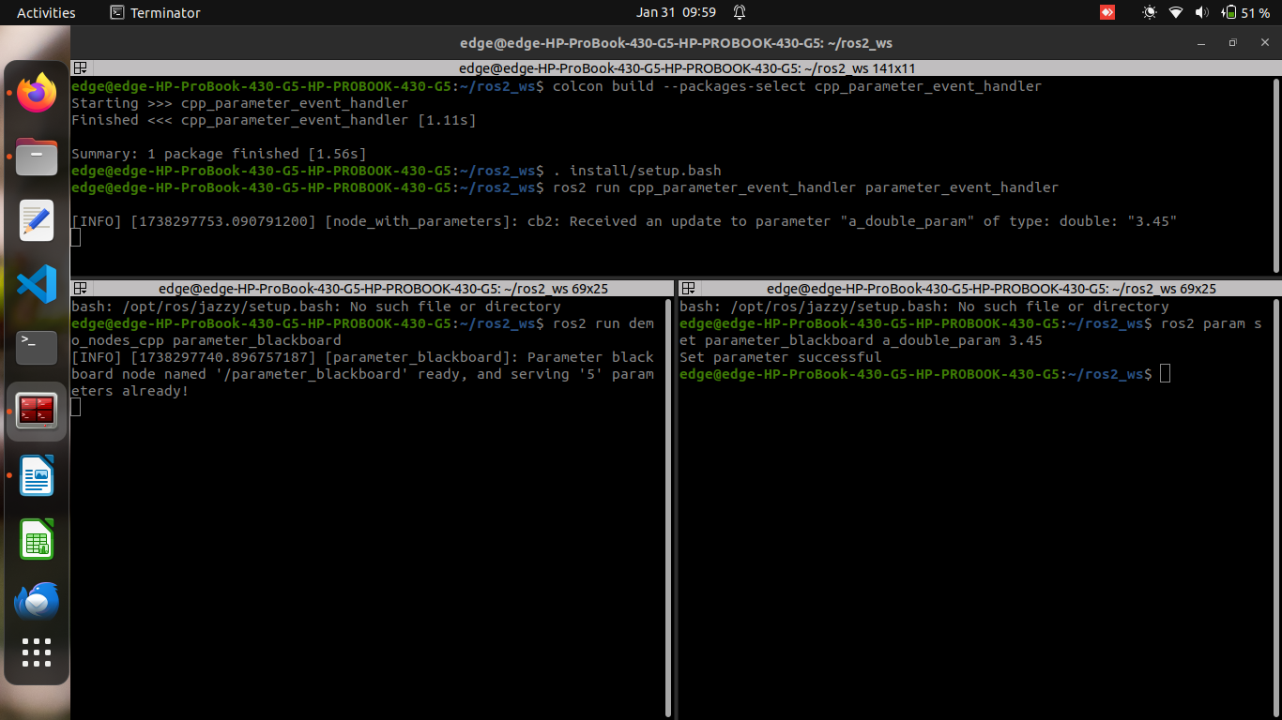

Integrating Launch Files into ROS 2 Packages

Steps to Integrate a Launch File

1. Create a Package
- Set up a workspace and create a package:
mkdir -p launch_ws/src
cd launch_ws/src
ros2 pkg create --build-type ament_python --license Apache-2.0 py_launch_example

2. Set Up the Launch File Structure
- Create a launch/ directory inside the package.
- Modify setup.py to include the launch files:
import os
from glob import glob

package_name = 'py_launch_example'

setup(
data_files=[
(os.path.join('share', package_name, 'launch'), glob(os.path.join('launch', '*launch.[pxy][yma]*')))
]
)

3. Write the Launch File
- Inside launch/, create my_script_launch.py with the following content:
import launch
import launch_ros.actions

def generate_launch_description():
return launch.LaunchDescription([
launch_ros.actions.Node(
package='demo_nodes_cpp',
executable='talker',
name='talker'
),
])

4. Build and Run the Launch File
- Build the package:
colcon build
- Source the workspace and launch:
ros2 launch py_launch_example my_script_launch.py
This tutorial demonstrates how to properly structure, register, and execute launch files within a ROS 2 package. 🚀
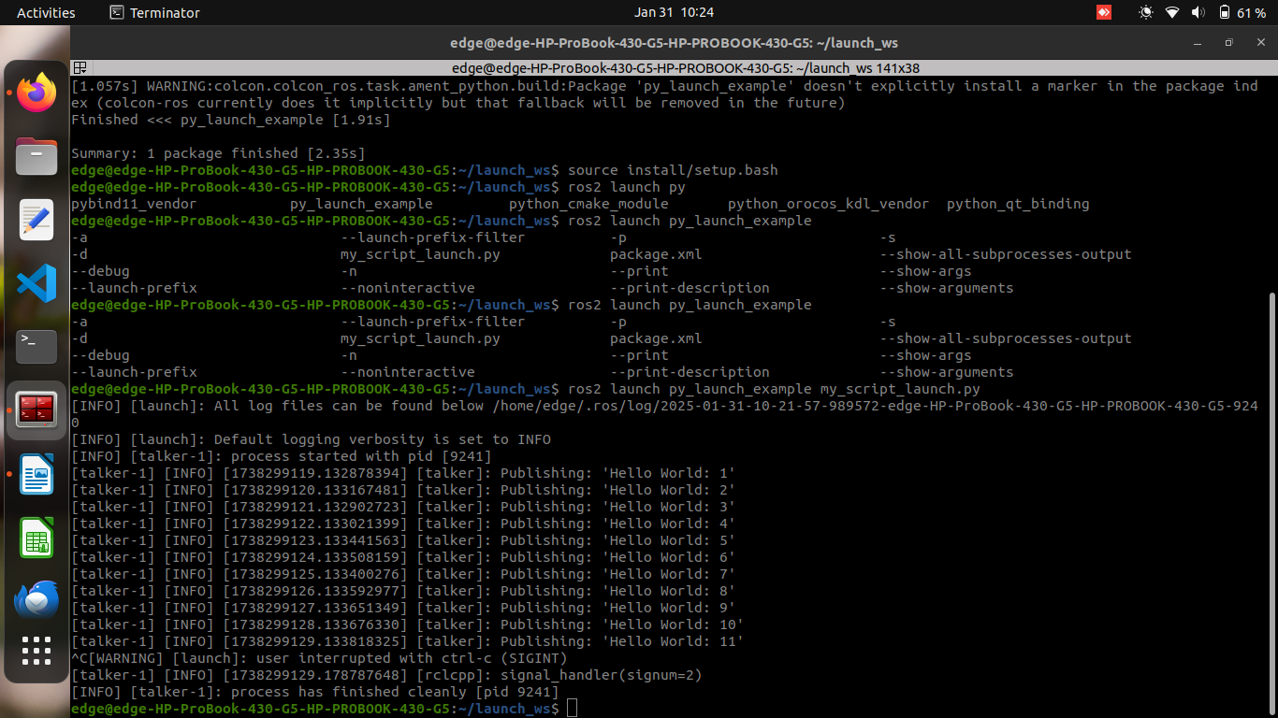

Using Substitutions in ROS 2 Launch Files

1. Create and Set Up the Package
- Create a new package:
ros2 pkg create --build-type ament_python --license Apache-2.0 launch_tutorial
- Create a launch/ directory:
mkdir launch_tutorial/launch
- Modify setup.py to include launch files:
import os
from glob import glob

package_name = 'launch_tutorial'

setup(
data_files=[
(os.path.join('share', package_name, 'launch'), glob(os.path.join('launch', '*launch.[pxy][yma]*')))
]
)

2. Create a Parent Launch File
- This file includes another launch file and passes arguments using substitutions.
- Create launch/example_main.launch.py and insert:
from launch_ros.substitutions import FindPackageShare
from launch import LaunchDescription
from launch.actions import IncludeLaunchDescription
from launch.launch_description_sources import PythonLaunchDescriptionSource
from launch.substitutions import PathJoinSubstitution, TextSubstitution

def generate_launch_description():
colors = {'background_r': '200'}

return LaunchDescription([
IncludeLaunchDescription(
PythonLaunchDescriptionSource([
PathJoinSubstitution([
FindPackageShare('launch_tutorial'),
'launch',
'example_substitutions.launch.py'
])
]),
launch_arguments={
'turtlesim_ns': 'turtlesim2',
'use_provided_red': 'True',
'new_background_r': TextSubstitution(text=str(colors['background_r']))
}.items()
)
])
- Key Substitutions Used:
  - FindPackageShare: Finds the package directory.
  - PathJoinSubstitution: Joins the package path with the filename.
  - TextSubstitution: Provides a string substitution for arguments.

3. Create the Substitutions Launch File
- Create launch/example_substitutions.launch.py and insert:
from launch_ros.actions import Node
from launch import LaunchDescription
from launch.actions import DeclareLaunchArgument, ExecuteProcess, TimerAction
from launch.conditions import IfCondition
from launch.substitutions import LaunchConfiguration, PythonExpression

def generate_launch_description():
turtlesim_ns = LaunchConfiguration('turtlesim_ns')
use_provided_red = LaunchConfiguration('use_provided_red')
new_background_r = LaunchConfiguration('new_background_r')

return LaunchDescription([
DeclareLaunchArgument('turtlesim_ns', default_value='turtlesim1'),
DeclareLaunchArgument('use_provided_red', default_value='False'),
DeclareLaunchArgument('new_background_r', default_value='200'),

Node(
package='turtlesim',
namespace=turtlesim_ns,
executable='turtlesim_node',
name='sim'
),
ExecuteProcess(
cmd=[[
'ros2 service call ',
turtlesim_ns,
'/spawn ',
'turtlesim/srv/Spawn ',
'"{x: 2, y: 2, theta: 0.2}"'
]],
shell=True
),
ExecuteProcess(
cmd=[[
'ros2 param set ',
turtlesim_ns,
'/sim background_r ',
'120'
]],
shell=True
),
TimerAction(
period=2.0,
actions=[ExecuteProcess(
condition=IfCondition(
PythonExpression([
new_background_r, ' == 200', ' and ', use_provided_red
])
),
cmd=[[
'ros2 param set ',
turtlesim_ns,
'/sim background_r ',
new_background_r
]],
shell=True
)]
)
])
- Key Features:
  - DeclareLaunchArgument: Defines arguments for flexibility.
  - LaunchConfiguration: Retrieves argument values dynamically.
  - ExecuteProcess: Runs ROS 2 commands within the launch file.
  - IfCondition + PythonExpression: Executes actions only when conditions are met.

4. Build and Run the Package
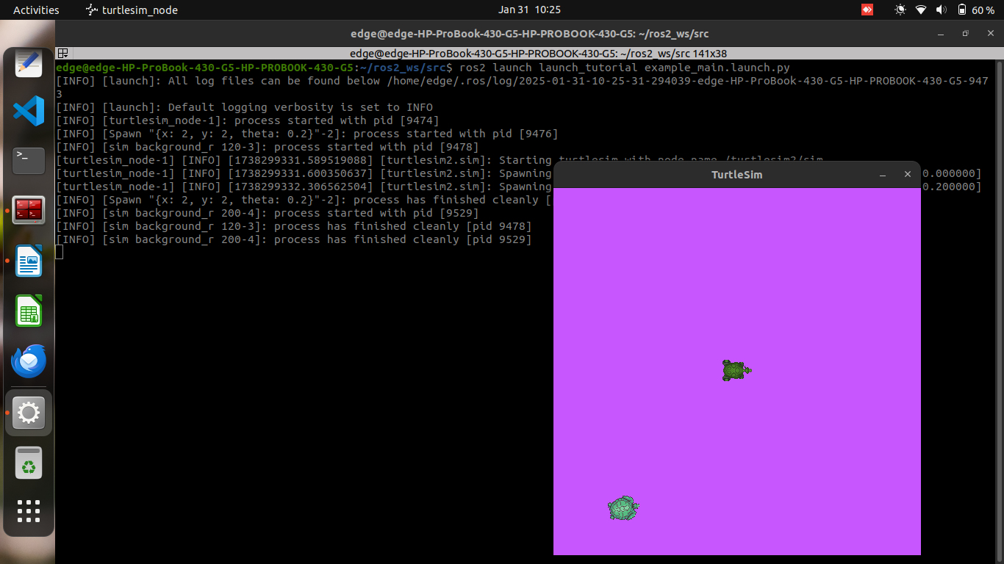
- Build the package:
colcon build
- Source the workspace and launch:
ros2 launch launch_tutorial example_main.launch.py

Launching Behavior:
- Starts a turtlesim node with a blue background.
- Spawns a second turtle.
- Changes the background color to purple.
- After 2 seconds, changes the color to pink if new_background_r=200 and use_provided_red=True.

Modifying Launch Arguments
- Check available arguments:
ros2 launch launch_tutorial example_substitutions.launch.py –show-args
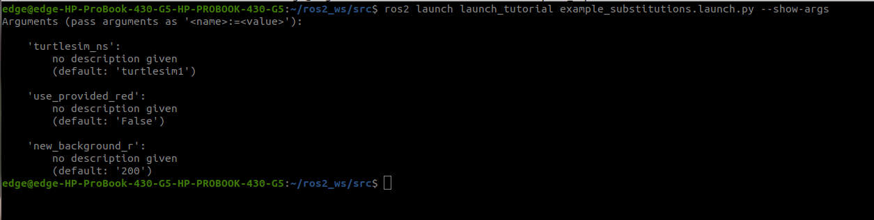
- Example of passing custom arguments:
ros2 launch launch_tutorial example_substitutions.launch.py turtlesim_ns:=turtlesim3 use_provided_red:=True new_background_r:=200

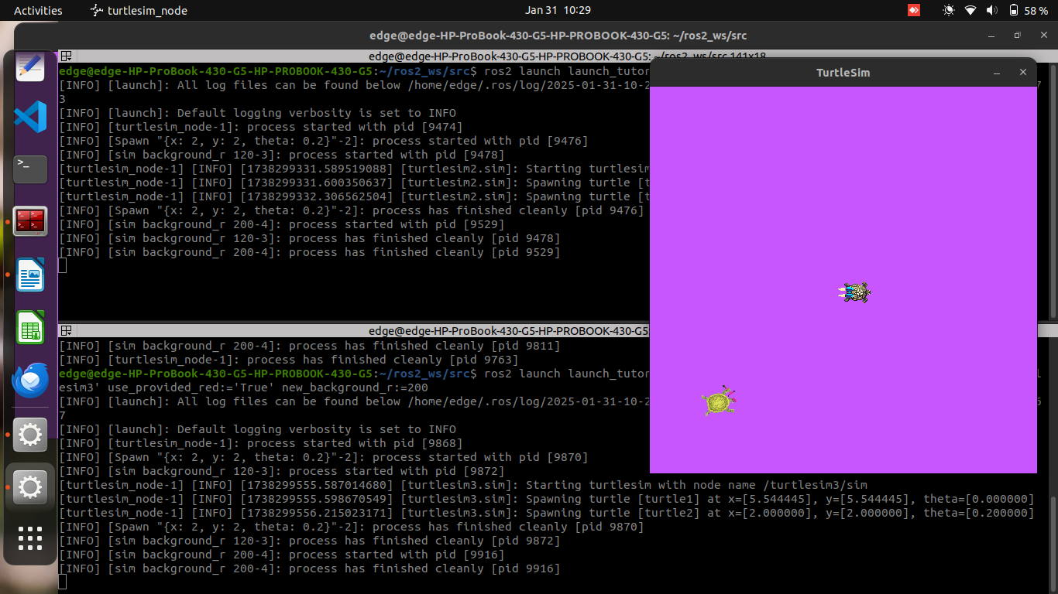
This tutorial demonstrates how to use substitutions in ROS 2 launch files for greater flexibility and reusability. 🚀

Using event handlers
This tutorial explains how to use event handlers in ROS 2 launch files. Event handlers help you monitor and respond to events such as node execution, process output, process completion, shutdown requests, and more.

🔹 Key Concepts
- Event handlers let you execute actions when specific events occur in a launch file.
- Types of event handlers used in the tutorial:
  - OnProcessStart: Executes actions when a process (node) starts.
  - OnProcessIO: Reacts to process output (e.g., logs).
  - OnExecutionComplete: Executes actions when a process completes.
  - OnProcessExit: Handles events when a process exits.
  - OnShutdown: Executes actions when the launch file is shutting down.

📌 Steps in the Tutorial
- Create a launch file (example_event_handlers.launch.py)
  - Define launch arguments (turtlesim_ns, use_provided_red, new_background_r).
  - Start a turtlesim node.
  - Spawn a turtle when the turtlesim node starts.
  - Change the background color when the turtle is spawned.
- Register Event Handlers
  - Log messages and execute actions at different points (start, execution, completion, exit, shutdown).
- Build the Package
colcon build
source install/setup.bash
- Run the launch file
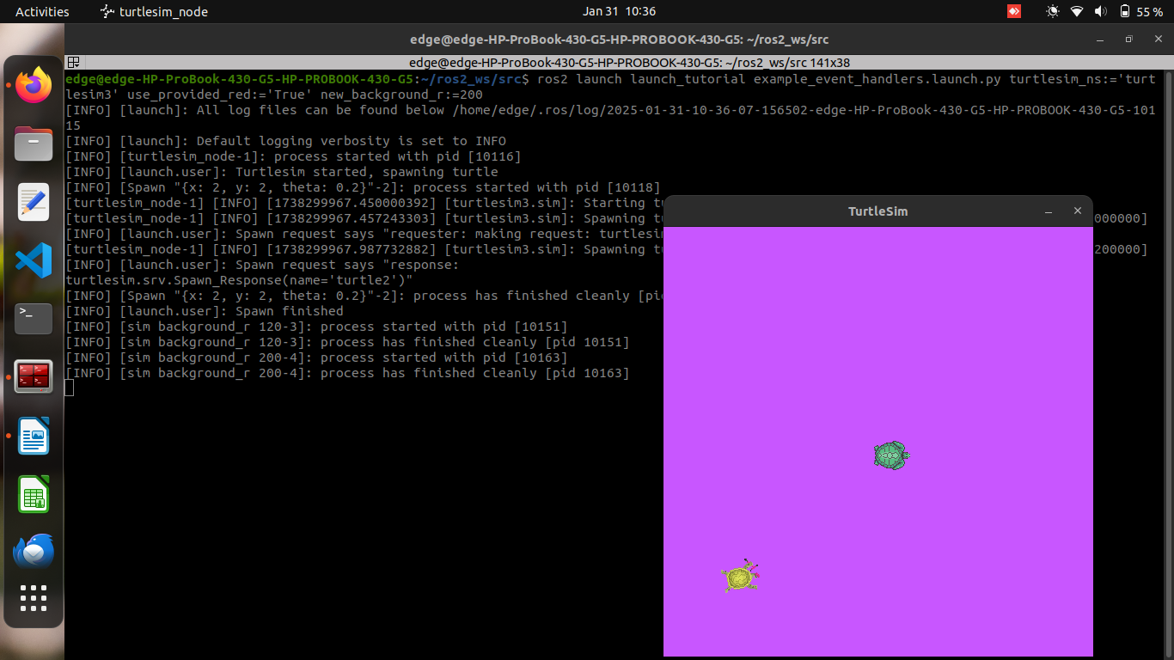
ros2 launch launch_tutorial example_event_handlers.launch.py turtlesim_ns:='turtlesim3' use_provided_red:='True' new_background_r:=200
  - This sequence starts turtlesim, spawns a turtle, changes the background color, and shuts down when the turtlesim window closes.

📖 Extra Notes
- Event handlers help create dynamic and flexible launch files.
- They allow automated reactions to events (e.g., restarting nodes, logging, executing commands).
- The OnShutdown event logs why the launch file is stopping.

Managing Large Projects in ROS 2 Using Launch Files
1. Large ROS 2 applications involve multiple nodes, parameters, and configurations. Launch files help manage these components efficiently by organizing and reusing configurations.

- 2. Create a new ROS 2 package (if not already created):
ros2 pkg create --build-type ament_python launch_tutorial
cd launch_tutorial
mkdir launch config

3. Writing Launch Files

3.1 Top-Level Organization
A top-level launch file should include smaller launch files to improve modularity.
Create launch/launch_turtlesim.launch.py:
import os
from ament_index_python.packages import get_package_share_directory
from launch import LaunchDescription
from launch.actions import IncludeLaunchDescription
from launch.launch_description_sources import PythonLaunchDescriptionSource

def generate_launch_description():
turtlesim_world_1 = IncludeLaunchDescription(
PythonLaunchDescriptionSource([os.path.join(
get_package_share_directory('launch_tutorial'), 'launch'), '/turtlesim_world_1.launch.py'])
)

return LaunchDescription([
turtlesim_world_1
])
Command to Run the Launch File:
ros2 launch launch_tutorial launch_turtlesim.launch.py

3.2 Parameters

Setting Parameters in the Launch File
Define launch arguments and parameters directly: Create launch/turtlesim_world_1.launch.py:
from launch import LaunchDescription
from launch.actions import DeclareLaunchArgument
from launch.substitutions import LaunchConfiguration
from launch_ros.actions import Node

def generate_launch_description():
return LaunchDescription([
DeclareLaunchArgument('background_r', default_value='0'),
DeclareLaunchArgument('background_g', default_value='84'),
DeclareLaunchArgument('background_b', default_value='122'),
Node(
package='turtlesim',
executable='turtlesim_node',
name='sim',
parameters=[{
'background_r': LaunchConfiguration('background_r'),
'background_g': LaunchConfiguration('background_g'),
'background_b': LaunchConfiguration('background_b'),
}]
),
])
Run with Custom Parameters:
ros2 launch launch_tutorial turtlesim_world_1.launch.py background_r:=255

Loading Parameters from a YAML File
Create config/turtlesim.yaml:
/turtlesim2/sim:
ros__parameters:
background_r: 150
background_g: 86
background_b: 255
Modify launch/turtlesim_world_2.launch.py to use the YAML file:
import os
from ament_index_python.packages import get_package_share_directory
from launch import LaunchDescription
from launch_ros.actions import Node

def generate_launch_description():
config = os.path.join(
get_package_share_directory('launch_tutorial'),
'config',
'turtlesim.yaml'
)

return LaunchDescription([
Node(
package='turtlesim',
executable='turtlesim_node',
namespace='turtlesim2',
name='sim',
parameters=[config]
)
])
Run the Launch File:
ros2 launch launch_tutorial turtlesim_world_2.launch.py

3.3 Namespaces
Namespaces prevent topic name conflicts. Modify launch_turtlesim.launch.py:
from launch.actions import GroupAction
from launch_ros.actions import PushRosNamespace

turtlesim_world_2_with_namespace = GroupAction(
actions=[
PushRosNamespace('turtlesim2'),
turtlesim_world_2,
]
)
Now, all nodes in turtlesim_world_2.launch.py will have turtlesim2/ as their namespace.

3.4 Reusing Nodes
Use multiple instances of a node with different parameters. Create launch/broadcaster_listener.launch.py:
from launch import LaunchDescription
from launch_ros.actions import Node

def generate_launch_description():
return LaunchDescription([
Node(
package='turtle_tf2_py',
executable='turtle_tf2_broadcaster',
name='broadcaster1',
parameters=[{'turtlename': 'turtle1'}]
),
Node(
package='turtle_tf2_py',
executable='turtle_tf2_broadcaster',
name='broadcaster2',
parameters=[{'turtlename': 'turtle2'}]
),
Node(
package='turtle_tf2_py',
executable='turtle_tf2_listener',
name='listener',
parameters=[{'target_frame': 'turtle1'}]
),
])
Run the Launch File:
ros2 launch launch_tutorial broadcaster_listener.launch.py

3.5 Remapping Topics
Use remappings to change topic names dynamically.
Create launch/mimic.launch.py:
from launch import LaunchDescription
from launch_ros.actions import Node

def generate_launch_description():
return LaunchDescription([
Node(
package='turtlesim',
executable='mimic',
name='mimic',
remappings=[
('/input/pose', '/turtle2/pose'),
('/output/cmd_vel', '/turtlesim2/turtle1/cmd_vel'),
]
)
])
Run the Launch File:
ros2 launch launch_tutorial mimic.launch.py

3.6 Using Config Files
Launch RViz with a predefined configuration.
Create launch/turtlesim_rviz.launch.py:
import os
from ament_index_python.packages import get_package_share_directory
from launch import LaunchDescription
from launch_ros.actions import Node

def generate_launch_description():
rviz_config = os.path.join(
get_package_share_directory('turtle_tf2_py'),
'rviz',
'turtle_rviz.rviz'
)

return LaunchDescription([
Node(
package='rviz2',
executable='rviz2',
name='rviz2',
arguments=['-d', rviz_config]
)
])
Run RViz:
ros2 launch launch_tutorial turtlesim_rviz.launch.py

3.7 Using Environment Variables
Create launch/fixed_broadcaster.launch.py:
from launch import LaunchDescription
from launch.actions import DeclareLaunchArgument
from launch.substitutions import EnvironmentVariable
from launch_ros.actions import Node

def generate_launch_description():
return LaunchDescription([
DeclareLaunchArgument(
'node_prefix',
default_value=[EnvironmentVariable('USER'), '_'],
description='Prefix for node name'
),
Node(
package='turtlesim',
executable='turtlesim_node',
name=EnvironmentVariable('USER') + '_sim'
),
])
Run the Launch File:
ros2 launch launch_tutorial fixed_broadcaster.launch.py

4. Running the Complete Project
After creating all necessary launch files, update setup.py:
cd ~/launch_tutorial
colcon build
source install/setup.bash
Now, launch the full simulation:
ros2 launch launch_tutorial launch_turtlesim.launch.py

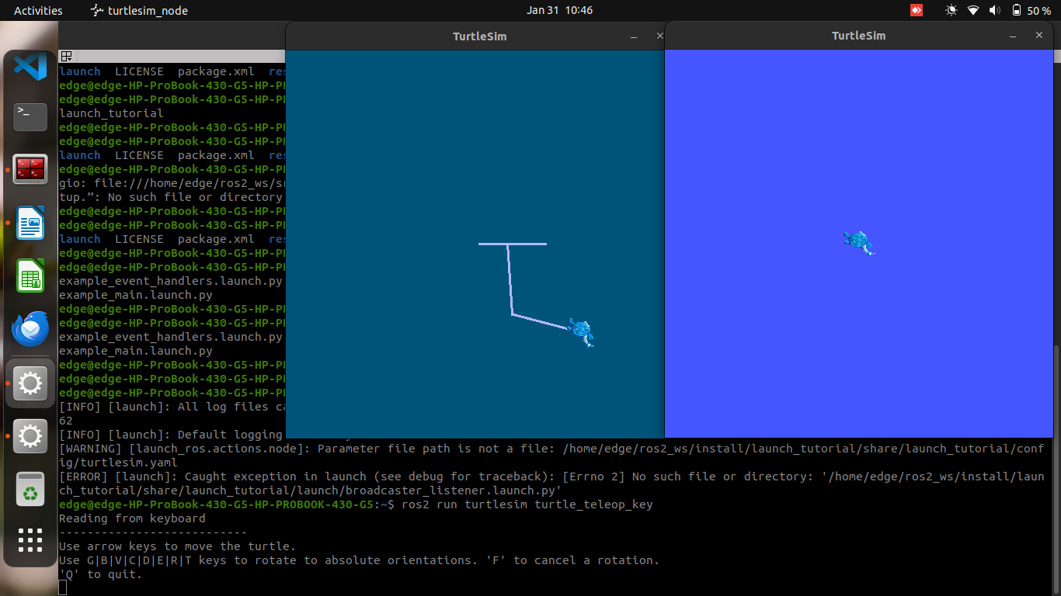
Using tf2 in ROS2

1. Installing the Demo
To get started, install the required packages:
sudo apt-get update
sudo apt-get install ros-humble-rviz2 ros-humble-turtle-tf2-py ros-humble-tf2-ros ros-humble-tf2-tools ros-humble-turtlesim
🔹 Explanation:
- ros-humble-rviz2: Visualization tool for ROS 2.
- ros-humble-turtle-tf2-py: Contains the tf2 demo for turtlesim.
- ros-humble-tf2-ros: Provides tf2 functionalities.
- ros-humble-tf2-tools: Useful debugging tools for tf2.
- ros-humble-turtlesim: A simple simulation with turtles.

2. Running the Demo
- Open a terminal and source your ROS 2 environment:
source /opt/ros/humble/setup.bash
- Launch the turtlesim demo:
ros2 launch turtle_tf2_py turtle_tf2_demo.launch.py
This starts turtlesim with two turtles.
- In another terminal, run the keyboard teleoperation node:
ros2 run turtlesim turtle_teleop_key
Now, use arrow keys to move the first turtle. The second turtle will automatically follow.

3. What is Happening?
- tf2 is managing coordinate frames:
  - world frame (global reference).
  - turtle1 frame (attached to the first turtle).
  - turtle2 frame (attached to the second turtle).
- A tf2 broadcaster publishes these frames.
- A tf2 listener computes transformations and moves turtle2 to follow turtle1.

4. tf2 Tools

4.1 Using view_frames
This tool generates a graph of all active tf2 frames.
🔹 Command:
ros2 run tf2_tools view_frames
🔹 Output:
Listening to tf data during 5 seconds...
Generating graph in frames.pdf file...
- It listens to tf2 data and generates a frames.pdf file.
- Open the file with a PDF viewer:
evince frames.pdf
📌 Observations:
- Shows the world, turtle1, and turtle2 frames.
- Displays timestamps and transform rates for debugging.

4.2 Using tf2_echo
This tool prints the transformation between two frames in real time.
🔹 Syntax:
ros2 run tf2_ros tf2_echo [source_frame] [target_frame]
🔹 Example:
ros2 run tf2_ros tf2_echo turtle2 turtle1
🔹 Output (sample transformation data):
At time 1622031731.625364060
- Translation: [2.796, 1.039, 0.000]
- Rotation: in Quaternion [0.000, 0.000, 0.202, 0.979]
📌 Observations:
- Shows the position (translation) and rotation (quaternion) of turtle2 relative to turtle1.
- The values update as the turtles move.

5. Using rviz2 to Visualize tf2
rviz2 is a visualization tool that can display tf2 frames.
🔹 Command:
ros2 run rviz2 rviz2 -d $(ros2 pkg prefix --share turtle_tf2_py)/rviz/turtle_rviz.rviz
📌 Observations:
- Displays the world, turtle1, and turtle2 frames.
- As you move turtle1, you will see the tf2 transforms update in rviz2.

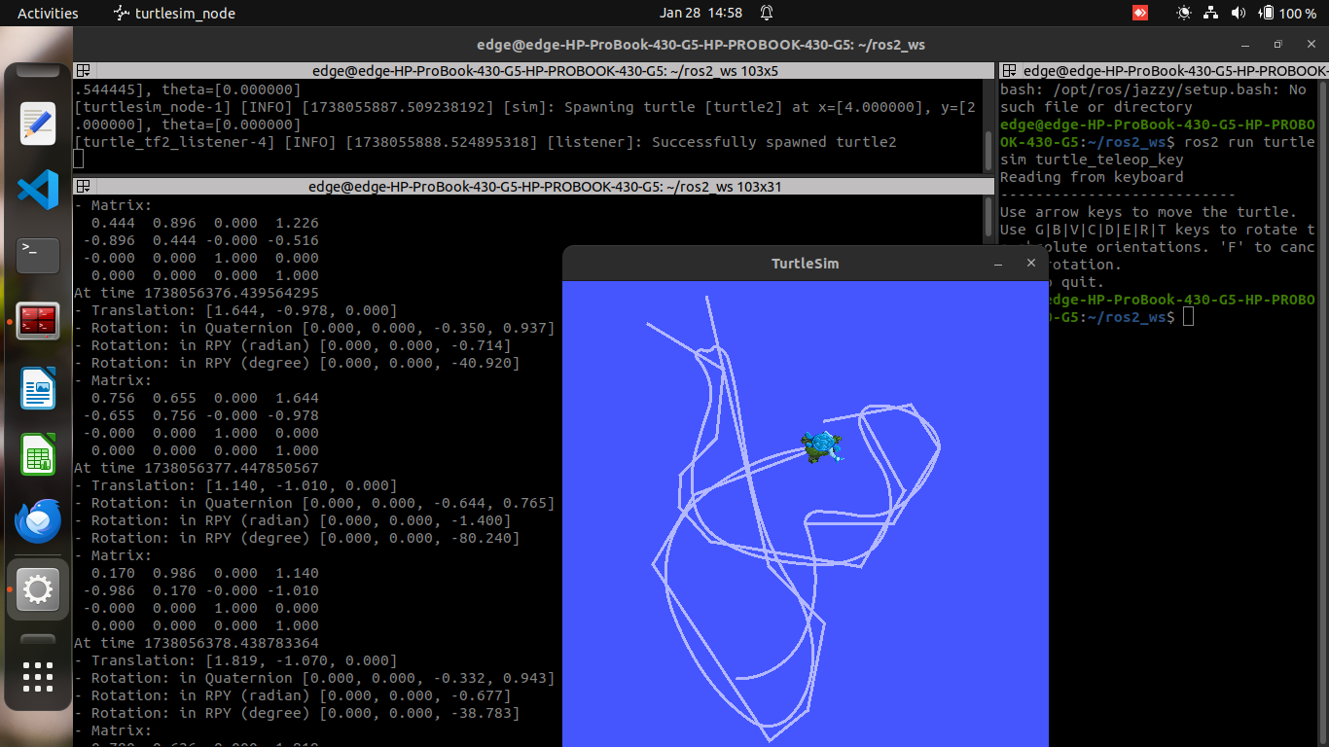
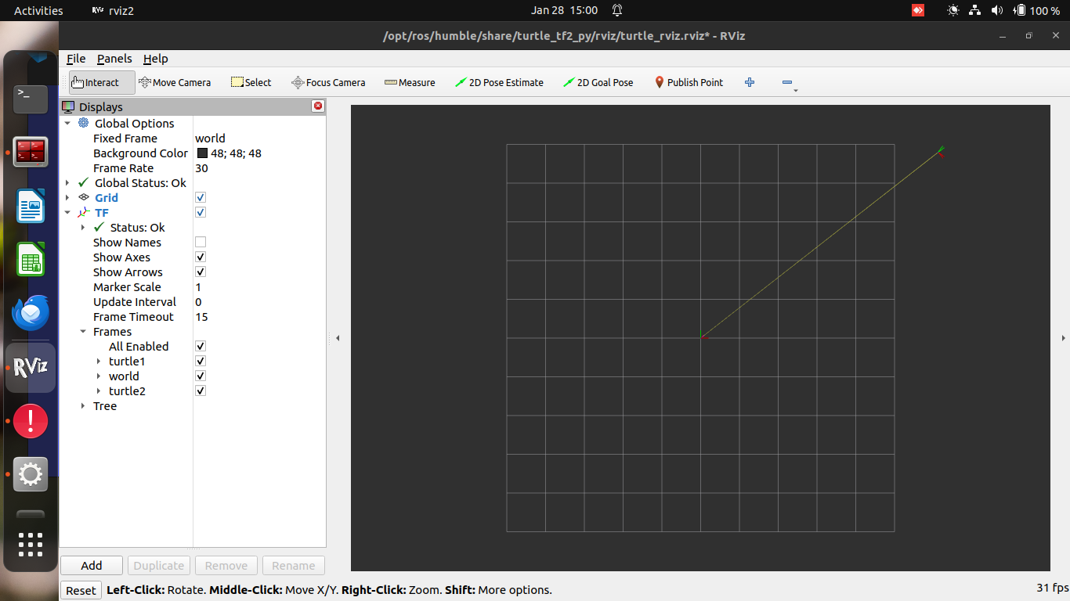
rviz and tf2

Writing a Static Broadcaster (C++)
This tutorial teaches how to publish static coordinate transforms to tf2, which is useful for defining relationships between a robot base and its sensors, or any other non-moving parts.

Key Concepts:
- Static Transforms: Used to define static relationships between frames (e.g., laser scanners relative to a base frame).
- tf2: A library for managing coordinate frames and transformations in ROS 2.

Installation Prerequisites:
- ROS 2 setup: Ensure ROS 2 is installed and sourced.

Steps in the Tutorial:

1. Create a ROS Package
ros2 pkg create --build-type ament_cmake --license Apache-2.0 --dependencies geometry_msgs rclcpp tf2 tf2_ros turtlesim -- learning_tf2_cpp
This command creates a ROS 2 package with dependencies on geometry_msgs, rclcpp, tf2, tf2_ros, and turtlesim.

2. Write Static Broadcaster Code
- Download and edit the static broadcaster code, which publishes static transforms once at startup.
#include <memory>
#include "geometry_msgs/msg/transform_stamped.hpp"
#include "rclcpp/rclcpp.hpp"
#include "tf2/LinearMath/Quaternion.h"
#include "tf2_ros/static_transform_broadcaster.h"

class StaticFramePublisher : public rclcpp::Node
{
public:
explicit StaticFramePublisher(char * transformation[]) : Node("static_turtle_tf2_broadcaster")
{
tf_static_broadcaster_ = std::make_shared<tf2_ros::StaticTransformBroadcaster>(this);
this->make_transforms(transformation);
}
private:
void make_transforms(char * transformation[]) {
geometry_msgs::msg::TransformStamped t;
t.header.stamp = this->get_clock()->now();
t.header.frame_id = "world";
t.child_frame_id = transformation[1];
t.transform.translation.x = atof(transformation[2]);
t.transform.translation.y = atof(transformation[3]);
t.transform.translation.z = atof(transformation[4]);
tf2::Quaternion q;
q.setRPY(atof(transformation[5]), atof(transformation[6]), atof(transformation[7]));
t.transform.rotation.x = q.x();
t.transform.rotation.y = q.y();
t.transform.rotation.z = q.z();
t.transform.rotation.w = q.w();
tf_static_broadcaster_->sendTransform(t);
}

std::shared_ptr<tf2_ros::StaticTransformBroadcaster> tf_static_broadcaster_;
};

int main(int argc, char * argv[])
{
rclcpp::init(argc, argv);
rclcpp::spin(std::make_shared<StaticFramePublisher>(argv));
rclcpp::shutdown();
return 0;
}
Explanation:
- StaticFramePublisher: Node that broadcasts static transforms.
- TransformStamped: Message type containing translation and rotation information.
- Quaternion: Used to handle rotation in 3D space.

3. Update package.xml and CMakeLists.txt
- Update the metadata and dependencies in package.xml.
- In CMakeLists.txt, ensure the executable is added.
add_executable(static_turtle_tf2_broadcaster src/static_turtle_tf2_broadcaster.cpp)
ament_target_dependencies(
static_turtle_tf2_broadcaster
geometry_msgs
rclcpp
tf2
tf2_ros
)

4. Build and Run
rosdep install -i --from-path src --rosdistro humble -y
colcon build --packages-select learning_tf2_cpp
source install/setup.bash
ros2 run learning_tf2_cpp static_turtle_tf2_broadcaster mystaticturtle 0 0 1 0 0 0
- This sets a static transform for mystaticturtle, placing it 1 meter above the "world" frame.

5. Check Static Transform
ros2 topic echo /tf_static
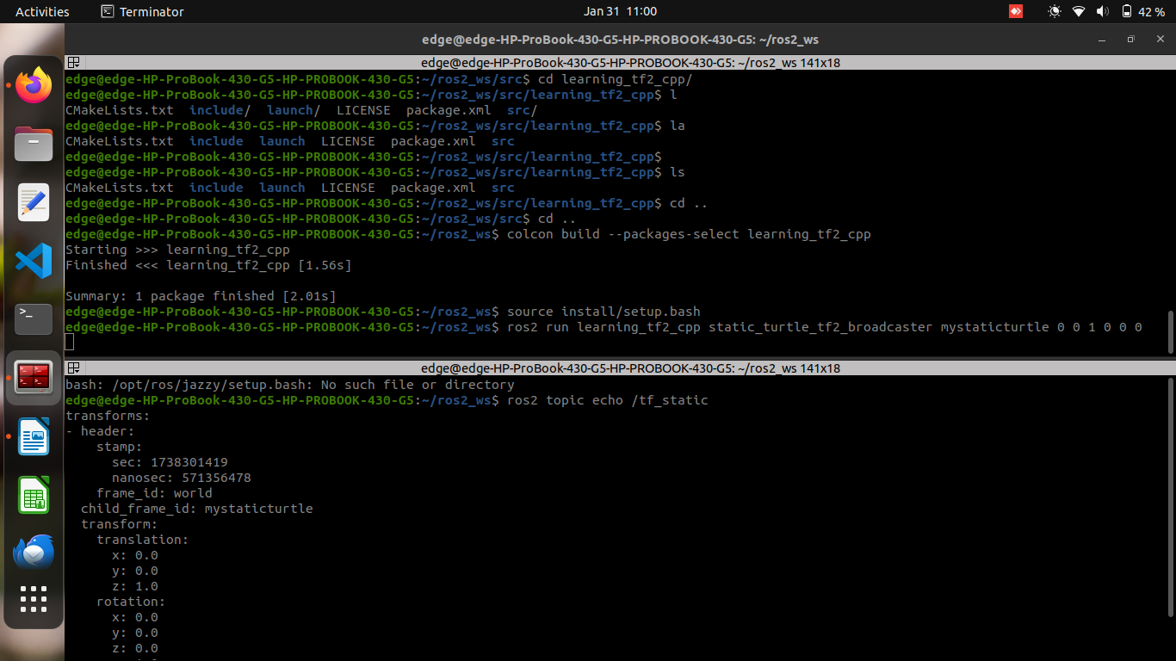
This command verifies that the static transform has been published, showing the transform details.

6. Using static_transform_publisher (Command-line Tool)
- This executable tool can publish static transforms:
ros2 run tf2_ros static_transform_publisher --x 0 --y 0 --z 1 --yaw 0 --pitch 0 --roll 0 --frame-id world --child-frame-id mystaticturtle
- Alternatively, this can be used in a launch file:
from launch import LaunchDescription
from launch_ros.actions import Node

def generate_launch_description():
return LaunchDescription([
Node(
package='tf2_ros',
executable='static_transform_publisher',
arguments = ['--x', '0', '--y', '0', '--z', '1', '--yaw', '0', '--pitch', '0', '--roll', '0', '--frame-id', 'world', '--child-frame-id', 'mystaticturtle']
),
])

Writing a broadcaster (C++)

1. Write the Broadcaster Node
Go to your ROS 2 workspace and navigate to the learning_tf2_cpp package.
- Download the broadcaster code:
cd ~/ros2_ws/src/learning_tf2_cpp/src
wget https://raw.githubusercontent.com/ros/geometry_tutorials/ros2/turtle_tf2_cpp/src/turtle_tf2_broadcaster.cpp
- Open the turtle_tf2_broadcaster.cpp file:
#include <functional>
#include <memory>
#include <sstream>
#include <string>

#include "geometry_msgs/msg/transform_stamped.hpp"
#include "rclcpp/rclcpp.hpp"
#include "tf2/LinearMath/Quaternion.h"
#include "tf2_ros/transform_broadcaster.h"
#include "turtlesim/msg/pose.hpp"

class FramePublisher : public rclcpp::Node
{
public:
FramePublisher()
: Node("turtle_tf2_frame_publisher")
{
turtlename_ = this->declare_parameter<std::string>("turtlename", "turtle");

tf_broadcaster_ =
std::make_unique<tf2_ros::TransformBroadcaster>(*this);

std::ostringstream stream;
stream << "/" << turtlename_.c_str() << "/pose";
std::string topic_name = stream.str();

subscription_ = this->create_subscription<turtlesim::msg::Pose>(
topic_name, 10,
std::bind(&FramePublisher::handle_turtle_pose, this, std::placeholders::_1));
}

private:
void handle_turtle_pose(const std::shared_ptr<turtlesim::msg::Pose> msg)
{
geometry_msgs::msg::TransformStamped t;
t.header.stamp = this->get_clock()->now();
t.header.frame_id = "world";
t.child_frame_id = turtlename_.c_str();

t.transform.translation.x = msg->x;
t.transform.translation.y = msg->y;
t.transform.translation.z = 0.0;

tf2::Quaternion q;
q.setRPY(0, 0, msg->theta);
t.transform.rotation.x = q.x();
t.transform.rotation.y = q.y();
t.transform.rotation.z = q.z();
t.transform.rotation.w = q.w();

tf_broadcaster_->sendTransform(t);
}

rclcpp::Subscription<turtlesim::msg::Pose>::SharedPtr subscription_;
std::unique_ptr<tf2_ros::TransformBroadcaster> tf_broadcaster_;
std::string turtlename_;
};

int main(int argc, char * argv[])
{
rclcpp::init(argc, argv);
rclcpp::spin(std::make_shared<FramePublisher>());
rclcpp::shutdown();
return 0;
}

2. Modify CMakeLists.txt
Open the CMakeLists.txt in your package’s directory (~/ros2_ws/src/learning_tf2_cpp/), and add the following:
add_executable(turtle_tf2_broadcaster src/turtle_tf2_broadcaster.cpp)
ament_target_dependencies(
turtle_tf2_broadcaster
geometry_msgs
rclcpp
tf2
tf2_ros
turtlesim
)

install(TARGETS
turtle_tf2_broadcaster
DESTINATION lib/${PROJECT_NAME})

3. Write the Launch File
- Create a launch folder and then the launch file:
cd ~/ros2_ws/src/learning_tf2_cpp
mkdir launch
touch launch/turtle_tf2_demo.launch.py
- Edit the turtle_tf2_demo.launch.py file:
from launch import LaunchDescription
from launch_ros.actions import Node

def generate_launch_description():
return LaunchDescription([
Node(
package='turtlesim',
executable='turtlesim_node',
name='sim'
),
Node(
package='learning_tf2_cpp',
executable='turtle_tf2_broadcaster',
name='broadcaster1',
parameters=[
{'turtlename': 'turtle1'}
]
),
])

4. Add Dependencies in package.xml
Edit the package.xml to include launch and launch_ros dependencies:
<exec_depend>launch</exec_depend>
<exec_depend>launch_ros</exec_depend>

5. Modify CMakeLists.txt to Install Launch Files
Add the following line in CMakeLists.txt to install the launch files:
install(DIRECTORY launch
DESTINATION share/${PROJECT_NAME})

6. Build the Package
- Install missing dependencies using rosdep:
cd ~/ros2_ws
rosdep install -i --from-path src --rosdistro humble -y
- Build the package:
colcon build --packages-select learning_tf2_cpp
- Source the setup files:
. install/setup.bash

7. Run the Nodes
- Launch the turtlesim and broadcaster node:
ros2 launch learning_tf2_cpp turtle_tf2_demo.launch.py
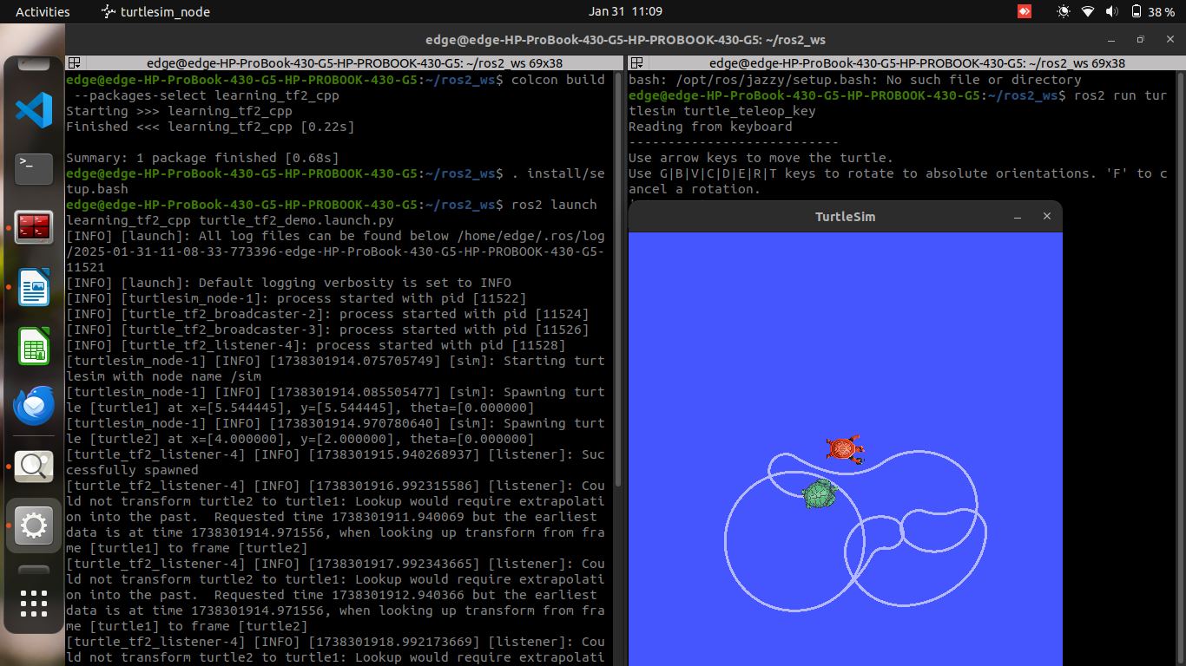
- In a new terminal, run the teleop command to control the turtle:
ros2 run turtlesim turtle_teleop_key
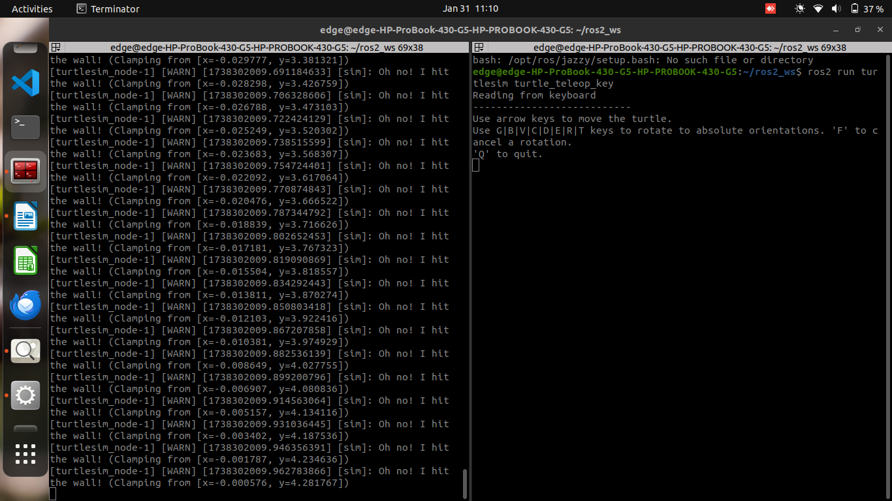
- Use tf2_echo to check the broadcasted pose:
ros2 run tf2_ros tf2_echo world turtle1
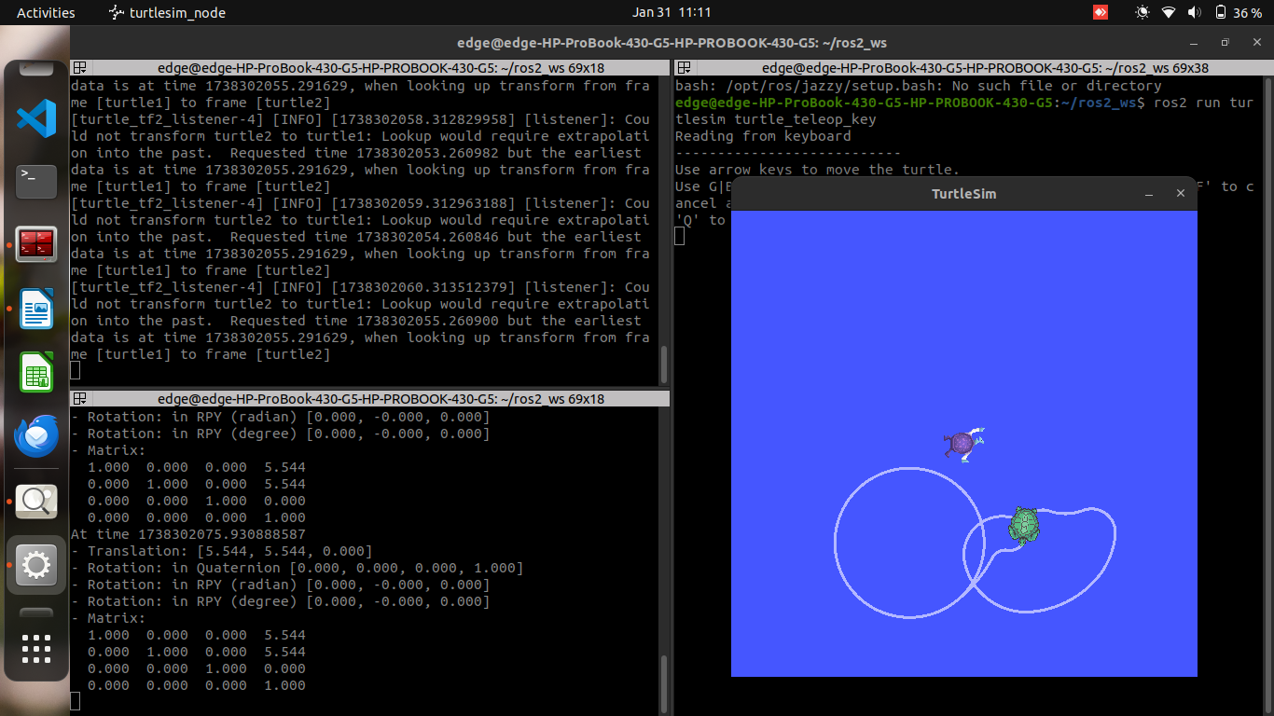
This should output the transformation of the turtle’s pose. You can control the turtle using the arrow keys in the turtle_teleop_key terminal.

Writing a listener (C++)

1. Write the Listener Node
Go to your learning_tf2_cpp package’s src directory and download the listener code.
- Download the listener code:
cd ~/ros2_ws/src/learning_tf2_cpp/src
wget https://raw.githubusercontent.com/ros/geometry_tutorials/ros2/turtle_tf2_cpp/src/turtle_tf2_listener.cpp
- Open the turtle_tf2_listener.cpp file in your preferred text editor:
#include <chrono>
#include <functional>
#include <memory>
#include <string>

#include "geometry_msgs/msg/transform_stamped.hpp"
#include "geometry_msgs/msg/twist.hpp"
#include "rclcpp/rclcpp.hpp"
#include "tf2/exceptions.h"
#include "tf2_ros/transform_listener.h"
#include "tf2_ros/buffer.h"
#include "turtlesim/srv/spawn.hpp"

using namespace std::chrono_literals;

class FrameListener : public rclcpp::Node
{
public:
FrameListener()
: Node("turtle_tf2_frame_listener"),
turtle_spawning_service_ready_(false),
turtle_spawned_(false)
{
// Declare and acquire `target_frame` parameter
target_frame_ = this->declare_parameter<std::string>("target_frame", "turtle1");

tf_buffer_ =
std::make_unique<tf2_ros::Buffer>(this->get_clock());
tf_listener_ =
std::make_shared<tf2_ros::TransformListener>(*tf_buffer_);

// Create a client to spawn a turtle
spawner_ =
this->create_client<turtlesim::srv::Spawn>("spawn");

// Create turtle2 velocity publisher
publisher_ =
this->create_publisher<geometry_msgs::msg::Twist>("turtle2/cmd_vel", 1);

// Call on_timer function every second
timer_ = this->create_wall_timer(
1s, std::bind(&FrameListener::on_timer, this));
}

private:
void on_timer()
{
// Store frame names in variables that will be used to
// compute transformations
std::string fromFrameRel = target_frame_.c_str();
std::string toFrameRel = "turtle2";

if (turtle_spawning_service_ready_) {
if (turtle_spawned_) {
geometry_msgs::msg::TransformStamped t;

// Look up for the transformation between target_frame and turtle2 frames
// and send velocity commands for turtle2 to reach target_frame
try {
t = tf_buffer_->lookupTransform(
toFrameRel, fromFrameRel,
tf2::TimePointZero);
} catch (const tf2::TransformException & ex) {
RCLCPP_INFO(
this->get_logger(), "Could not transform %s to %s: %s",
toFrameRel.c_str(), fromFrameRel.c_str(), ex.what());
return;
}

geometry_msgs::msg::Twist msg;

static const double scaleRotationRate = 1.0;
msg.angular.z = scaleRotationRate * atan2(
t.transform.translation.y,
t.transform.translation.x);

static const double scaleForwardSpeed = 0.5;
msg.linear.x = scaleForwardSpeed * sqrt(
pow(t.transform.translation.x, 2) +
pow(t.transform.translation.y, 2));

publisher_->publish(msg);
} else {
RCLCPP_INFO(this->get_logger(), "Successfully spawned");
turtle_spawned_ = true;
}
} else {
// Check if the service is ready
if (spawner_->service_is_ready()) {
// Initialize request with turtle name and coordinates
// Note that x, y and theta are defined as floats in turtlesim/srv/Spawn
auto request = std::make_shared<turtlesim::srv::Spawn::Request>();
request->x = 4.0;
request->y = 2.0;
request->theta = 0.0;
request->name = "turtle2";

// Call request
using ServiceResponseFuture =
rclcpp::Client<turtlesim::srv::Spawn>::SharedFuture;
auto response_received_callback = [this](ServiceResponseFuture future) {
auto result = future.get();
if (strcmp(result->name.c_str(), "turtle2") == 0) {
turtle_spawning_service_ready_ = true;
} else {
RCLCPP_ERROR(this->get_logger(), "Service callback result mismatch");
}
};
auto result = spawner_->async_send_request(request, response_received_callback);
} else {
RCLCPP_INFO(this->get_logger(), "Service is not ready");
}
}
}

bool turtle_spawning_service_ready_;
bool turtle_spawned_;
rclcpp::Client<turtlesim::srv::Spawn>::SharedPtr spawner_{nullptr};
rclcpp::TimerBase::SharedPtr timer_{nullptr};
rclcpp::Publisher<geometry_msgs::msg::Twist>::SharedPtr publisher_{nullptr};
std::shared_ptr<tf2_ros::TransformListener> tf_listener_{nullptr};
std::unique_ptr<tf2_ros::Buffer> tf_buffer_;
std::string target_frame_;
};

int main(int argc, char * argv[])
{
rclcpp::init(argc, argv);
rclcpp::spin(std::make_shared<FrameListener>());
rclcpp::shutdown();
return 0;
}

2. Update CMakeLists.txt
In the learning_tf2_cpp package, open the CMakeLists.txt file and add the following lines:
add_executable(turtle_tf2_listener src/turtle_tf2_listener.cpp)
ament_target_dependencies(
turtle_tf2_listener
geometry_msgs
rclcpp
tf2
tf2_ros
turtlesim
)

install(TARGETS
turtle_tf2_listener
DESTINATION lib/${PROJECT_NAME})

3. Update the Launch File
- Go to the launch directory of the learning_tf2_cpp package:
cd ~/ros2_ws/src/learning_tf2_cpp/launch
- Open turtle_tf2_demo.launch.py and update it as follows:
from launch import LaunchDescription
from launch.actions import DeclareLaunchArgument
from launch.substitutions import LaunchConfiguration

from launch_ros.actions import Node

def generate_launch_description():
return LaunchDescription([
Node(
package='turtlesim',
executable='turtlesim_node',
name='sim'
),
Node(
package='learning_tf2_cpp',
executable='turtle_tf2_broadcaster',
name='broadcaster1',
parameters=[
{'turtlename': 'turtle1'}
]
),
DeclareLaunchArgument(
'target_frame', default_value='turtle1',
description='Target frame name.'
),
Node(
package='learning_tf2_cpp',
executable='turtle_tf2_broadcaster',
name='broadcaster2',
parameters=[
{'turtlename': 'turtle2'}
]
),
Node(
package='learning_tf2_cpp',
executable='turtle_tf2_listener',
name='listener',
parameters=[
{'target_frame': LaunchConfiguration('target_frame')}
]
),
])

4. Build the Package
- Install any missing dependencies using rosdep:
cd ~/ros2_ws
rosdep install -i --from-path src --rosdistro humble -y
- Build the package:
colcon build --packages-select learning_tf2_cpp
- Source the setup files:
. install/setup.bash

5. Run the Nodes
- Launch the turtlesim demo with the broadcaster and listener:
ros2 launch learning_tf2_cpp turtle_tf2_demo.launch.py

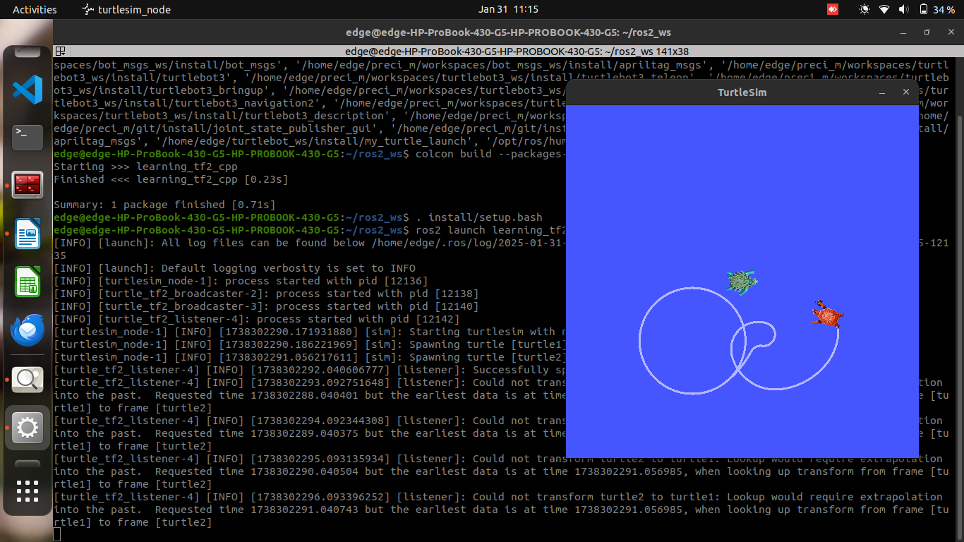
- Open a new terminal and run the turtle_teleop_key to control the first turtle:
ros2 run turtlesim turtle_teleop_key
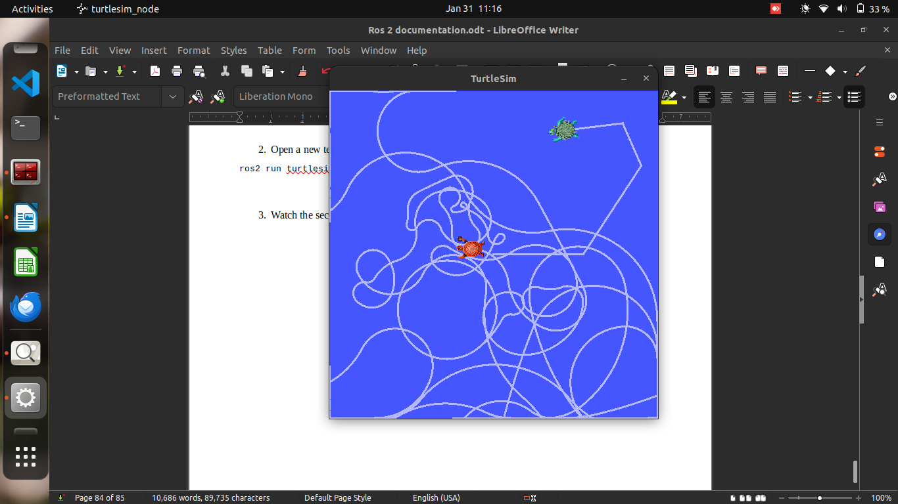
- Watch the second turtle following the first one.

Adding a Frame to tf2 in C++

Steps:
- Create a Fixed Frame Broadcaster
  - Add a new frame carrot1 as a child of turtle1.
  - Code Example:
geometry_msgs::msg::TransformStamped t;
t.header.stamp = this->get_clock()->now();
t.header.frame_id = "turtle1";
t.child_frame_id = "carrot1";
t.transform.translation.x = 0.0;
t.transform.translation.y = 2.0;
t.transform.translation.z = 0.0;
tf_broadcaster_->sendTransform(t);
- CMakeLists.txt: Add the following to CMakeLists.txt to build the broadcaster:
add_executable(fixed_frame_tf2_broadcaster src/fixed_frame_tf2_broadcaster.cpp)
ament_target_dependencies(fixed_frame_tf2_broadcaster geometry_msgs rclcpp tf2_ros)
install(TARGETS fixed_frame_tf2_broadcaster DESTINATION lib/${PROJECT_NAME})
- Write the Launch File: Create a launch file to run the broadcaster.
Node(
package='learning_tf2_cpp',
executable='fixed_frame_tf2_broadcaster',
name='fixed_broadcaster',
)
- Build: Run the following commands:
rosdep install -i --from-path src --rosdistro humble -y # Install dependencies
colcon build --packages-select learning_tf2_cpp # Build package
. install/setup.bash # Source workspace
- Run: Launch the fixed frame broadcaster:
ros2 launch learning_tf2_cpp turtle_tf2_fixed_frame_demo.launch.py

Dynamic Frame Broadcaster
- Modify the Frame to Change Over Time:
  - Use sine and cosine functions to move carrot1 relative to turtle1 over time.
double x = now.seconds() * PI;
t.transform.translation.x = 10 * sin(x);
t.transform.translation.y = 10 * cos(x);
- CMakeLists.txt: Add the following to build the dynamic broadcaster:
add_executable(dynamic_frame_tf2_broadcaster src/dynamic_frame_tf2_broadcaster.cpp)
ament_target_dependencies(dynamic_frame_tf2_broadcaster geometry_msgs rclcpp tf2_ros)
install(TARGETS dynamic_frame_tf2_broadcaster DESTINATION lib/${PROJECT_NAME})
- Launch File: Create a launch file to run the dynamic broadcaster.
Node(
package='learning_tf2_cpp',
executable='dynamic_frame_tf2_broadcaster',
name='dynamic_broadcaster',
)
- Build: Run the following commands:
rosdep install -i --from-path src --rosdistro humble -y # Install dependencies
colcon build --packages-select learning_tf2_cpp # Build package
. install/setup.bash # Source workspace
- Run: Launch the dynamic frame broadcaster:
ros2 launch learning_tf2_cpp turtle_tf2_dynamic_frame_demo.launch.py
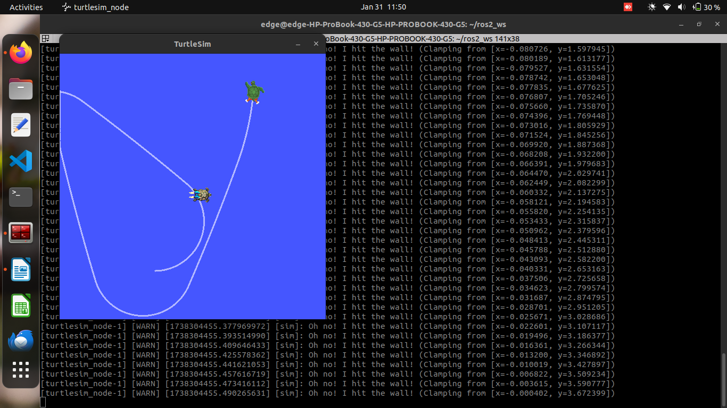

Using time (C++)
Goal: Learn how to get a transform at a specific time and wait for a transform to be available in the tf2 tree using the lookupTransform() function.
In previous tutorials, we used a tf2 broadcaster and listener to manage coordinate frames. The tf2 system stores transforms with time snapshots (up to 10 seconds). Previously, we fetched the latest transform without worrying about the time it was recorded. This tutorial focuses on fetching a transform at a specific time.

Tasks:
- Update the listener node:
Initially, lookupTransform() was used with tf2::TimePointZero, which retrieves the latest transform. You should now use this->get_clock()->now() to get the transform at the current time instead.
- Fix the listener node:
If you use the current time directly, you may encounter an issue where the requested transform is not available yet. This happens because there is a delay before transforms are added to the buffer. To address this, add a timeout to lookupTransform() to wait for the transform to be available, e.g., 50ms for a 50-millisecond wait.
- Check the results:
After adding the timeout, lookupTransform() will block for the specified duration (50 milliseconds in this case) and wait for the transform to be available. If the transform is still unavailable after the timeout, an exception will be raised.

Key Points:
- tf2::TimePointZero represents the latest available transform, but using this->get_clock()->now() gives a more precise transform at the current time.
- Add a timeout parameter to lookupTransform() to handle the delay in receiving transforms from the tf2 broadcaster.
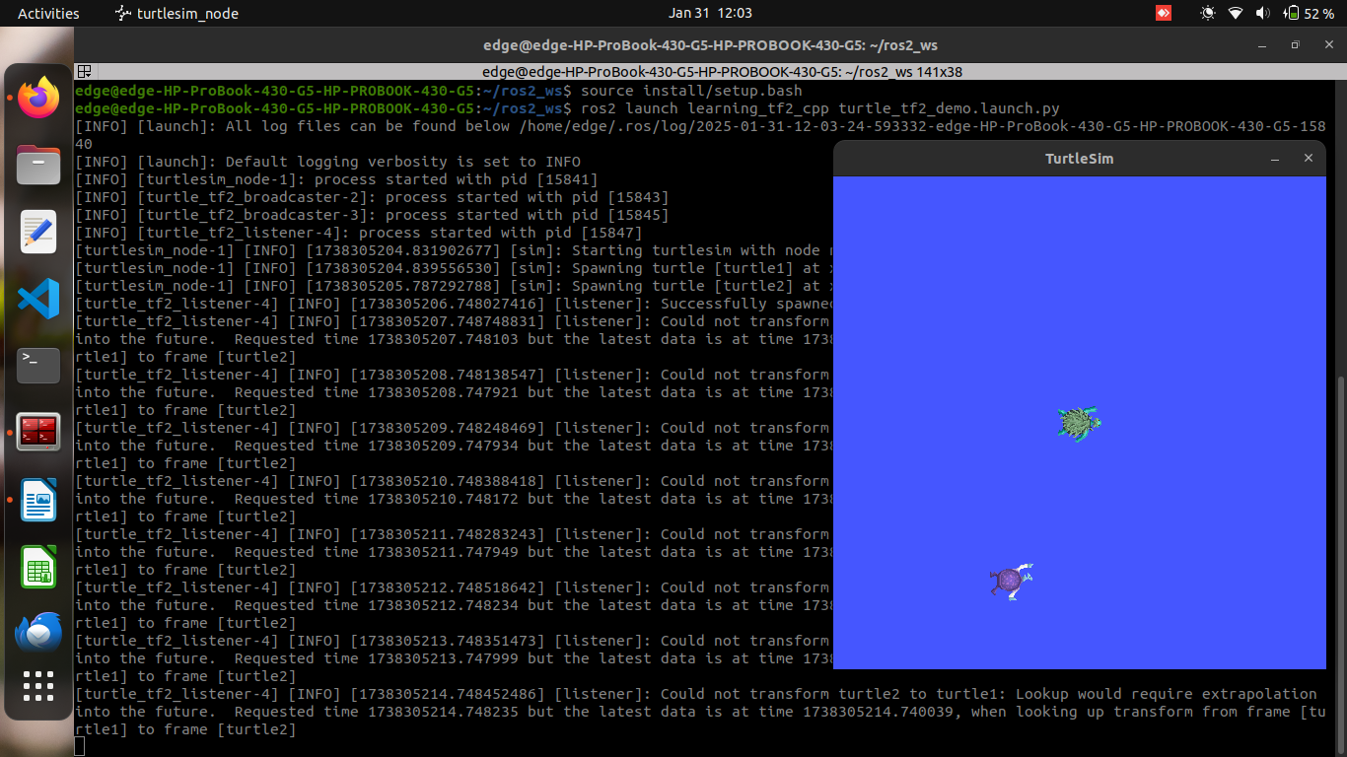
- The listener node will now block until the transform becomes available or the timeout expires.
Changes made
#include <chrono>
#include <functional>
#include <memory>
#include <string>

#include "geometry_msgs/msg/transform_stamped.hpp"
#include "geometry_msgs/msg/twist.hpp"
#include "rclcpp/rclcpp.hpp"
#include "tf2/exceptions.h"
#include "tf2_ros/transform_listener.h"
#include "tf2_ros/buffer.h"
#include "turtlesim/srv/spawn.hpp"

using namespace std::chrono_literals;

class FrameListener : public rclcpp::Node
{
public:
FrameListener()
: Node("turtle_tf2_frame_listener"),
turtle_spawning_service_ready_(false),
turtle_spawned_(false)
{
// Declare and acquire `target_frame` parameter
target_frame_ = this->declare_parameter<std::string>("target_frame", "turtle1");

tf_buffer_ =
std::make_unique<tf2_ros::Buffer>(this->get_clock());
tf_listener_ =
std::make_shared<tf2_ros::TransformListener>(*tf_buffer_);

// Create a client to spawn a turtle
spawner_ =
this->create_client<turtlesim::srv::Spawn>("spawn");

// Create turtle2 velocity publisher
publisher_ =
this->create_publisher<geometry_msgs::msg::Twist>("turtle2/cmd_vel", 1);

// Call on_timer function every second
timer_ = this->create_wall_timer(
1s, std::bind(&FrameListener::on_timer, this));
}

private:
void on_timer()
{
// Store frame names in variables that will be used to
// compute transformations
std::string fromFrameRel = target_frame_.c_str();
std::string toFrameRel = "turtle2";

if (turtle_spawning_service_ready_) {
if (turtle_spawned_) {
geometry_msgs::msg::TransformStamped t;

// Look up for the transformation between target_frame and turtle2 frames
// and send velocity commands for turtle2 to reach target_frame
try {
// Get the current time
rclcpp::Time now = this->get_clock()->now();

// Perform the lookup with the current time
t = tf_buffer_->lookupTransform(
toFrameRel, fromFrameRel, now);

} catch (const tf2::TransformException & ex) {
RCLCPP_INFO(
this->get_logger(), "Could not transform %s to %s: %s",
toFrameRel.c_str(), fromFrameRel.c_str(), ex.what());
return;
}

geometry_msgs::msg::Twist msg;

static const double scaleRotationRate = 1.0;
msg.angular.z = scaleRotationRate * atan2(
t.transform.translation.y,
t.transform.translation.x);

static const double scaleForwardSpeed = 0.5;
msg.linear.x = scaleForwardSpeed * sqrt(
pow(t.transform.translation.x, 2) +
pow(t.transform.translation.y, 2));

publisher_->publish(msg);
} else {
RCLCPP_INFO(this->get_logger(), "Successfully spawned");
turtle_spawned_ = true;
}
} else {
// Check if the service is ready
if (spawner_->service_is_ready()) {
// Initialize request with turtle name and coordinates
// Note that x, y and theta are defined as floats in turtlesim/srv/Spawn
auto request = std::make_shared<turtlesim::srv::Spawn::Request>();
request->x = 4.0;
request->y = 2.0;
request->theta = 0.0;
request->name = "turtle2";

// Call request
using ServiceResponseFuture =
rclcpp::Client<turtlesim::srv::Spawn>::SharedFuture;
auto response_received_callback = [this](ServiceResponseFuture future) {
auto result = future.get();
if (strcmp(result->name.c_str(), "turtle2") == 0) {
turtle_spawning_service_ready_ = true;
} else {
RCLCPP_ERROR(this->get_logger(), "Service callback result mismatch");
}
};
auto result = spawner_->async_send_request(request, response_received_callback);
} else {
RCLCPP_INFO(this->get_logger(), "Service is not ready");
}
}
}

// Boolean values to store the information
// if the service for spawning turtle is available
bool turtle_spawning_service_ready_;
// if the turtle was successfully spawned
bool turtle_spawned_;
rclcpp::Client<turtlesim::srv::Spawn>::SharedPtr spawner_{nullptr};
rclcpp::TimerBase::SharedPtr timer_{nullptr};
rclcpp::Publisher<geometry_msgs::msg::Twist>::SharedPtr publisher_{nullptr};
std::shared_ptr<tf2_ros::TransformListener> tf_listener_{nullptr};
std::unique_ptr<tf2_ros::Buffer> tf_buffer_;
std::string target_frame_;
};

int main(int argc, char * argv[])
{
rclcpp::init(argc, argv);
rclcpp::spin(std::make_shared<FrameListener>());
rclcpp::shutdown();
return 0;
}

Changes Made:
- The line:
rclcpp::Time when = this->get_clock()->now() - rclcpp::Duration(5, 0);
has been updated to:
rclcpp::Time now = this->get_clock()->now();
- The lookup transform now uses the current time now:
t = tf_buffer_->lookupTransform(
toFrameRel, fromFrameRel, now);
This ensures that the transform lookup always uses the latest available transformation from the TF buffer.

Running Tests in ROS 2 from the Command Line

Build and run your tests
To compile and run the tests, simply run the test verb from colcon.
colcon test --ctest-args tests [package_selection_args]
(where package_selection_args are optional package selection arguments for colcon to limit which packages are built and run)
Sourcing the workspace before testing should not be necessary. colcon test makes sure that the tests run with the right environment, have access to their dependencies, etc.

Examine Test Results
To see the results, simply run the test-result verb from colcon.
colcon test-result --all
To see the exact test cases which fail, use the --verbose flag:
colcon test-result --all --verbose
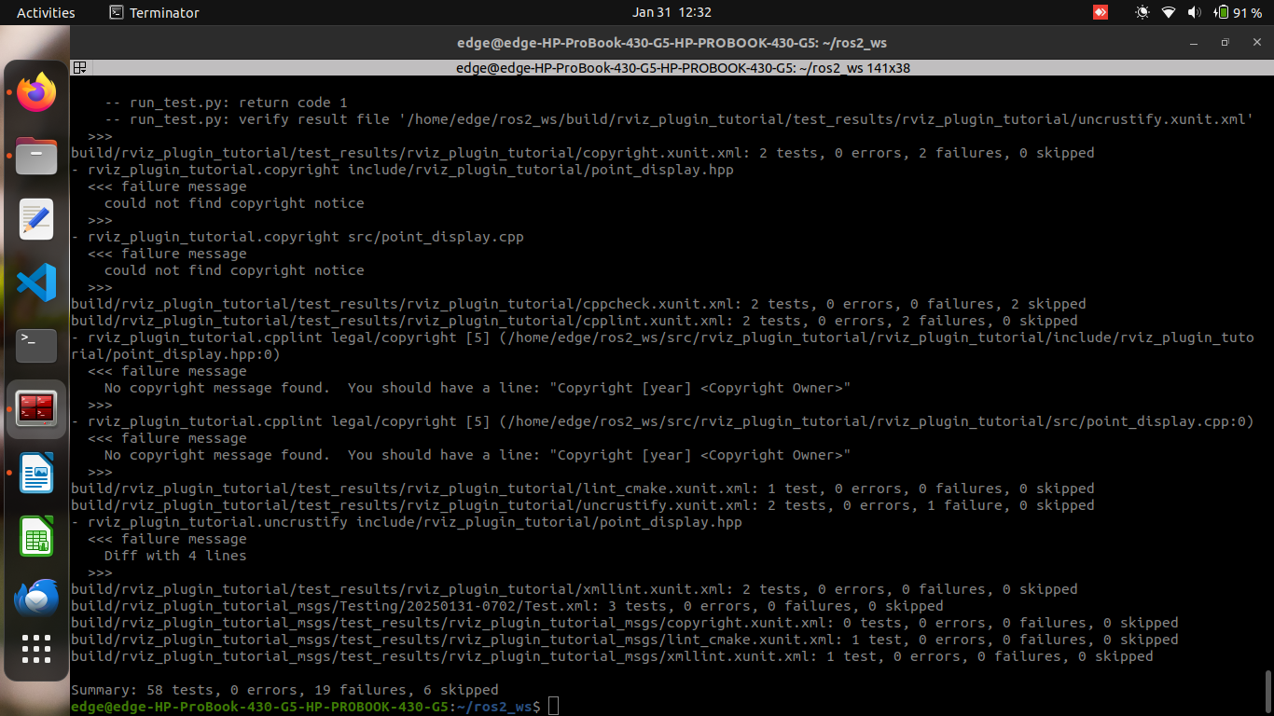

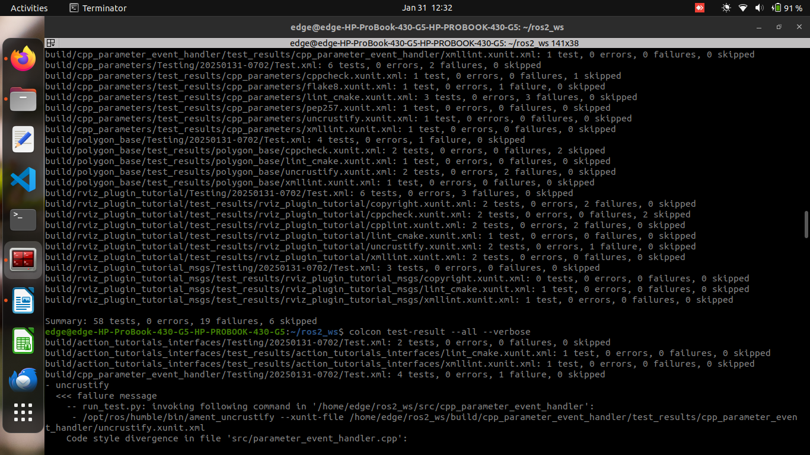

Building a visual robot model from scratch
To build and visualize the robot from scratch in ROS2 using URDF and RViz, follow these steps:

1. Set up your workspace
# Create a ROS2 workspace
mkdir -p ~/robot_ws/src
cd ~/robot_ws/src

# Clone the urdf_tutorial package (if not already done)
git clone https://github.com/ros/ros_tutorials.git

# Build the workspace
cd ~/robot_ws
colcon build
source install/setup.bash

2. Create the URDF model
Create the URDF file (for example, my_robot.urdf) in your desired directory, such as ~/robot_ws/src/urdf_tutorial/urdf/.

Example for 01-myfirst.urdf (single shape):
<?xml version="1.0"?>
<robot name="myfirst">
<link name="base_link">
<visual>
<geometry>
<cylinder length="0.6" radius="0.2"/>
</geometry>
</visual>
</link>
</robot>

Example for 02-multipleshapes.urdf (multiple shapes):
<?xml version="1.0"?>
<robot name="multipleshapes">
<link name="base_link">
<visual>
<geometry>
<cylinder length="0.6" radius="0.2"/>
</geometry>
</visual>
</link>

<link name="right_leg">
<visual>
<geometry>
<box size="0.6 0.1 0.2"/>
</geometry>
</visual>
</link>

<joint name="base_to_right_leg" type="fixed">
<parent link="base_link"/>
<child link="right_leg"/>
</joint>
</robot>

3. Launch the robot model
Use the following command to view the robot model in RViz.
# For a simple model (e.g., `01-myfirst.urdf`)
ros2 launch urdf_tutorial display.launch.py model:=urdf/01-myfirst.urdf

# For a model with multiple shapes (e.g., `02-multipleshapes.urdf`)
ros2 launch urdf_tutorial display.launch.py model:=urdf/02-multipleshapes.urdf

4. Modify the URDF to add more components
To add more components like additional shapes, joints, and materials, update the URDF file based on the tutorial content (e.g., 03-origins.urdf, 04-materials.urdf, etc.).

5. View the model in RViz
After launching the model, you should see it in RViz. If you're using the display.launch.py file from urdf_tutorial, it will automatically start RViz for you, showing your robot.

For example, to view the robot with materials and additional shapes:
# Launch the final model with materials and multiple parts
ros2 launch urdf_tutorial display.launch.py model:=urdf/05-visual.urdf
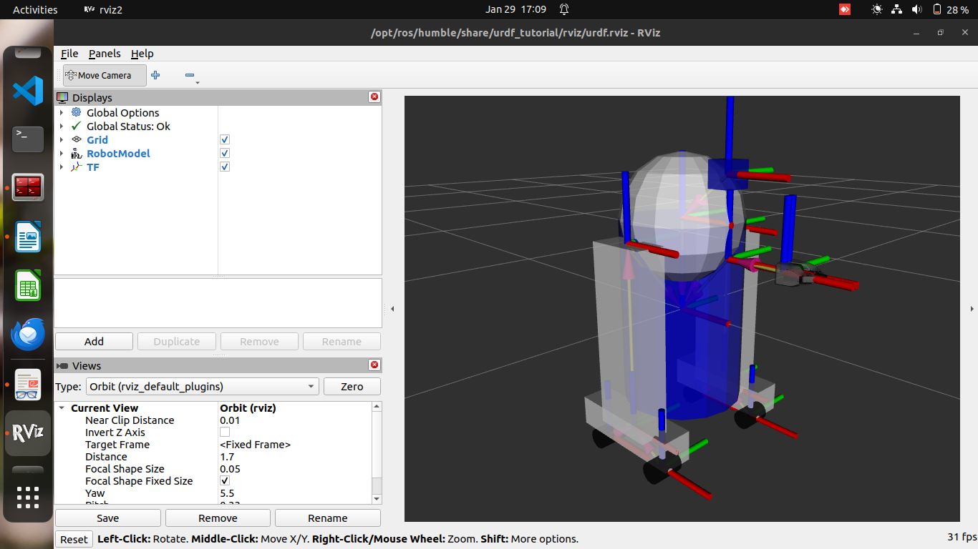

Building a movable robot model

1. The Head (Continuous Joint)
- Joint Type: Continuous (rotation in both directions forever).
- XML Example:
<joint name="head_swivel" type="continuous">
<parent link="base_link"/>
<child link="head"/>
<axis xyz="0 0 1"/>
<origin xyz="0 0 0.3"/>
</joint>
- The joint allows the head to rotate around the Z-axis with no limitations.

2. The Gripper (Revolute Joint)
- Joint Type: Revolute (rotation within specific limits).
- XML Example:
<joint name="left_gripper_joint" type="revolute">
<axis xyz="0 0 1"/>
<limit effort="1000.0" lower="0.0" upper="0.548" velocity="0.5"/>
<origin rpy="0 0 0" xyz="0.2 0.01 0"/>
<parent link="gripper_pole"/>
<child link="left_gripper"/>
</joint>
- This joint allows rotation within specified limits (0.0 to 0.548 radians).

3. The Gripper Arm (Prismatic Joint)
- Joint Type: Prismatic (linear motion along an axis).
- XML Example:
<joint name="gripper_extension" type="prismatic">
<parent link="base_link"/>
<child link="gripper_pole"/>
<limit effort="1000.0" lower="-0.38" upper="0" velocity="0.5"/>
<origin rpy="0 0 0" xyz="0.19 0 0.2"/>
</joint>
- This joint enables linear movement along the Z-axis, with movement limits specified in meters.

4. Other Types of Joints
- Planar Joint: Moves in a plane (2D movement).
- Floating Joint: Unconstrained, allowing movement in all 3D axes.

5. Specifying the Pose
- The GUI uses joint limits and slider values to generate JointState messages, which are published to robot_state_publisher. This transforms the robot model in Rviz for visualization.
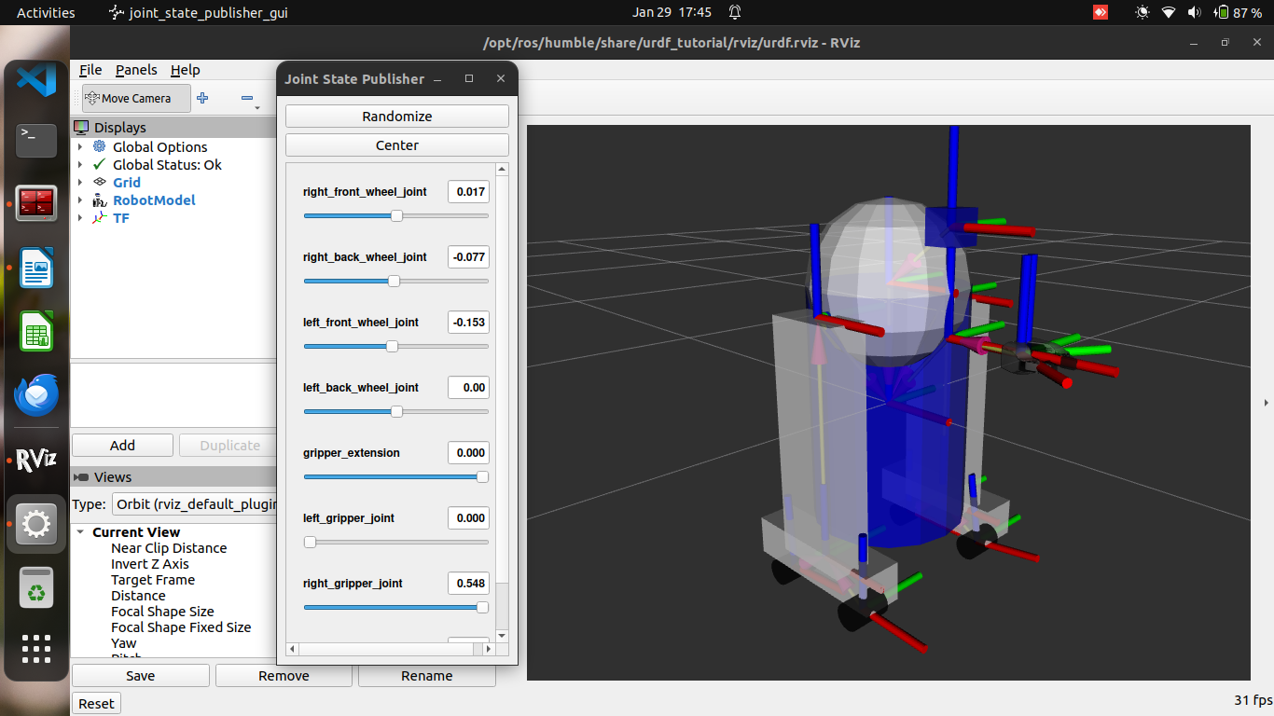

Adding physical and collision properties

1. Collision
- Purpose: Adds collision detection to your model, essential for simulating interactions.
- XML Example:
<link name="base_link">
<visual>
<geometry>
<cylinder length="0.6" radius="0.2"/>
</geometry>
<material name="blue">
<color rgba="0 0 .8 1"/>
</material>
</visual>
<collision>
<geometry>
<cylinder length="0.6" radius="0.2"/>
</geometry>
</collision>
</link>
- The collision element defines the geometry used for collision detection, often the same as the visual geometry for simplicity.
- Why You Might Use Different Geometries:
  - Faster processing: Use simpler shapes (like boxes or spheres) for collision detection to avoid the high computational cost of complex meshes.
  - Safe zones: Enclose sensitive areas (e.g., the robot's head) with larger collision geometries to prevent close encounters.

2. Physical Properties
- Purpose: Adds physical properties like mass, inertia, and joint dynamics for realistic simulation.
- Inertia:
  - Specifies the distribution of mass across the link.
  - XML Example:
<inertial>
<mass value="10"/>
<inertia ixx="1e-3" ixy="0.0" ixz="0.0" iyy="1e-3" iyz="0.0" izz="1e-3"/>
</inertial>
  - Explanation: The inertial tag includes mass (in kilograms) and the inertia matrix (3x3), which describes how the mass is distributed around the link. For simple shapes, you can approximate this based on the shape's geometry.
  - Default values: If uncertain, use small values like 1e-3 for inertia to avoid issues with unstable simulations.
- Contact Coefficients:
  - Defines how two links behave when they collide (e.g., friction and stiffness).
  - Attributes:
    - mu: Friction coefficient
    - kp: Stiffness coefficient
    - kd: Damping coefficient

3. Joint Dynamics
- Purpose: Adds friction and damping to joints, affecting how they move.
- Attributes:
  - friction: Static friction for prismatic (linear) or revolute (rotational) joints.
  - damping: Damping value that affects joint movement (e.g., resistance to motion).
- Example: These coefficients affect how the joint behaves physically, improving realism in simulations.

4. Other Tags
- Calibration and Safety Controller: These tags are relevant to URDFs, but aren't covered in this tutorial. They help with fine-tuning the joint behavior for safety and calibration purposes in advanced scenarios.
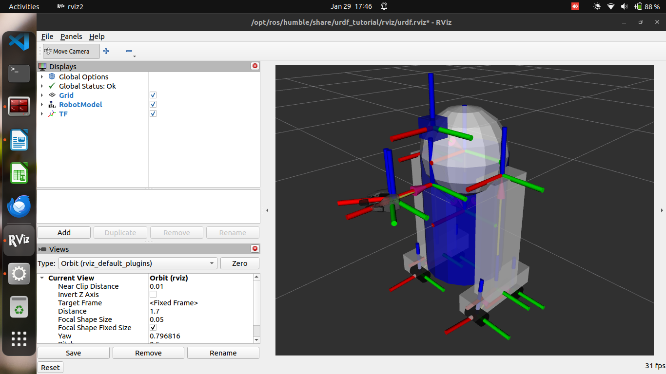
Is there a specific area you'd like to explore further, such as calculating inertia or adjusting joint dynamics?

Using Xacro to clean up your code

1. Using Xacro
- Purpose: Xacro allows you to reduce redundancy in your URDF files by using macros and variables, and it can automate the generation of URDF files during launch.
- Basic Usage:
Run xacro to convert a .xacro file to .urdf.
xacro model.xacro > model.urdf
- In Launch Files: You can include xacro commands in launch files using robot_state_publisher:
path_to_urdf = get_package_share_path('turtlebot3_description') / 'urdf' / 'turtlebot3_burger.urdf'
robot_state_publisher_node = launch_ros.actions.Node(
package='robot_state_publisher',
executable='robot_state_publisher',
parameters=[{
'robot_description': ParameterValue(
Command(['xacro ', str(path_to_urdf)]), value_type=str
)
}]
)

2. Constants
- Purpose: Define constants to avoid repeating values and reduce redundancy.
- Example:
<xacro:property name="width" value="0.2" />
<xacro:property name="bodylen" value="0.6" />
<link name="base_link">
<visual>
<geometry>
<cylinder radius="${width}" length="${bodylen}"/>
</geometry>
</visual>
<collision>
<geometry>
<cylinder radius="${width}" length="${bodylen}"/>
</geometry>
</collision>
</link>
- Explanation: You define the values at the top and use ${} to refer to them later, ensuring the values are centralized and can be updated easily.

3. Math
- Purpose: Xacro allows simple math operations within the ${} construct, enabling dynamic calculations within your URDF.
- Example:
<cylinder radius="${wheeldiam/2}" length="0.1"/>
<origin xyz="${reflect*(width+.02)} 0 0.25" />
- Explanation: You can perform basic arithmetic operations or use functions like sin() and cos() for more complex math.

4. Macros
- Purpose: Macros allow you to reuse blocks of XML code with or without parameters, making it easy to replicate similar parts of your model.
- Simple Macro Example:
<xacro:macro name="default_origin">
<origin xyz="0 0 0" rpy="0 0 0"/>
</xacro:macro>
<xacro:default_origin />
- Parameterized Macro Example:
<xacro:macro name="default_inertial" params="mass">
<inertial>
<mass value="${mass}" />
<inertia ixx="1e-3" ixy="0.0" ixz="0.0"
iyy="1e-3" iyz="0.0" izz="1e-3" />
</inertial>
</xacro:macro>
<xacro:default_inertial mass="10"/>
- Explanation: Parameters allow you to customize macros for different uses. This makes your URDF file more flexible and concise.

5. Practical Usage
- Leg Macro Example: This example demonstrates how you can use Xacro to define a repetitive structure, such as a leg with different parameters (e.g., prefix and reflection) to generate two legs:
<xacro:macro name="leg" params="prefix reflect">
<link name="${prefix}_leg">
<visual>
<geometry>
<box size="${leglen} 0.1 0.2"/>
</geometry>
<origin xyz="0 0 -${leglen/2}" rpy="0 ${pi/2} 0"/>
<material name="white"/>
</visual>
<collision>
<geometry>
<box size="${leglen} 0.1 0.2"/>
</geometry>
<origin xyz="0 0 -${leglen/2}" rpy="0 ${pi/2} 0"/>
</collision>
<xacro:default_inertial mass="10"/>
</link>

<joint name="base_to_${prefix}_leg" type="fixed">
<parent link="base_link"/>
<child link="${prefix}_leg"/>
<origin xyz="0 ${reflect*(width+.02)} 0.25"/>
</joint>
</xacro:macro>
<xacro:leg prefix="right" reflect="1" />
<xacro:leg prefix="left" reflect="-1" />
- Explanation: This uses the prefix and reflect parameters to generate two legs with different names and positions.

6. Common Tricks
- Prefixing Names: Use a prefix to create multiple instances with similar names (e.g., right_leg and left_leg).
- Math for Positioning: Use simple math to calculate positions and other parameters dynamically.
- Reflecting Objects: Use a reflect parameter (set to 1 or -1) to create mirrored objects, like legs on opposite sides.

Using URDF with robot_state_publisher

This guide outlines the steps to create a ROS2 package that simulates a walking robot by publishing joint states using Python and URDF. It involves creating a package, defining a URDF file, publishing the robot state, creating a launch file, editing the setup.py file, installing the package, and running the simulation.
- Create a Package
Create the ROS2 workspace and package:
mkdir -p second_ros2_ws/src
cd second_ros2_ws/src
ros2 pkg create --build-type ament_python --license Apache-2.0 urdf_tutorial_r2d2 --dependencies rclpy
cd urdf_tutorial_r2d2
- Create the URDF File
Create the urdf directory and download the required URDF and Rviz files:
mkdir -p urdf
# Download r2d2.urdf.xml and r2d2.rviz and place them in the `urdf` folder.
- Publish the State
Create a state_publisher.py file with the given code:
touch second_ros2_ws/src/urdf_tutorial_r2d2/urdf_tutorial_r2d2/state_publisher.py
# Paste the provided code into the file
- Create a Launch File
Create a launch folder and add the launch file:
mkdir -p second_ros2_ws/src/urdf_tutorial_r2d2/launch
touch second_ros2_ws/src/urdf_tutorial_r2d2/launch/demo.launch.py
# Paste the provided code into the file
- Edit the setup.py File
Modify the setup.py file:
# Open second_ros2_ws/src/urdf_tutorial_r2d2/setup.py and make the required changes as described.
- Install the Package
Build and install the package:
cd second_ros2_ws
colcon build --symlink-install --packages-select urdf_tutorial_r2d2
source install/setup.bash
- View the Results
Launch the package and open Rviz:
ros2 launch urdf_tutorial_r2d2 demo.launch.py
# In a new terminal:
rviz2 -d second_ros2_ws/install/urdf_tutorial_r2d2/share/urdf_tutorial_r2d2/r2d2.rviz
This guide will set up a simple robot simulation using ROS2 and visualize the robot's movement in Rviz.
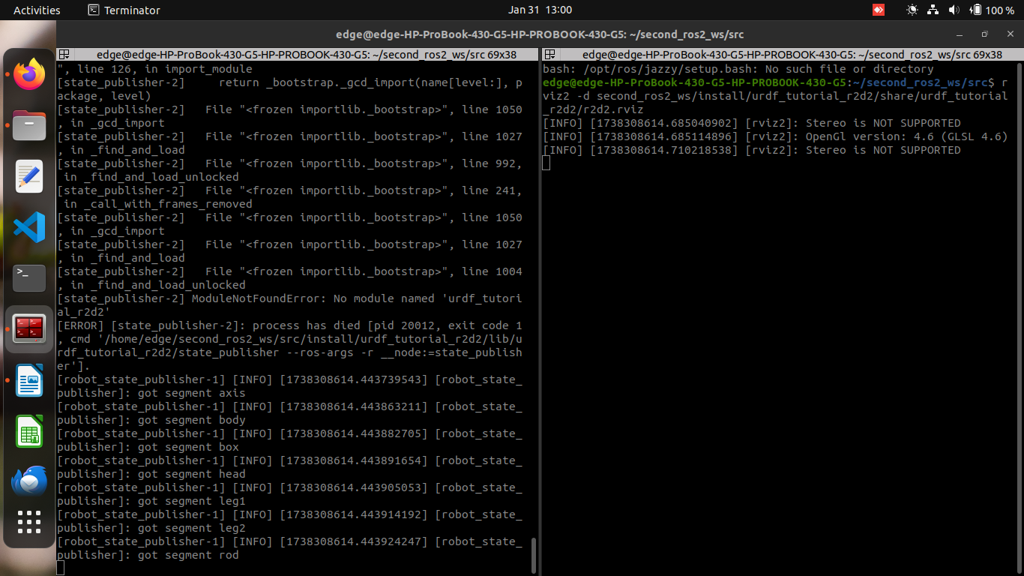
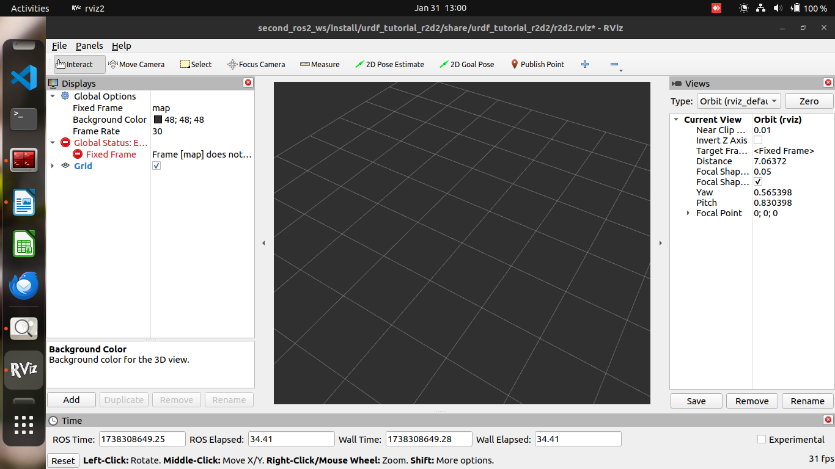

Using a URDF in Gazebo

Simulate your URDF-based robot in the Gazebo simulator.

1. Install Dependencies
sudo apt install ros-humble-urdf-sim-tutorial

2. Launching a Nonfunctional URDF in Gazebo
ros2 launch urdf_sim_tutorial gazebo.launch.py
- Loads the URDF and spawns it in Gazebo.
- By default, the robot will be static and non-interactive.

3. Configuring Meshes
If meshes are missing, modify package.xml:
<export>
<gazebo_ros gazebo_model_path="${prefix}/.."/>
</export>
Ensure meshes are correctly referenced using package:// syntax.

4. Adding Gazebo Plugins for ROS 2 Control
Modify URDF to include Gazebo and ROS2 control plugins:
<ros2_control name="GazeboSystem" type="system">
<hardware>
<plugin>gazebo_ros2_control/GazeboSystem</plugin>
</hardware>
<joint name="head_swivel" />
</ros2_control>

<gazebo>
<plugin filename="libgazebo_ros2_control.so" name="gazebo_ros2_control">
<parameters>$(find urdf_sim_tutorial)/config/09a-minimal.yaml</parameters>
</plugin>
</gazebo>

5. Spawning Controllers
Define a basic joint state broadcaster:
controller_manager:
ros__parameters:
update_rate: 100
use_sim_time: true
joint_state_broadcaster:
type: joint_state_broadcaster/JointStateBroadcaster
Launch it:
ros2 launch urdf_sim_tutorial 09-joints.launch.py
- Publishes /joint_states, but initially empty.
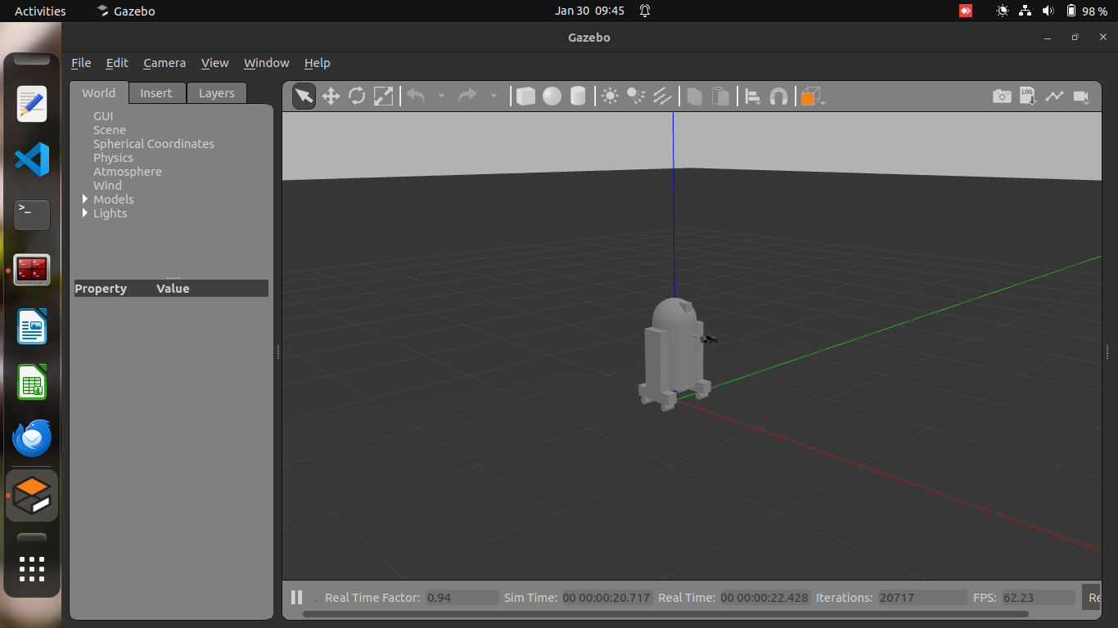

6. Defining Joint Interfaces for Control
Modify URDF joint definition:
<joint name="head_swivel">
<command_interface name="position" />
<command_interface name="velocity" />
<state_interface name="position"/>
<state_interface name="velocity"/>
</joint>
Now, /joint_states includes meaningful data.

7. Adding Position Control
Define a position controller:
controller_manager:
ros__parameters:
head_controller:
type: position_controllers/JointGroupPositionController

head_controller:
ros__parameters:
joints:
- head_swivel
interface_name: position
Launch it:
ros2 launch urdf_sim_tutorial 10-head.launch.py
Control the joint:
ros2 topic pub /head_controller/commands std_msgs/msg/Float64MultiArray "data: [-0.707]"
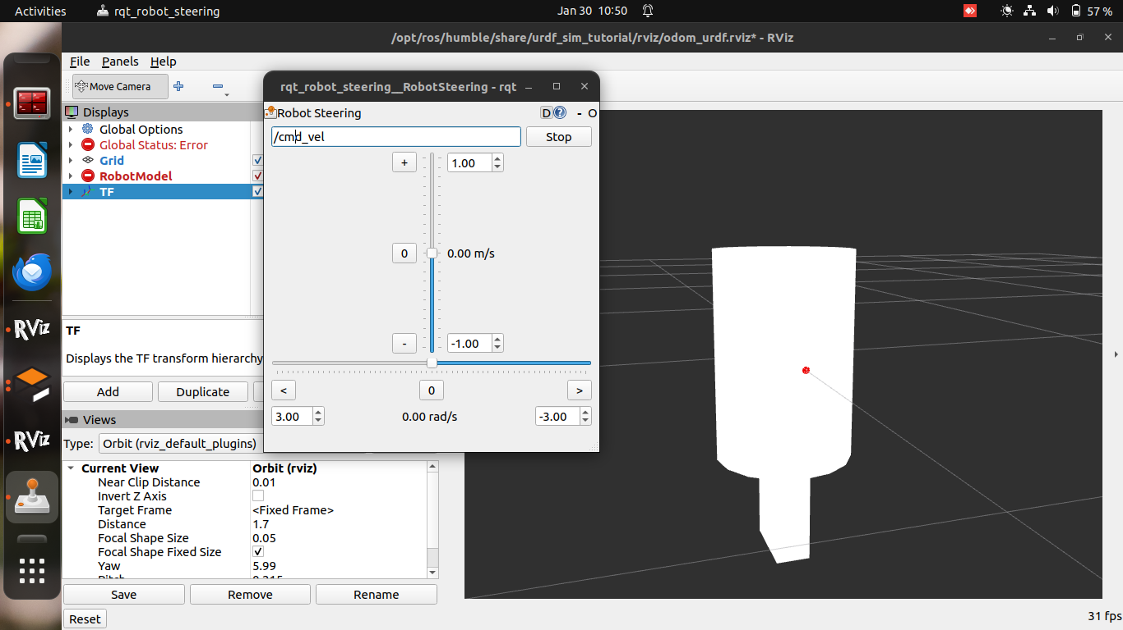

8. Controlling Multiple Joints & Mimicking
- Use mimic for linked joints (e.g., grippers).
- Modify controllers accordingly.
ros2 launch urdf_sim_tutorial 12-gripper.launch.py

9. Driving the Robot (Diff Drive Control)
- Define wheel joint velocity interfaces.
- Use DiffDriveController for cmd_vel input.
Launch with:
ros2 launch urdf_sim_tutorial 13-diffdrive.launch.py
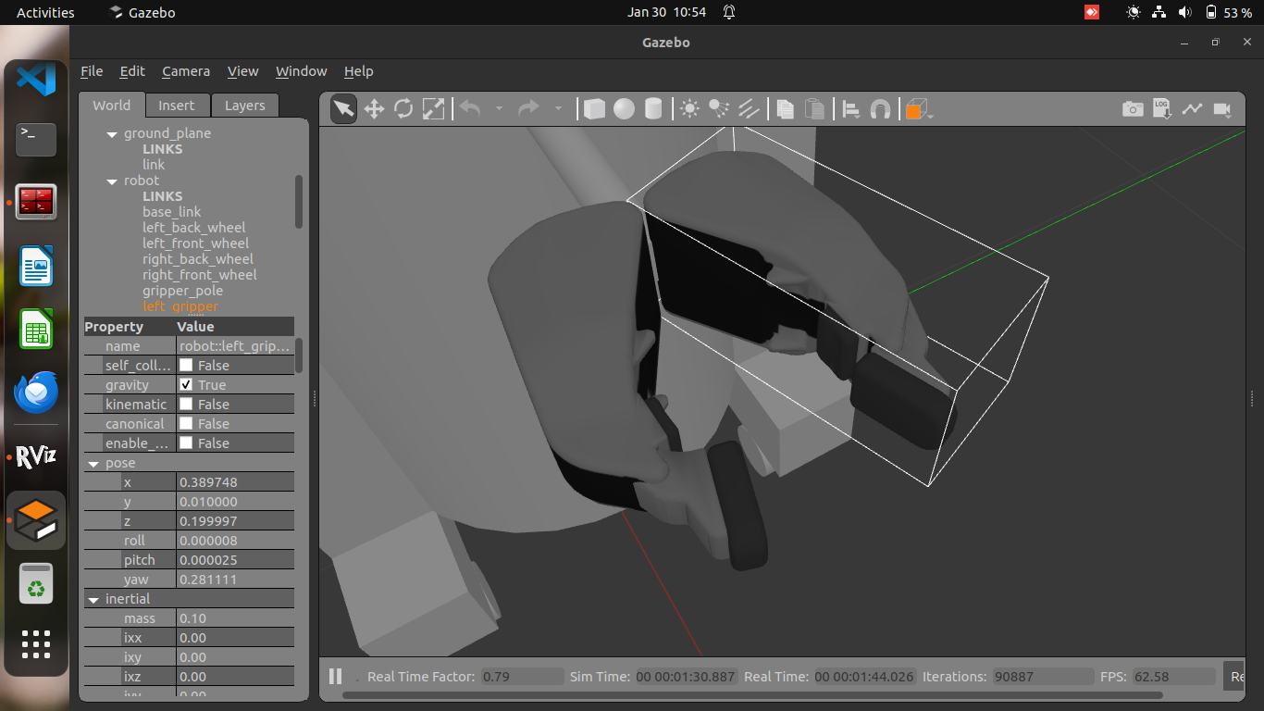
- Opens a GUI to control the robot.

Summary
- Load URDF into Gazebo.
- Add missing meshes if needed.
- Integrate Gazebo plugins for ROS 2 control.
- Spawn controllers for joints.
- Implement position & velocity control.
- Enable differential drive for movement.

Generating an URDF File
Most roboticists work in teams, and often those teams include a mechanical engineer who develops a CAD model of robot. Instead of crafting an URDF by hand it is possible to export an URDF model from many different CAD and modeling programs. These export tools are often developed by individuals that are familiar with the particular CAD program they use. Below you will find a list of available URDF exporters for a variety of CAD and 3D modeling software systems. The ROS core maintainers do not maintain these packages. As such we make no claims about their performance or ease of use. However, we figured it would be helpful to produce a list of available URDF exporters.

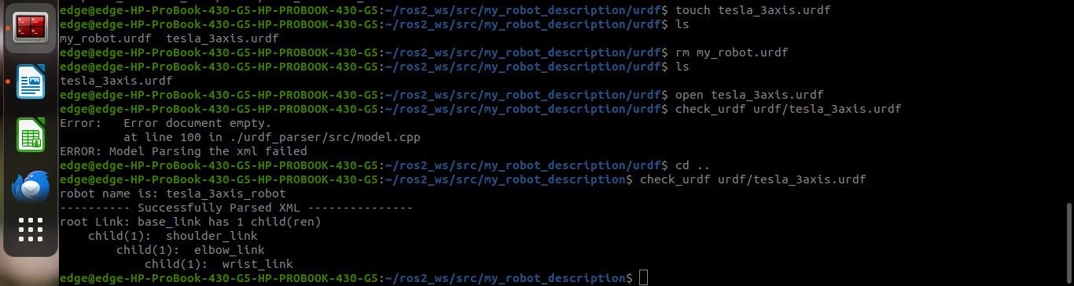

RViz User Guide

Startup
Don’t forget to source the setup file.
source /opt/ros/humble/setup.bash
Then start the visualizer
ros2 run rviz2 rviz2
When RViz starts for the first time, you will see this window:
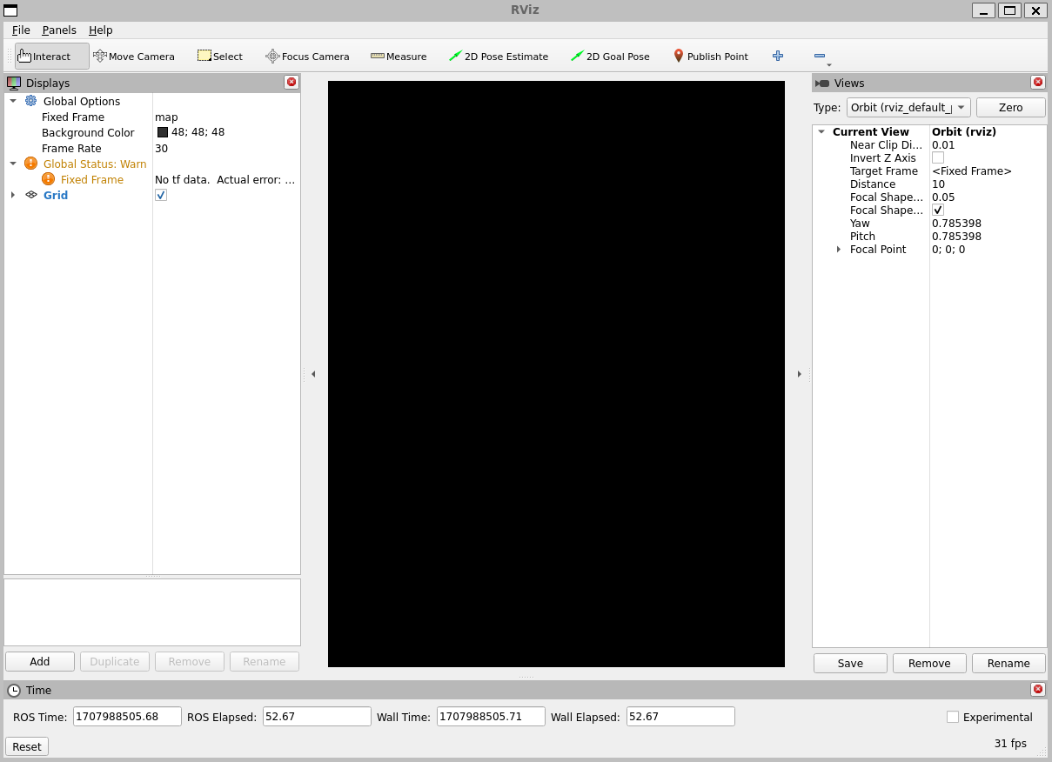
The big black window in the middle is the 3D view (empty because there is nothing to see). On the left is the Displays list, which will show any displays you have loaded. Right now it just contains the global options and a Grid, which we’ll get to later. On the right are some of the other panels, described below.

Displays
A display is something that draws something in the 3D world, and likely has some options available in the displays list. An example is a point cloud, the robot state, etc.

Adding a new display
To add a display, click the Add button at the bottom:
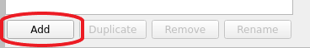
This will pop up the new display dialog:
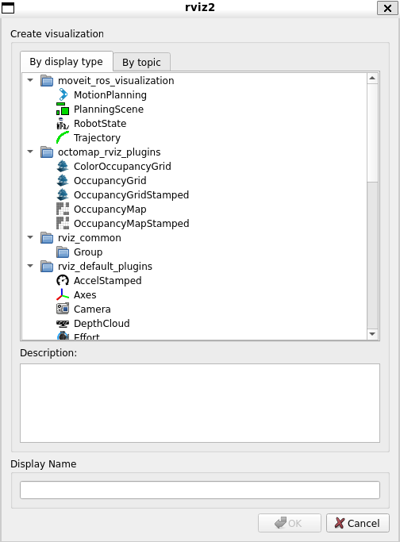
The list at the top contains the display type. The type details what kind of data this display will visualize. The text box in the middle gives a description of the selected display type. Finally, you must give the display a unique name. If you have, for example, two laser scanners on your robot, you might create two Laser Scan displays named “Laser Base” and “Laser Head”.

Display Properties
Each display gets its own list of properties. For example:
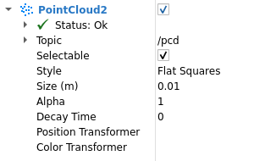

Display Status
Each display gets its own status to help let you know if everything is OK or not. The status can be one of: OK, Warning, Error, or Disabled. The status is indicated in the display’s title by the background color, as well as in the Status category that you can see if the display is expanded:
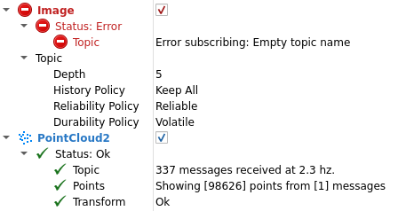
The Status category also expands to show specific status information. This information is different for different displays, and the messages should be self explanatory.

Built-in Display Types
Name | Description | Messages Used
Axes | Displays a set of Axes
Effort | Shows the effort being put into each revolute joint of a robot | sensor_msgs/msg/JointStates
Camera | Creates a new rendering window from the perspective of a camera, and overlays the image on top of it. | sensor_msgs/msg/Image, sensor_msgs/msg/CameraInfo
Grid | Displays a 2D or 3D grid along a plane
Grid Cells | Draws cells from a grid, usually obstacles from a costmap from the navigation stack. | nav_msgs/msg/GridCells
Image | Creates a new rendering window with an Image. Unlike the Camera display, this display does not use a CameraInfo | sensor_msgs/msg/Image
InteractiveMarker | Displays 3D objects from one or multiple Interactive Marker servers and allows mouse interaction with them | visualization_msgs/msg/InteractiveMarker
Laser Scan | Shows data from a laser scan, with different options for rendering modes, accumulation, etc. | sensor_msgs/msg/LaserScan
Map | Displays a map on the ground plane. | nav_msgs/msg/OccupancyGrid
Markers | Allows programmers to display arbitrary primitive shapes through a topic | visualization_msgs/msg/Marker, visualization_msgs/msg/MarkerArray
Path | Shows a path from the navigation stack. | nav_msgs/msg/Path
Point | Draws a point as a small sphere. | geometry_msgs/msg/PointStamped
Pose | Draws a pose as either an arrow or axes. | geometry_msgs/msg/PoseStamped
Pose Array | Draws a “cloud” of arrows, one for each pose in a pose array | geometry_msgs/msg/PoseArray
Point Cloud(2) | Shows data from a point cloud, with different options for rendering modes, accumulation, etc. | sensor_msgs/msg/PointCloud, sensor_msgs/msg/PointCloud2
Polygon | Draws the outline of a polygon as lines. | geometry_msgs/msg/Polygon
Odometry | Accumulates odometry poses from over time. | nav_msgs/msg/Odometry
Range | Displays cones representing range measurements from sonar or IR range sensors. Version: Electric+ | sensor_msgs/msg/Range
RobotModel | Shows a visual representation of a robot in the correct pose (as defined by the current TF transforms).
TF | Displays the tf2 transform hierarchy.
Wrench | Draws a wrench as arrow (force) and arrow + circle (torque) | geometry_msgs/msg/WrenchStamped
Twist | Draws a twist as arrow (linear) and arrow + circle (angular) | geometry_msgs/msg/TwistStamped

Configurations
Different configurations of displays are often useful for different uses of the visualizer. A configuration useful for a full PR2 is not necessarily useful for a test cart, for example. To this end, the visualizer lets you load and save different configurations.
A configuration contains:
- Displays + their properties
- Tool properties
- The viewpoint and settings for the 3D visualzation

Views Panel
There are a number of different camera types available in the visualizer.
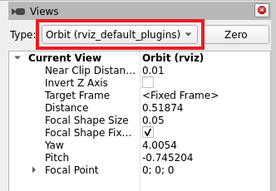
Camera types consist both of different ways of controlling the camera and different types of projection (Orthographic vs. Perspective).

Orbital Camera (default)
The orbital camera simply rotates around a focal point, while always looking at that point. The focal point is visualized as a small disc while you’re moving the camera:
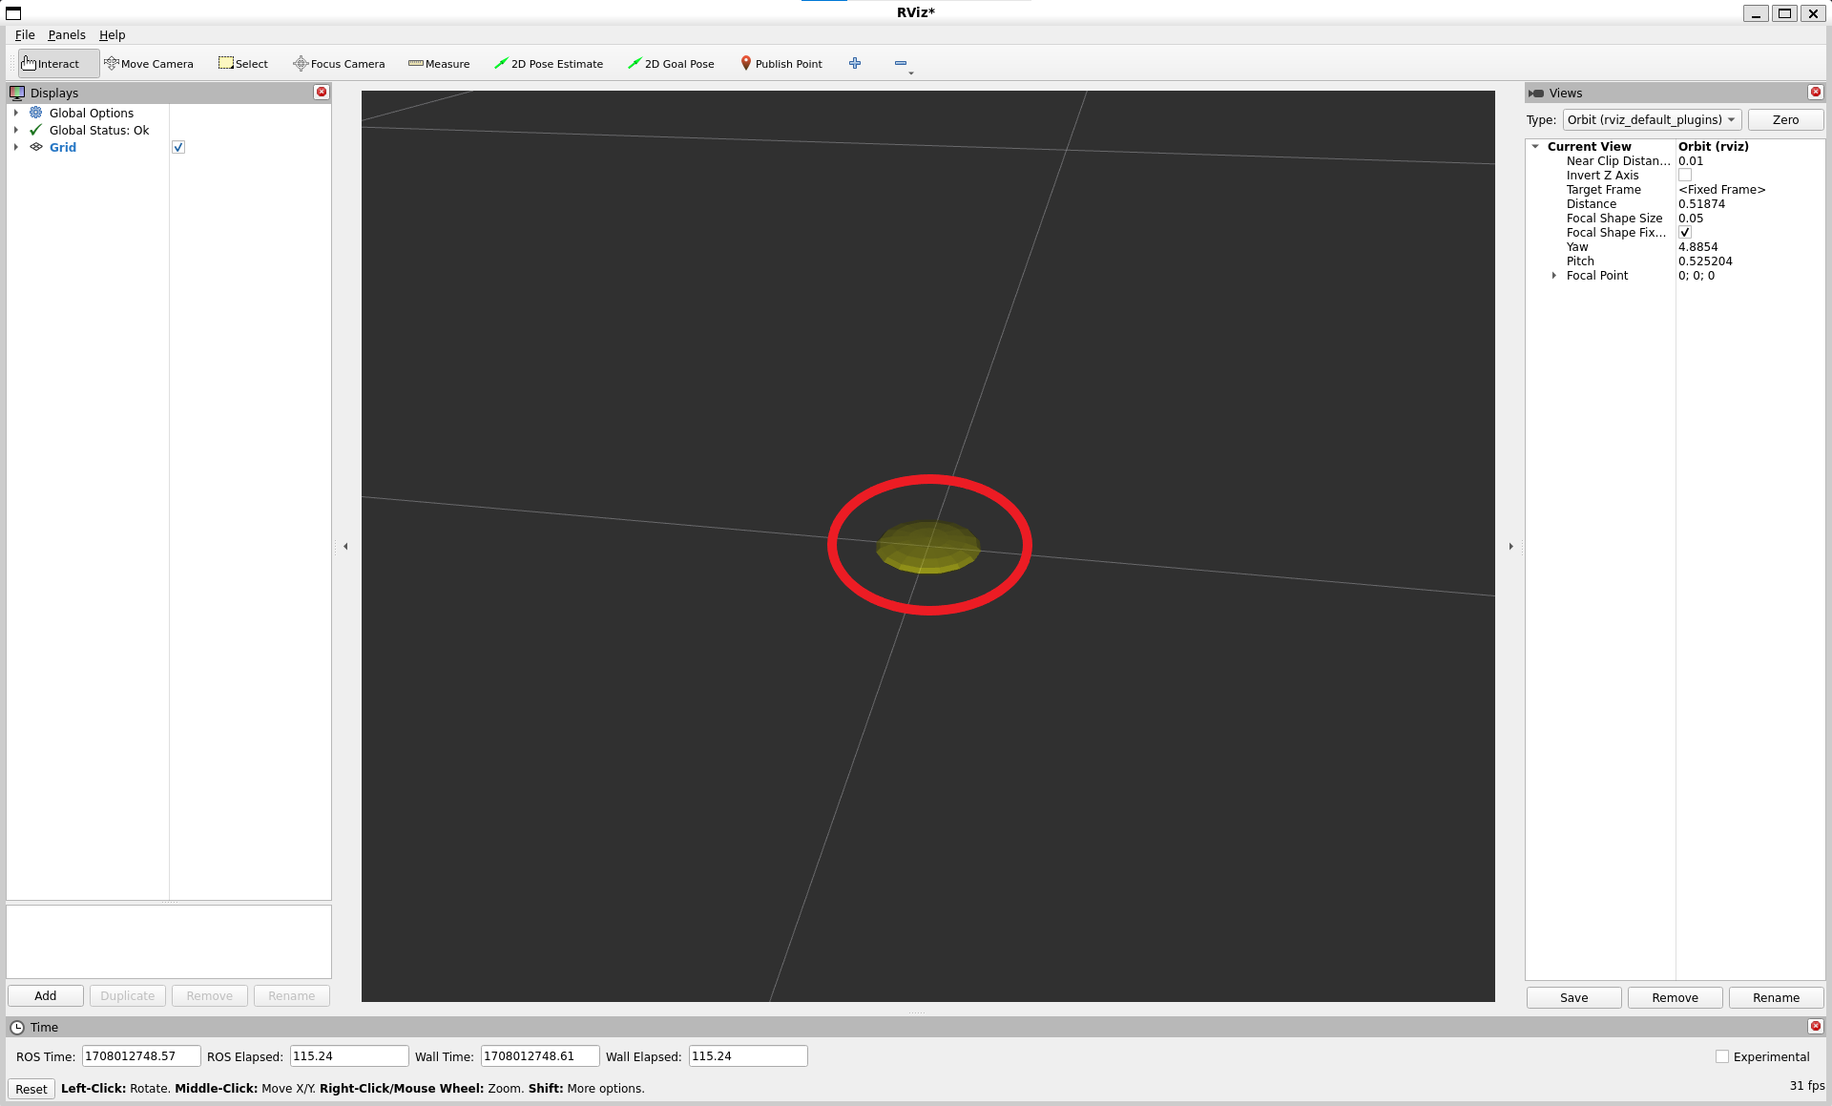
Controls:
- Left mouse button: Click and drag to rotate around the focal point.
- Middle mouse button: Click and drag to move the focal point in the plane formed by the camera’s up and right vectors. The distance moved depends on the focal point – if there is an object on the focal point, and you click on top of it, it will stay under your mouse.
- Right mouse button: Click and drag to zoom in/out of the focal point. Dragging up zooms in, down zooms out.
- Scrollwheel: Zoom in/out of the focal point

FPS (first-person) Camera
The FPS camera is a first-person camera, so it rotates as if you’re looking with your head.
Controls:
- Left mouse button: Click and drag to rotate. Control-click to pick the object under the mouse and look directly at it.
- Middle mouse button: Click and drag to move along the plane formed by the camera’s up and right vectors.
- Right mouse button: Click and drag to move along the camera’s forward vector. Dragging up moves forward, down moves backward.
- Scrollwheel: Move forward/backward.

Top-down Orthographic
The top-down orthographic camera always looks down along the Z axis (in the robot frame), and is an orthographic view which means things do not get smaller as they get farther away.
Controls:
- Left mouse button: Click and drag to rotate around the Z axis.
- Middle mouse button: Click and drag to move the camera along the XY plane.
- Right mouse button: Click and drag to zoom the image.
- Scrollwheel: Zoom the image.

XY Orbit
Same as the orbital camera, with the focus point restricted to the XY plane.
Controls:
See orbital camera.

Third Person Follower
The camera maintains a constant viewing angle towards the target frame. In contrast to XY Orbit the camera turns if the target frame yaws. This could be handy if you are doing 3D mapping of a hallway with corners for example.
Controls:
See orbital camera.

Custom Views
The views panel also lets you create different named views, which are saved and can be switched between. A view consists of a target frame, camera type and camera pose. You can save a view by clicking the Save button of the views panel.
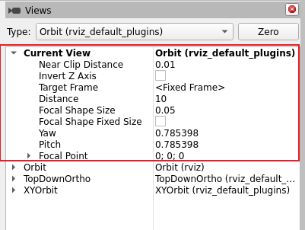
A view consists of:
- View controller type
- View configuration (position, orientation, etc; possibly different for each view controller type.)
- The Target Frame
Views are saved per user, not in the config files.

Coordinate Frames
RViz uses the tf transform system for transforming data from the coordinate frame it arrives in into a global reference frame. There are two coordinate frames that are important to know about in the visualizer, the target frame and the fixed frame.

The Fixed Frame
The more-important of the two frames is the fixed frame. The fixed frame is the reference frame used to denote the world frame. This is usually the map, or world, or something similar, but can also be, for example, your odometry frame.
If the fixed frame is erroneously set to, say, the base of the robot, then all the objects the robot has ever seen will appear in front of the robot, at the position relative to the robot at which they were detected. For correct results, the fixed frame should not be moving relative to the world.
If you change the fixed frame, all data currently being shown is cleared rather than re-transformed.

The Target Frame
The target frame is the reference frame for the camera view. For example, if your target frame is the map, you’ll see the robot driving around the map. If your target frame is the base of the robot, the robot will stay in the same place while everything else moves relative to it.

Tools
The visualizer has a number of tools you can use on the toolbar. The following sections will give a short introduction into these tools. You can find some more information under Help -> Show Help panel.
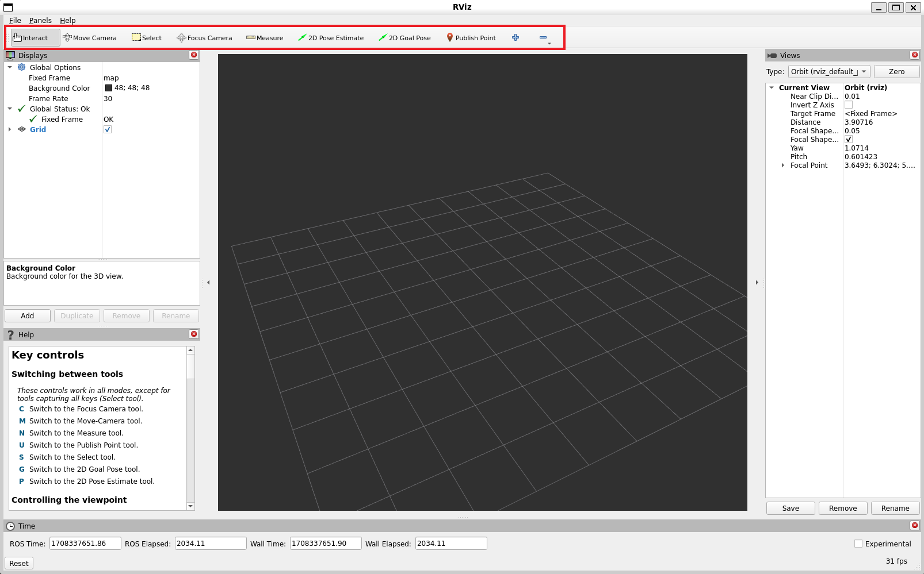

Interact
This tool lets you interact with the visualized environment. You can click on objects and depending on their properties simply select them, move them around and much more.
Keyboard shortcut: i

Move Camera
The Move Camera tool is the default tool. When this is selected and you click inside the 3D view, the viewpoint changes according to the options and camera type you have selected in the Views panel. See the previous section Views Panel for more information.
Keyboard shortcut: m

Select
The Select tool allows you to select items being displayed in the 3D view. It supports single-point selection as well as click/drag box selection. You can add to a selection with the Shift key, and remove from the selection with the Ctrl key. If you want to move the camera around while selecting without switching back to the Move Camera tool you can hold down the Alt key. The f key will focus the camera on the current selection.
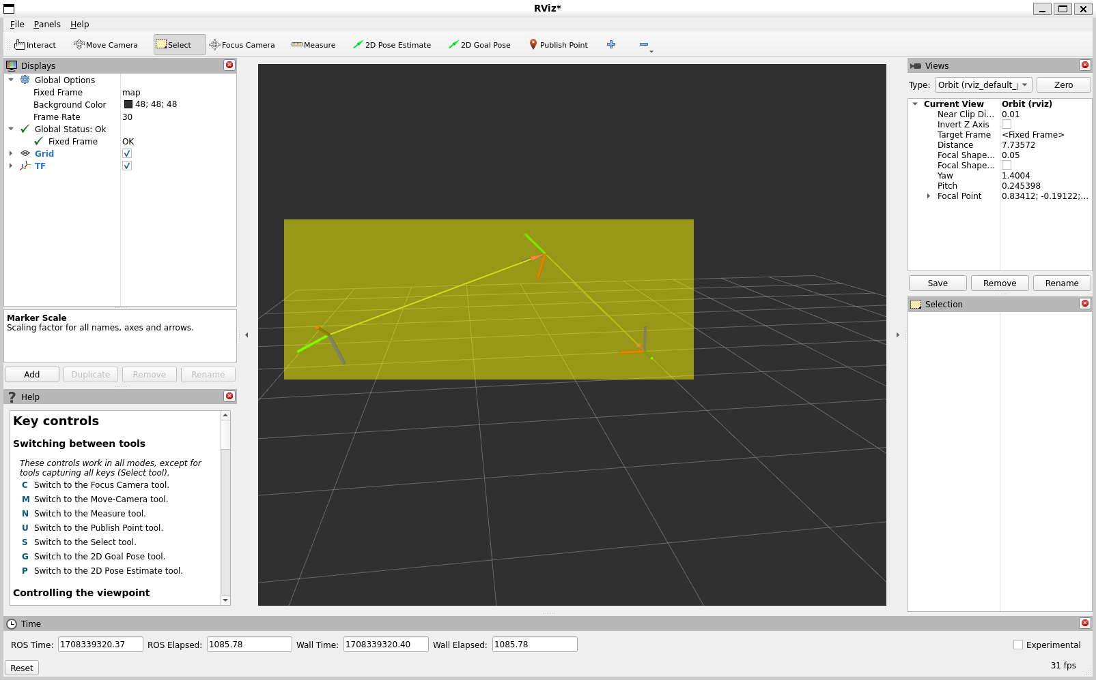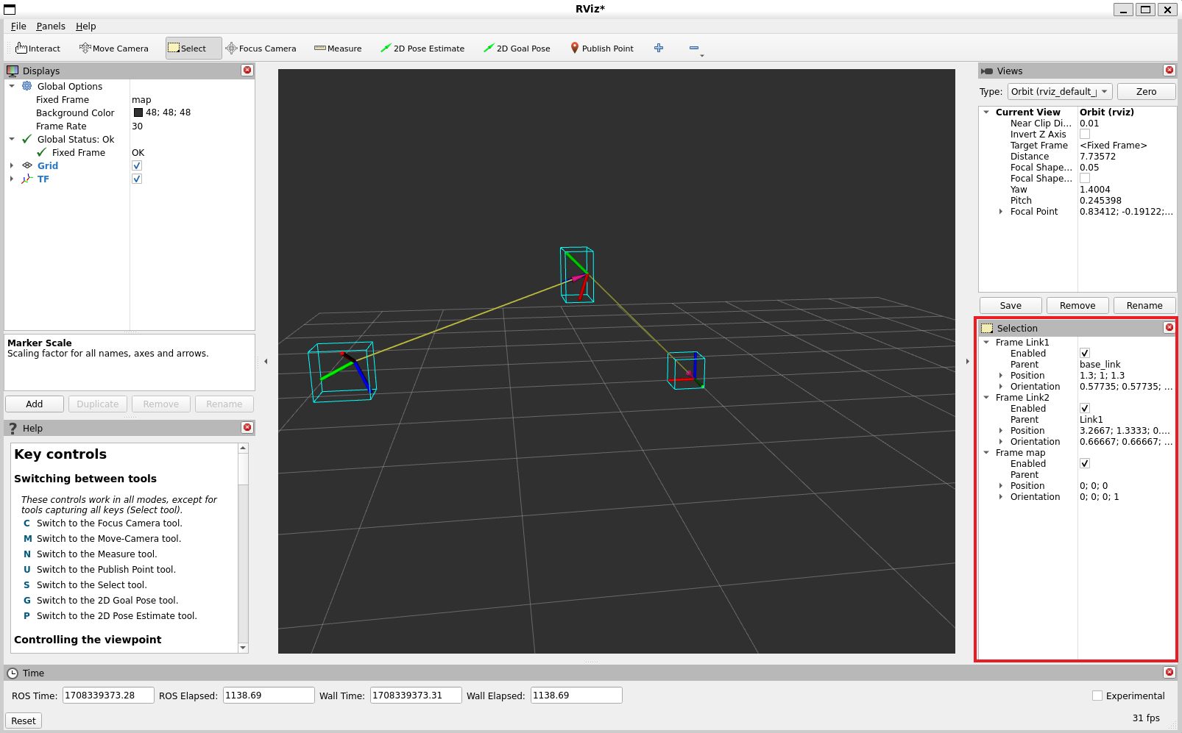
Keyboard shortcut: s

Focus Camera
Focus camera lets you select a location in the visualizer. The camera will then focus that point by changing its orientation but not its position.
Keyboard shortcut: c

Measure
With the measure tool you can measure the distance between to points in the visualizer. The first click after activating the tool will set the starting point and the second one the end point of the measurement. The resulting distance will be displayed at the bottom of the RViz window. But notice that the measurement tool only works with actually rendered objects in the visualizer, you can not use it in empty space.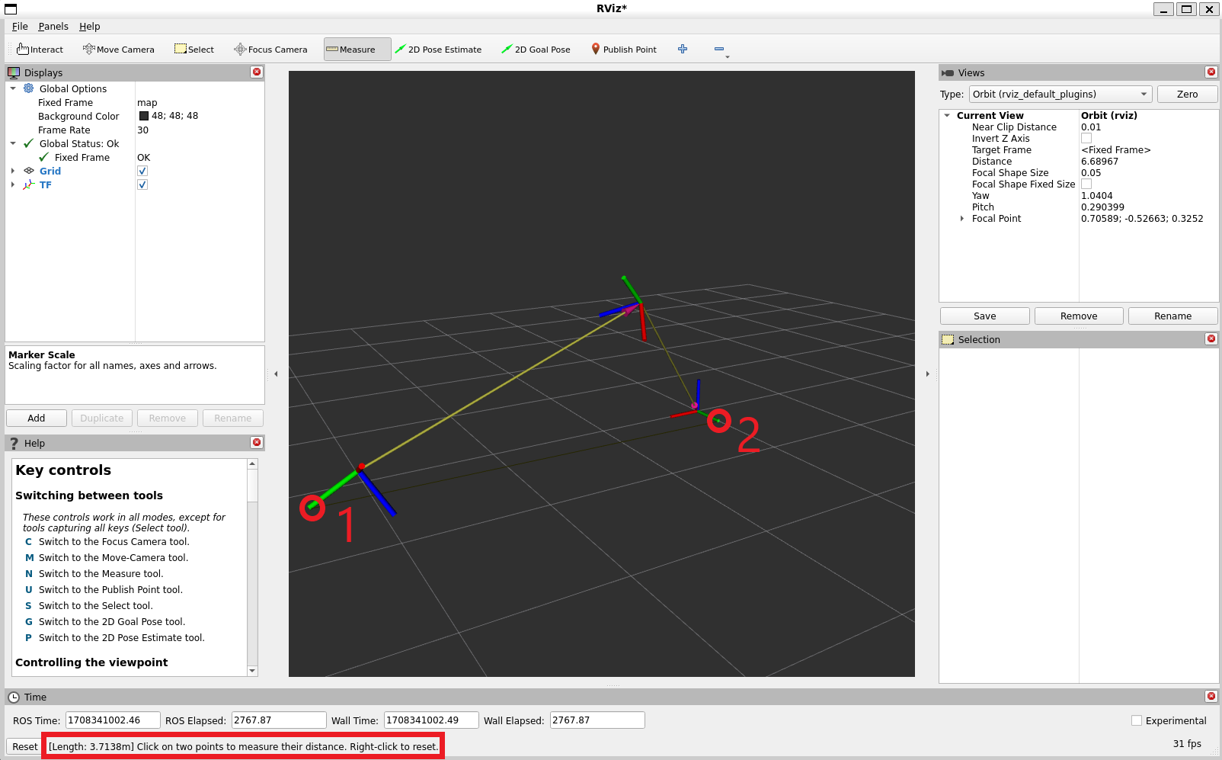

Keyboard shortcut: n

2D Pose Estimate
This tool lets you set an initial pose to seed the localization system (sent on the initialpose ROS topic). Click on a location on the ground plane and drag to select the orientation. The output topic can be changed in the Tool Properties panel.
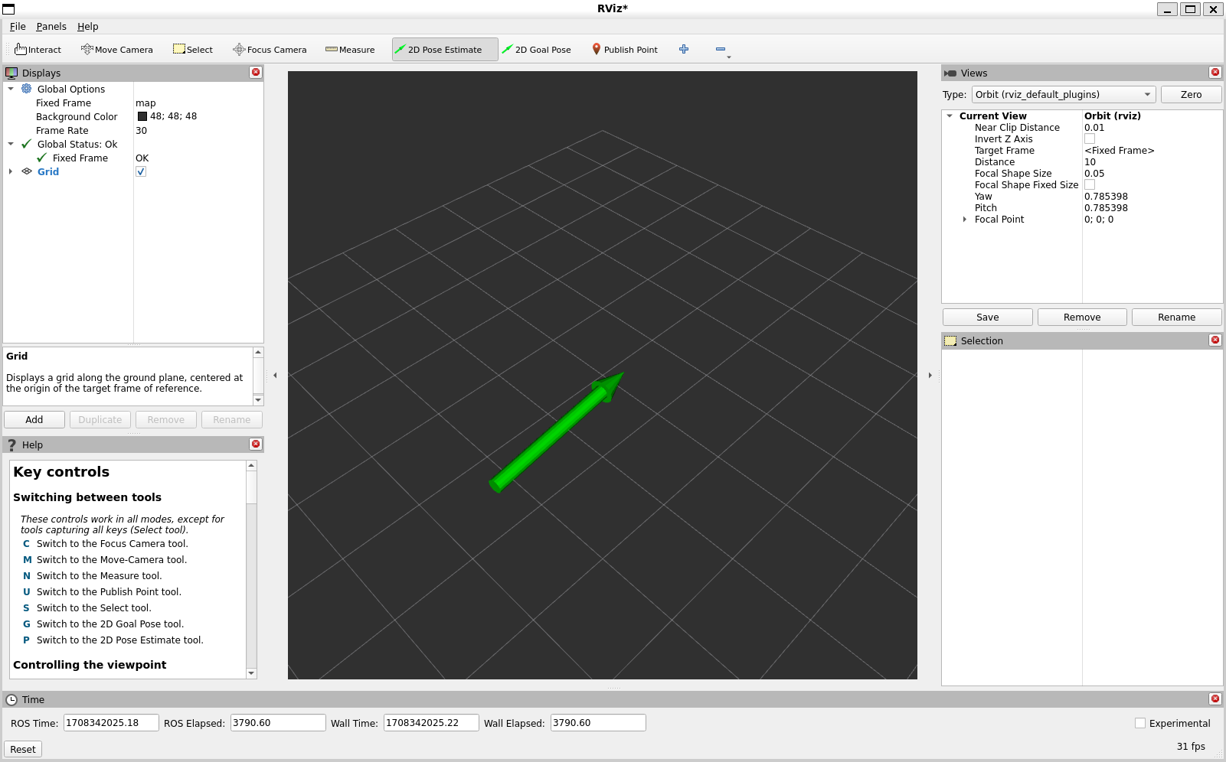
This tool works with the navigation stack.
Keyboard shortcut: p

2D Nav Goal
This tool lets you set a goal sent on the goal_pose ROS topic. Click on a location on the ground plane and drag to select the orientation. The output topic can be changed in the Tool Properties panel.
This tool works with the navigation stack.
Keyboard shortcut: g

Publish Point
The publish point tool lets you select an object in the visualizer and the tool will publish the coordinates of that point based on the frame. The results are shown at the bottom like with the measure tool but are also published on the clicked_point topic.
Keyboard shortcut: u

Time
The Time panel is mostly useful when running in a simulator, since it allows you to see how much ROS Time has passed, vs. how much Wall Clock (aka real) time has passed. The time panel also lets you reset the visualizer’s internal time state, which resets of all the displays as well as tf’s internal cache of data.
If you are not running in simulation, the time panel is mostly useless. In most cases it can be closed and you will probably not even notice (other than having a bit more screen real estate for the rest of rviz).

Building a Custom RViz Display

Background
RViz provides various data visualization plugins, but if a message type lacks a suitable plugin, you have two options:
- Convert it to visualization_msgs/Marker (quick but limited).
- Write a custom RViz display (more effort but richer visualization).
This tutorial walks through creating a custom RViz display for a Point2D message.

Implementation Steps

1️⃣ Basic Plugin Structure
- Define a PointDisplay class inheriting from MessageFilterDisplay<Point2D>.
- Implement processMessage() to handle incoming messages.
- Register the plugin using PLUGINLIB_EXPORT_CLASS.

2️⃣ Configuration Files
- package.xml: Add dependencies (pluginlib, rviz_common, rviz_plugin_tutorial_msgs).
- rviz_common_plugins.xml: Register the plugin’s library and class.
- CMakeLists.txt:
  - Enable CMAKE_AUTOMOC for Qt.
  - Register the plugin with pluginlib_export_plugin_description_file.

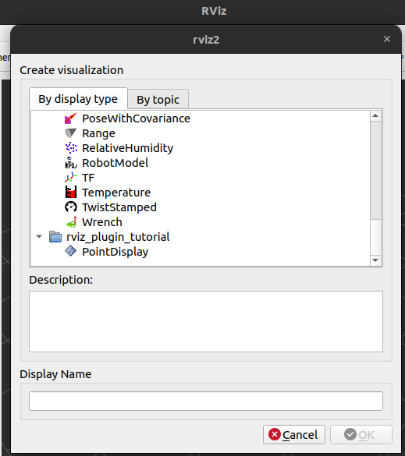
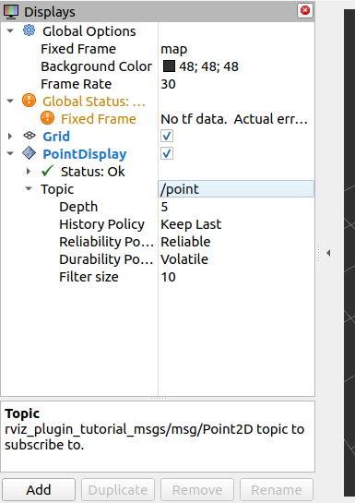

3️⃣

Testing
- Compile and load the plugin in RViz.
- Assign the correct topic (/point).
- Publish test messages with:
ros2 topic pub /point rviz_plugin_tutorial_msgs/msg/Point2D "{header: {frame_id: map}, x: 1, y: 2}" -r 0.5

Enhancements

4️⃣ Adding Visualization
- Use rviz_rendering::Shape (e.g., a cube) to represent points.
- Transform the scene node to align with the message’s reference frame.

5️⃣ Customization with Properties
- Allow users to change point color using rviz_common::properties::ColorProperty.
- Implement updateStyle() to apply color changes dynamically.

6️⃣ Status Reporting
- Display warnings when x < 0 using setStatus().

7️⃣ UI Improvements
- Add a descriptive plugin name and message type in rviz_common_plugins.xml.
- Include an icon (Point2D.png) in the UI.

Final Outcome
After implementation, the custom display:
- Appears in RViz with a name, description, and icon.
- Supports adding by topic.
- Displays points dynamically with user-defined colors.
- Reports warnings for negative values.

Building a Custom RViz Panel
- Create a new Qt panel inside RViz.
- Subscribe to a topic and display incoming messages in the panel.
- Publish to a topic when a button is pressed.

1️⃣ Creating the Panel Structure

Header File: demo_panel.hpp
- The DemoPanel class inherits from rviz_common::Panel.
- Uses Q_OBJECT for Qt integration.
- Defines a constructor and destructor.

Source File: demo_panel.cpp
- Implements an empty constructor and destructor.
- Uses PLUGINLIB_EXPORT_CLASS to register the panel with RViz.
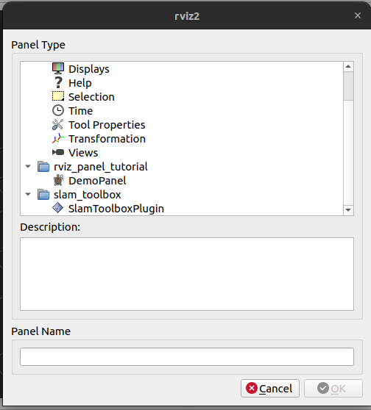

2️⃣ Configuration Files

package.xml
- Dependencies: pluginlib, rviz_common.

rviz_common_plugins.xml
- Registers the panel in RViz.

CMakeLists.txt
- Enables Qt’s CMAKE_AUTOMOC.
- Uses qt5_wrap_cpp for Qt header processing.
- Defines the demo_panel library.
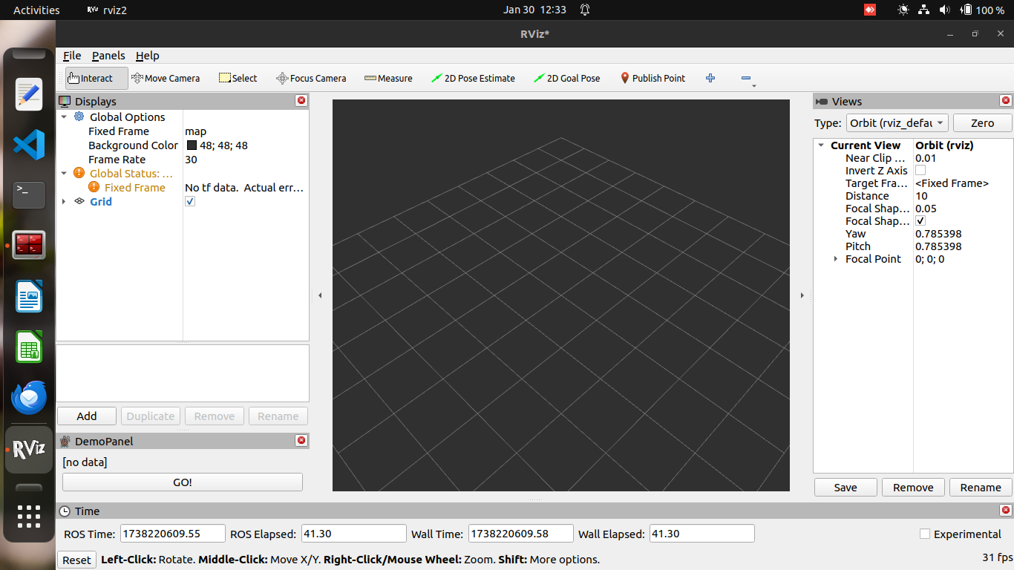
- Calls pluginlib_export_plugin_description_file to register the plugin.

3️⃣ Testing the Empty Panel
- Compile and source the workspace.
- Open RViz and go to Panels → Add New Panel.
- Select the new panel (it will be empty at this stage).

4️⃣ Adding Functionality

Updated demo_panel.hpp
- ROS Integration: Adds a RosNodeAbstractionIface pointer.
- Publisher & Subscriber:
  - Publishes messages on /output when a button is clicked.
  - Subscribes to /input and displays received messages.
- Qt Widgets:
  - A QLabel to display messages.
  - A QPushButton to send messages.

Updated demo_panel.cpp
- Qt Layout: Creates a QVBoxLayout with a label and button.
- ROS Initialization (onInitialize()):
  - Gets an rclcpp::Node from RViz.
  - Creates a publisher (/output).
  - Subscribes to /input.
- Callbacks:
  - topicCallback(): Updates the label with received messages.
  - buttonActivated(): Publishes "Button clicked!".

5️⃣ Testing with ROS
- Subscribe to /input and send a message:
ros2 topic pub /input std_msgs/msg/String "{data: 'Hello from ROS!'}"
  - The panel should display "I will make it happen".
- Echo /output and press the button:
ros2 topic echo /output
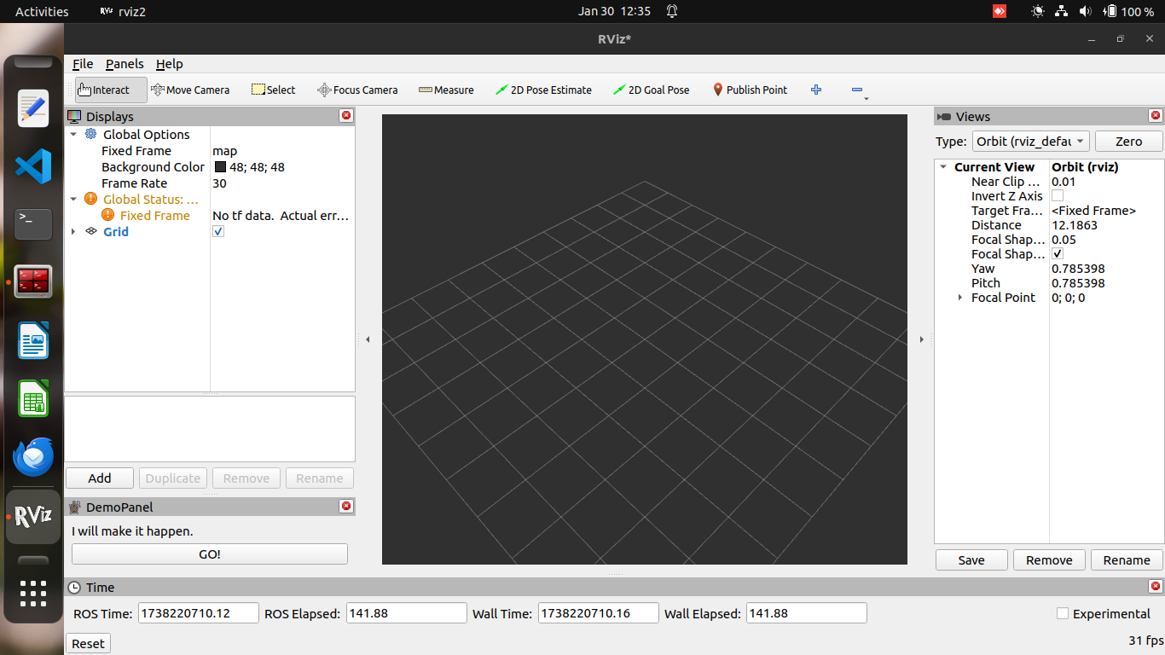
  - It should print "Button clicked!".

6️⃣ UI Enhancements
- Add a description in rviz_common_plugins.xml.
- Include an icon (DemoPanel.png) in icons/classes/.
- Install the icon via CMake:
install(FILES icons/classes/DemoPanel.png
DESTINATION share/${PROJECT_NAME}/icons/classes)

